Press release

Fourth generation of 90 tonne cranes – Saller takes delivery of Liebherr LTM 1090-4.2

⸺
This is the fourth generation of Liebherr 90 tonne cranes for Saller
Liebherr cranes have been part of the company from the very outset
Liebherr scores with its after-sales service, high spare part availability and a practical approach to complaints
Liebherr cranes have been part of Kranverleih Saller GmbH ever since the company was founded. The new addition is the fourth generation of 90 tonne cranes within the last four decades for the company based in Winhöring. Initially, cranes in this capacity class had chassis with six axles. Technical progress means that the same performance is now possible from four-axle mobile cranes. The LTM 1090-4.2 features a 60 metre telescopic boom. Its flexible axle loads mean that it can be used economically throughout the world. Saller plans to use the new crane primarily in the chemical industry.
Ehingen (Donau) (Germany), 28 March 2022 – Kranverleih Saller GmbH has taken delivery of a new Liebherr LTM 1090-4.2 at its head office in Winhöring in Bavaria. “This crane is now the fourth generation of Liebherr 90 tonne cranes our company has owned. The first, which we bought in 1981, was an LT 1090 truck crane on six axles with a 40 metre telescopic boom”, says outgoing Managing Director Johann Saller. He passed his position on to his brothers Herbert Saller and Nikolaus Saller at the turn of the year. Since the eighties, Liebherr has gradually replaced the LT truck cranes with its LTM all-terrain cranes. The first 90 tonne model in the LTM series was a 5-axle type. The current 90 tonne cranes have just four axles and are significantly lighter and more mobile. Thanks to technical progress, the same lifting capacity is now possible with two fewer axles than on the original LT truck crane – despite the fact that the modern crane has a significantly longer telescopic boom. “The LTM 1090-4.2 with its 60 metre main boom and the ballast which it can carry within its 48 tonne gross weight is now the perfect machine for this lifting capacity class for our customers in the chemical industry”, adds Saller.
Economical all-rounder
The LTM 1090-4.2 can be operated economically all over the world. It can travel with axle loads of 10 tonnes, 12 tonnes and 16 tonnes. As a result of its single-engine strategy, the reduced weight from not having a superstructure engine enables a longer boom and more ballast to be used with an axle load of 12 tonnes. The boom is 60 metres long, in other words ten metres longer than its direct predecessor, the LTM 1090-4.1. With an axle load of 12 tonnes, the new crane carries 8.8 tonnes of ballast, 2.1 tonnes more than its predecessor. That enables transport work and costs to be reduced in addition to its higher capacity. Thanks to ECOdrive and ECOmode, the LTM 1090-4.2 is eco-friendly and has lower fuel consumption and noise emission values. Its innovative VarioBallast® system enables the crane to be operated with two ballast radii.
Liebherr continues to beat its competitors after the sale
“Buying from the market leader Liebherr, means that we have a very competent supplier with outstanding after-sales service, high spare parts availability and a practical approach to complaints”, says Saller. This includes well trained service technicians, emergency services available at all times and the global availability of 95 percent of all spare parts within 24 hours.
Liebherr cranes from the very outset
Kranverleih Saller GmbH was founded in 1966 as a recovery and towing contractor. In 1978, Johann Saller became the first full-time employee at his father’s company. That was also the year that the company bought its first Liebherr crane from Ehingen, an LT 1035. The business relationship has grown over the decades. Saller has now purchased well over 100 Liebherr cranes and the company’s workforce has grown to more than 40. In addition to its head office in Winhöring, Saller has two additional outlets in the area known as the south-east Bavarian chemical triangle. This region is home to the relatively large number of companies active in the chemical industry and also to refineries. The main areas of work for Kranverleih Saller GmbH are therefore expansion and refurbishment work at these companies. Saller has many years of experience in this industry and meets the highest safety requirements which apply in this sector.
About Liebherr-Werk Ehingen GmbH
Liebherr-Werk Ehingen GmbH is a leading manufacturer of mobile and crawler cranes. Its range of mobile cranes extends from 2-axle 35 tonne cranes to heavy duty cranes with a lifting capacity of 1200 tonnes and a 9-axle chassis. Its lattice boom cranes on mobile or crawler crane chassis deliver lifting capacities of up to 3000 tonnes. With universal boom systems and extensive additional equipment, they can be seen in action on construction sites throughout the world. The Ehingen site has a workforce of 3,500. Extensive, global service guarantees the high availability of Liebherr mobile and crawler cranes. In 2020, the Liebherr plant in Ehingen recorded a turnover of 2.03 billion euros.

About the Liebherr Group

The Liebherr Group is a family-run technology company with a highly diversified product portfolio. The company is one of the largest construction equipment manufacturers in the world. It also provides high-quality and user-oriented products and services in a wide range of other areas. The Liebherr Group includes over 140 companies across all continents. In 2020, it employed around 48,000 staff and achieved combined revenues of over 10.3 billion euros. Liebherr was founded in Kirchdorf an der Iller in Southern Germany in 1949. Since then, the employees have been pursuing the goal of achieving continuous technological innovation, and bringing industry-leading solutions to its customers

Image:
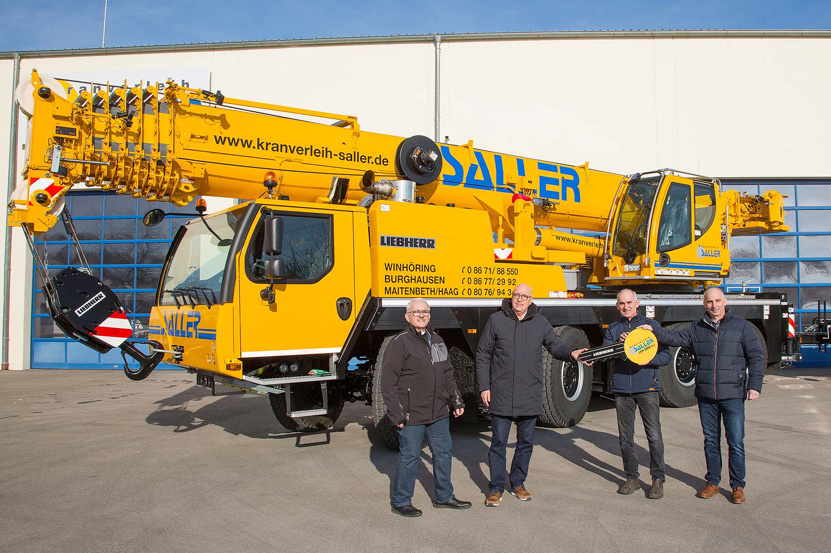
liebherr-ltm-1090-4-2-crane-handover-saller.jpg
Crane handover in Winhöring: (from left to right) Johann Saller (Kranverleih Saller GmbH), Wolfgang Sailer (Liebherr-Werk Ehingen GmbH), Herbert Saller, Nikolaus Saller (both from Kranverleih Saller GmbH).

Contacts
Wolfgang Beringer
Marketing and Communication
Phone: +49 7391/502 - 3663
Email: wolfgang.beringer@liebherr.com
Published by
Liebherr-Werk Ehingen GmbH
Ehingen (Donau) / Germany
www.liebherr.com

