Press release

Liebherr on-board in new air-free Siemens Brake System

⸺
Liebherr has been selected by rolling stock manufacturer Siemens Mobility for a joint development and the delivery of a key component of their new air-free Siemens Brake System: the electro-hydraulic brake actuator, which provides the brake force for the brake system. Unlike the conventional pneumatic brake, with the new air-free Siemens Brake System the control of the brake is fully electrical – “brake-by-wire” –, which means that all piping and all pneumatic components for controlling the brake can be eliminated.
Korneuburg (Austria) March 2022 – In close collaboration with Siemens Liebherr developed and produces a compact, closed, electrohydraulic brake actuator including all the components necessary to build-up and release the brake force as well as local control. The brake actuator is integrated in the bogie in the same installation space and has the same mechanical interfaces as the conventional pneumatic brake caliper. This brake actuator meets the highest safety requirements and Safety Integrity Levels up to SIL4 and also the latest rules and regulations for safety verification. The brake actuator is derived from the technology that Liebherr developed for aerospace flight control actuation applications.
As Mr. Jens Lichterfeld, Senior Expert Brakes at Siemens Mobility puts it: “Using the air-free brake results in a number of benefits on car-level, including reduced weight and reduced effort for installation and commissioning of the brake system. In addition, installation space that was previously required for the air brake components can now be used for other subsystems. That’s extremely useful when it comes to vehicle development". In operation, efforts can be reduced in several areas like maintenance, train’s start-up time and shortening of headways.
Siemens Mobility is implementing the new brake technology for the first time on the X-Wagen metro project in Vienna (Austria).
According to Mr. Robert Steinfelder, Vice President Siemens Brakes at Siemens Mobility: “Wiener Linien will then be the first transit authority in the world to benefit from our brake system, both in conventional operation with a driver and later in automated operation on the new U5 Line.”
About Liebherr-Transportation Systems
Liebherr’s transportation systems division supplies cab and saloon heating, ventilation and air conditioning (HVAC) systems, thermal management systems for diverse mobile and stationary e-mobility applications, hydraulic actuation systems, dampers and hydraulic load levelling equipment for rail vehicles of all kinds. Liebherr has many years of experience in the development, manufacture, and field service of these technologies, offering support throughout the entire product lifecycle. The company invests continuously in its R&D activities in order to offer its customers new generations of diverse transportation systems solutions.

Liebherr-Transportation Systems has four production plants in Korneuburg (Austria), Marica (Bulgaria), Pinghu (China) and Zhuji (China). In addition to its own sales and service centers, the division has access to the Liebherr Group’s extensive and unique technologies as well as development and service facilities around the world. This global set-up means that Liebherr-Transportation Systems is there for its customers wherever they may be.
About the Liebherr Group
The Liebherr Group is a family-run technology company with a highly diversified product portfolio. The company is one of the largest construction equipment manufacturers in the world. It also provides high-quality and user-oriented products and services in a wide range of other areas. The Liebherr Group includes over 140 companies across all continents. In 2020, it employed around 48,000 staff and achieved combined revenues of over 10.3 billion euros. Liebherr was founded in Kirchdorf an der Iller in Southern Germany in 1949. Since then, the employees have been pursuing the goal of achieving continuous technological innovation, and bringing industry-leading solutions to its customers.
Image
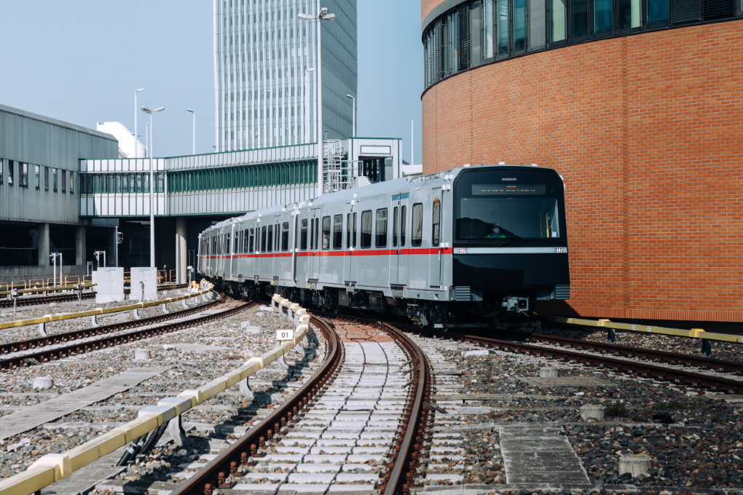
IM2021040546MO_original_Copyright-Siemens.jpg
Vienna: First test run with the new Metro „X-Wagen“ - © Siemens/Markus Schieder
Contact person
Ute Braam
Corporate Communications
Phone: +49 8381 / 46 - 4403
E-mail: ute.braam@liebherr.com
Published by
Liebherr-Aerospace & Transportation SAS
Toulouse / France
www.liebherr.com

