Press release

LHM 550 celebrates 300th delivery

⸺
The 300th delivery of a Liebherr LHM 550 mobile harbour crane to Polish port operator Port Gdańsk Eksploatacja
The new machine will primarily be used for bulk handling of coke, coal and scrap metal
The LHM 550 is the bestseller in Liebherr’s mobile harbour crane portfolio
One of the leading port operators in Poland, Port Gdańsk Eksploatacja S.A., has signed a contract with Liebherr for a new LHM 550 mobile harbour crane. The machine will primarily be used for bulk handling. This is the 300th order of this crane type in total. The LHM 550 thus marks more than ten years of international success for Liebherr.
Rostock (Germany), March 2022 - In the sales year 2022, the Liebherr LHM 550 mobile harbour crane continues its success story that has already lasted for over ten years. Liebherr can announce an anniversary with the 300th delivery of this crane type. One of Poland’s largest port-handling operators based in Gdansk, Port Gdańsk Eksploatacja S.A., recently took delivery of its 300th LHM 550. For the company, which carries out handling activities on a total area of over 89 hectares, it is one of the largest investments in the company's thirty-year history. The crane supplied has a boom length of 48 metres and a lifting capacity of up to 104 tonnes. The new machine will primarily be used for bulk handling of coke, coal and scrap metal.
"We want to increase the effectiveness, functionality and speed of our services. The quality of our work processes will improve significantly. This will have a positive impact on our handling rate. In addition, our customers can expect faster handling of the commissioned vessels. We greatly appreciate the extraordinary mobility of this machine. We trained our crane operators at an early stage and carried out extensive modernisation measures in the port area in advance so that we could use the machine as quickly and as efficiently as possible," comments Radosław Stojek, Chairman of the Board of Port Gdańsk Eksploatacja S.A.
A unique success story
The delivery of the first LHM 550 to Kuwait in 2010, marked the beginning of a Liebherr success story. As the most popular crane type in the Liebherr mobile harbour crane portfolio, the LHM 550 has contributed significantly to Liebherr's market leadership in the MHC market, which has lasted for more than ten years. In every year since its market launch, a double-digit number of this crane types alone have been delivered worldwide. In terms of sales per country, India leads the ranking with 23 units sold, closely followed by Italy and the USA. In the 2021 sales year alone, 26 LHM 550s were sold worldwide.

A versatile allrounder
The Liebherr mobile harbour crane series is suitable for a wide range of applications. For example, the LHM 550 can be used for bulk or general cargo handling as well as for container handling. Even heavy-duty lifts of up to 154 tonnes are possible. Statistics show that a large number of Liebherr customers use the LHM 550 for several applications. Well over 200 of the units sold are used for at least two or three applications. Of these, most are used for bulk and container handling.
Electric Drive
Further to the possibilities in application, multiple drive types are also versatile. In addition to a hybrid drive concept consisting of diesel and electric motors, the cranes can also be used exclusively in electric only operation, thus making an important contribution to emission-free goods handling. Over 30 % of the LHM 550s sold in the 2021 sales year were equipped with an electric main drive.

About Liebherr-MCCtec Rostock GmbH
Liebherr-MCCtec Rostock GmbH is one of the leading European manufacturers of maritime handling solutions. The product range includes ship, mobile harbour and offshore cranes. Reach stackers and components for container cranes are also included in the product portfolio.
About the Liebherr Group
The Liebherr Group is a family-run technology company with a highly diversified product portfolio. The company is one of the largest construction equipment manufacturers in the world. It also provides high-quality and user-oriented products and services in a wide range of other areas. The Liebherr Group includes over 140 companies across all continents. In 2020, it employed around 48,000 staff and achieved combined revenues of over 10.3 billion euros. Liebherr was founded in Kirchdorf an der Iller in Southern Germany in 1949. Since then, the employees have been pursuing the goal of achieving continuous technological innovation, and bringing industry-leading solutions to its customers.
Images
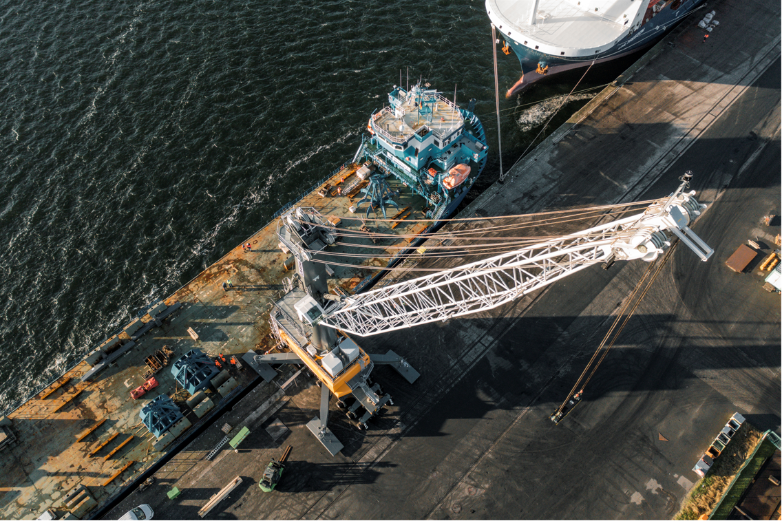
liebherr-lhm-550-roll-on.jpg
The 300th LHM 550 is loaded in Rostock’s city harbour for delivery to Gdansk.
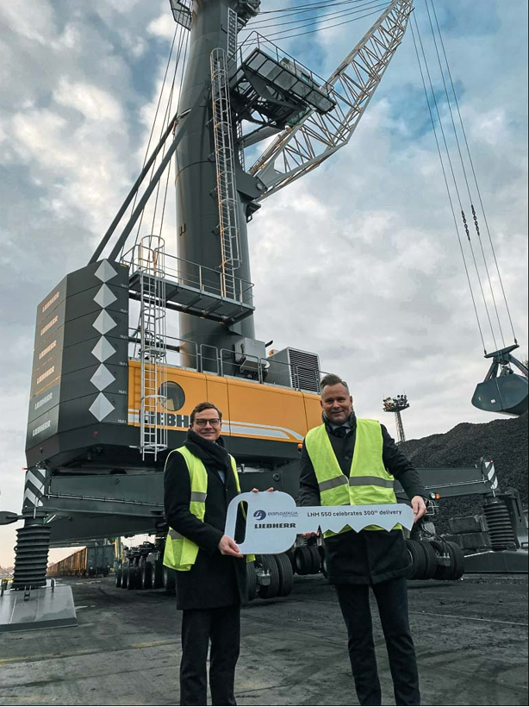
liebherr-lhm-550-handover.jpg
The new machine is handed over to Radosław Stojek, CEO of the Polish port operator Port Gdańsk Eksploatacja by Liebherr sales manager Jan Hammerschmidt.

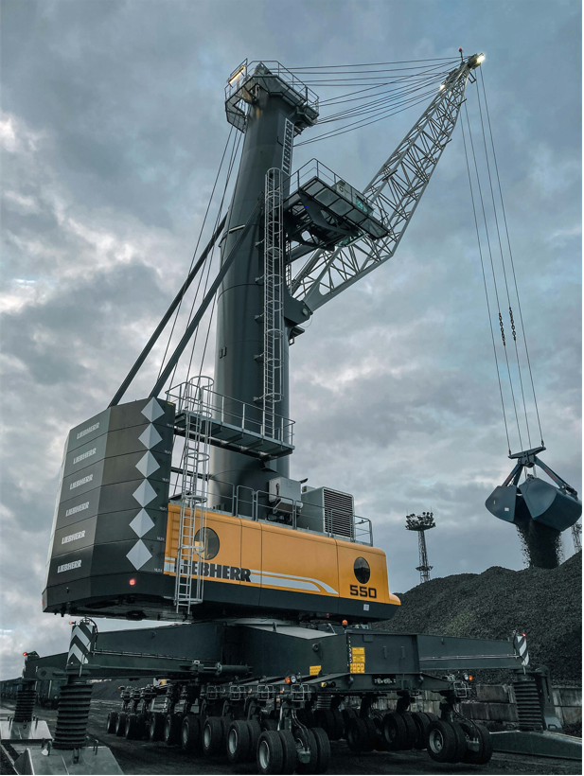
liebherr-lhm-550-in-operation.jpg
The mobile harbour crane LHM 550 handling bulk cargo in the port of Gdansk.

Contact
Björn Haß
Phone: +49 381 6006 5024
E-mail: Bjoern.Hass@liebherr.com
Published by
Liebherr-MCCtec Rostock GmbH
Rostock / Deutschland
www.liebherr.com

