Press release

LiMain: Changing the way you think about maintenance

⸺
Liebherr’s answer to the market demand for next generation maintenance
50 fewer service days on manned platforms, 75 % less mobilisation on unmanned platforms
Modular system serves individual customer requests

Liebherr Intelligent Maintenance (LiMain) paves the way for an even higher crane availability at lower operational costs (OPEX) on offshore platforms. The fully digital, semiautomatic, and remote maintenance system offers more independency of time, place and resources for platform owners, resulting in never-before-seen savings.
Rostock (Germany) March 2022 – Accelerated by the global pandemic, there is a growing desire among platform operators for new approaches to regular maintenance. Previously, maintenance processes for offshore platform equipment were time-consuming, costly and required many resources. Additionally, platform owners face many obstacles that are difficult to manage, such as availability of personnel, weather conditions and need for professional expertise. To solve the tension between increased crane availability at lower OPEX in combination with a higher degree of independence from these conditions, Liebherr has launched a highly demanded product called LiMain. It is short for Liebherr Intelligent Maintenance, performing maintenance processes without having to operate the crane on site. The achievable savings are outstanding: LiMain offers up to 75% less mobilisation on unmanned platforms and up to 50 fewer service days on manned platforms per year
“We commit ourselves to shape the future of maintenance for our customers. LiMain will change the way they think about maintenance”, said Stefan Schneider, Global Application Manager for General Purpose Offshore Cranes, “the result of our commitment is an intelligent maintenance system, which solves challenges that platform operators have grappled with all around the world for years.”
Into the new age at customers’ pace
A customer-orientated key element of LiMain is its modular system architecture, which consists of four different modules: “Automatic Greasing”, “Condition Monitoring”, “Predictive Maintenance” and “Remote Maintenance Cycle”. Whereas “Automatic Greasing” speaks for itself, meaning that core components of the crane are continuously checked and automatically lubricated, the other modules set a new standard on different levels of maintenance. With modern sensor technology as a part of the “Condition Monitoring” module, detailed data about the crane and its components are monitored in real time, which delivers an unprecedented level of transparency. With “Predictive Maintenance”, Liebherr raises the bar even further: it puts ad-hoc data into context, building on decades of experience from the construction of more than 1,000 offshore cranes and sharing this knowledge with the customers. “Remote Maintenance Cycle” represents the all-inclusive-approach, which combines all LiMain modules and enables semiautomatic maintenance as well as self-diagnosis of the crane.

“In addition to high-quality cranes made in Germany, Liebherr is well known for its comprehensive customer service, which we have taken to the next level with Liebherr Intelligent Maintenance”, said Gregor Levold, Sales Director Offshore, Ship and Port Cranes, “due to the modular architecture, our customers have the freedom to choose how automated their processes should be, meeting the specific needs of each client. In the near future, LiMain will also be available for further products in our Liebherr maritime crane portfolio.”
Besides the usual maintenance processes, LiMain also has a positive effect on general logistics. The ability to pinpoint the optimal time to exchange spare parts eliminates unnecessary service intervals and results in more storage space for other equipment – keeping costs down and availability high.

About Liebherr-MCCtec Rostock GmbH
Liebherr-MCCtec Rostock GmbH is one of the leading European manufacturers of maritime material handling solutions. The product range includes ship, mobile harbour and offshore cranes. Reachstackers and components for container cranes are also part of the product portfolio.
About the Liebherr Group
The Liebherr Group is a family-run technology company with a highly diversified product portfolio. The company is one of the largest construction equipment manufacturers in the world. It also provides high-quality and user-oriented products and services in a wide range of other areas. The Liebherr Group includes over 140 companies across all continents. In 2020, it employed around 48,000 staff and achieved combined revenues of over 10.3 billion euros. Liebherr was founded in Kirchdorf an der Iller in Southern Germany in 1949. Since then, the employees have been pursuing the goal of achieving continuous technological innovation, and bringing industry-leading solutions to its customers.
Images
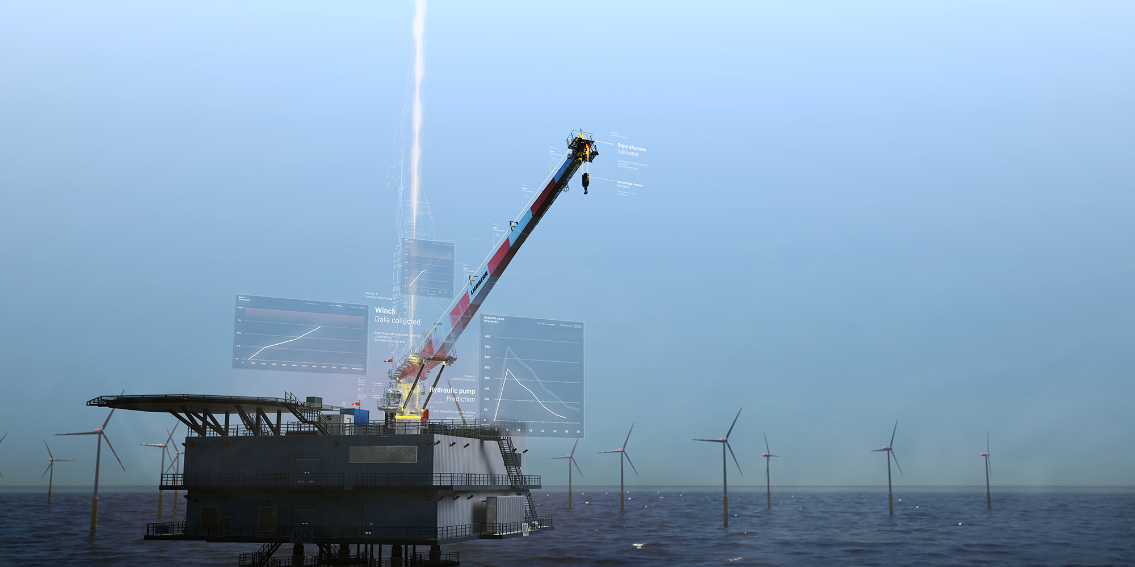
Liebherr_limain_keyvisual.jpg
A key element of Liebherr Intelligent Maintenance (LiMain) is its modular system architecture with four different modules to choose from.

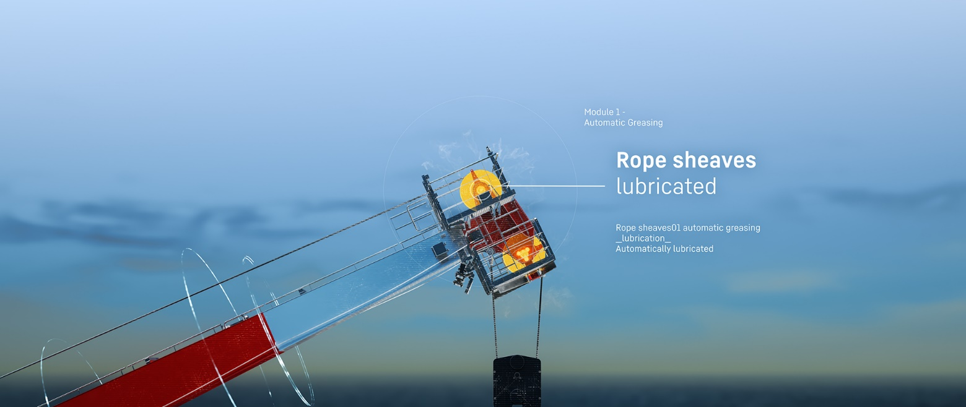
Module Automatic Greasing: Liebherr_limain_AutomaticGreasing.jpg
Even in complexly installed positions, critical components are continuously checked and automatically lubricated.
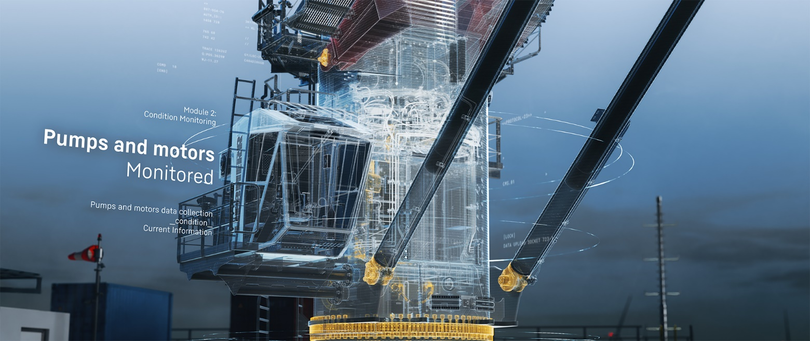
Module Condition Monitoring: Liebherr_limain_ConditionMonitoring.jpg
State-of-the-art sensor technology records detailed data about relevant components and crane systems, including potential environmental monitoring.

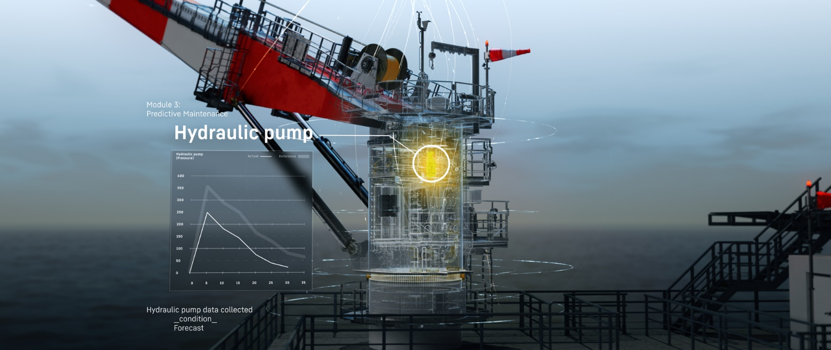
Module Predictive Maintenance: Liebherr_limain_PredictiveMaintenance.jpg
Advanced sensor technology and many years of experience are bundled to advance maintenance in the most efficient way possible.
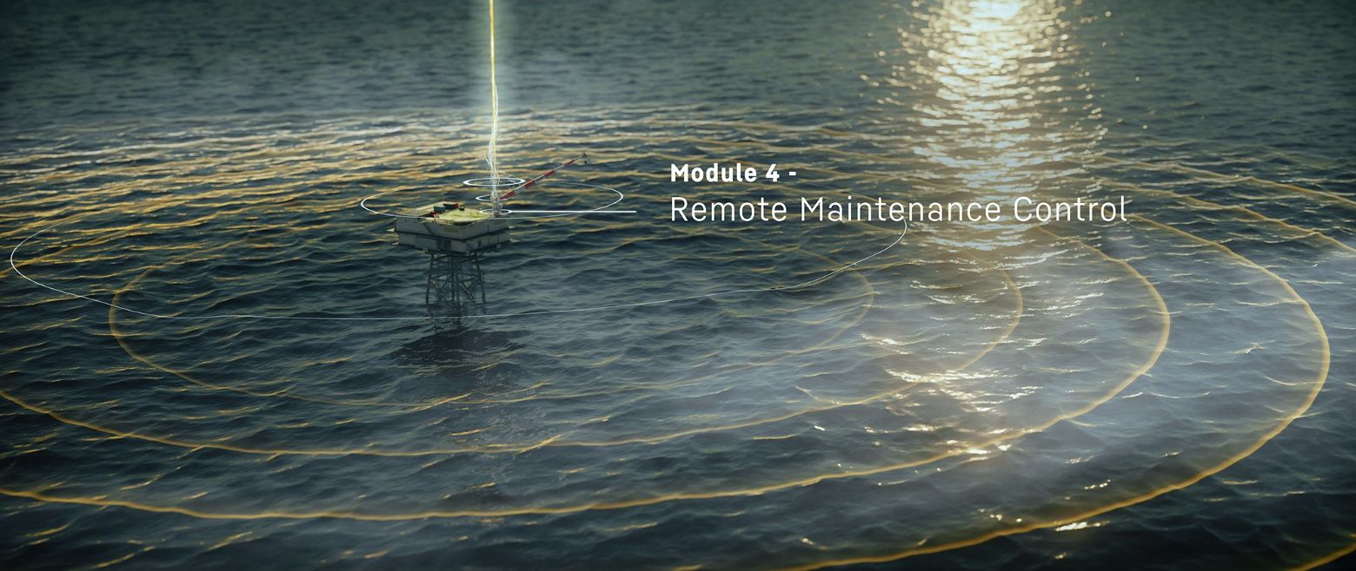
Module Remote Maintenance Control: Liebherr_limain_RemoteMaintenanceControl.jpg
The combination of all LiMain modules enables semiautomatic maintenance of the crane.

Contact

Stefan Froebe
Marketing Manager Maritime Cranes
Tel.: + 49 381 6006 5025
email: Stefan.Froebe@liebherr.com

Published by

Liebherr-MCCtec Rostock GmbH

Rostock / Germany

www.liebherr.com

