Press release

Reinforcements for ESEASA – seven new Liebherr rough terrain cranes for the fleet

⸺
ESEASA expands crane fleet with five new Liebherr LRT 1090-2.1 cranes and two LRT 1100-2.1 models
Retrofit for the LR 11350 – enabling the boom length to be extended to 228 metres
Liebherr scores heavily with reliability, value retention and support
Mexican crane and heavy haulage contractor ESEASA has expanded its crane fleet with seven new Liebherr LRTs. The versatile cranes will primarily be used in the new DOS BOCAS refinery in the Southern Gulf of Mexico, where the company has been contracted to erect a 178 metre tower. For this, ESEASA has ordered a retrofit for its LR 11350, which allows the boom to be extended to 228 metres. Liebherr’s reliability, value retention and support were major factors behind the decision to buy the cranes. ESEASA also regarded the technology and easy operation of Liebherr cranes as key for the company. e
Ehingen (Donau) (Germany), 10 March 2022 – ESEASA has significantly extended its fleet in the rough terrain crane segment with its purchase of five LRT 1090-2.1 cranes and two LRT 1100-2.1 models. To date the company’s fleet has mainly consisted of large mobile cranes as well as lattice boom and telescopic crawler cranes from Liebherr. In discussing the decision to buy the seven new LRTs, Aldo Santos, Operations Director at ESEASA comments: “The technology and easy operation of Liebherr cranes are key for our company. The versatility of LRT cranes make them the perfect choice for our jobs. And the high resale value was another factor which led to us choosing Liebherr.”
First job at DOS BACOS
The main areas of work for ESEASA’s new LRTs will be oil and gas jobs. The cranes will undertake their first jobs in the new DOS BOCAS refinery and in the erection of oil platforms for the ESEASA OFFSHORE Division. “Liebherr is renowned for its reliability and good service network”, continues Aldo Santos. “Retrofitting our LR 11350 once again demonstrated the excellent support that Liebherr provides. The combination of our 114 metre main boom with a luffing jib extended from 84 to 114 metres will enable us to assemble a complete boom with a length of 228 metres. We intend to use this to erect a 178 metre tower at the DOS BOCAS refinery,” adds Santos. The new 114 metre luffing jib for the LR 11350 underwent testing at the Liebherr production plant in Ehingen at the start of February.
The main features of Liebherr LRT rough terrain cranes are their high performance and safety during crane operations. These features are assisted by their easy operation and standard VarioBase®. The high comfort level is another factor behind their safety. The extended cab can be tilted and this, together with its clear, self-explanatory control units, ensures that the crane is easy to use. The sturdy, manoeuvrable crane also delivers excellent off-road handling. Its dimensions and weights have been adjusted for easy transport to ensure low cost global mobility.
Liebherr and ESEASA in Mexico City
Liebherr Mexiko S. de R.L. de C.V. is located in Mexico City from where it is responsible for sales and service of mobile and crawler cranes in Mexico, the Caribbean and Central America. ESEASA’s head office is also in Mexico City. The group mainly works in the energy sector (wind power and oil industry) and has specialised in engineering, logistics and crane assembly for large projects in Central America and the USA. The company has a 500-strong workforce and a total of over 250 cranes of every conceivable type. In addition to its new rough terrain cranes, ESEASA also has Liebherr LTR telescopic crawler cranes and a large number of LTM 11200-9.1 and LTR 11200 models, the largest telescopic cranes that Liebherr builds. In addition, the company’s fleet also includes powerful Liebherr crawler cranes, including the largest conventional crawler crane in the world, the LR 13000.

About Liebherr-Werk Ehingen GmbH
Liebherr-Werk Ehingen GmbH is a leading manufacturer of mobile and crawler cranes. Its range of mobile cranes extends from 2-axle 35 tonne cranes to heavy duty cranes with a lifting capacity of 1200 tonnes and a 9-axle chassis. Its lattice boom cranes on mobile or crawler crane chassis deliver lifting capacities of up to 3000 tonnes. With universal boom systems and extensive additional equipment, they can be seen in action on construction sites throughout the world. The Ehingen site has a workforce of 3,500. Extensive, global service guarantees the high availability of Liebherr mobile and crawler cranes. In 2020, the Liebherr plant in Ehingen recorded a turnover of 2.03 billion euros.

About the Liebherr Group
The Liebherr Group is a family-run technology company with a highly diversified product portfolio. The company is one of the largest construction equipment manufacturers in the world. It also provides high-quality and user-oriented products and services in a wide range of other areas. The Liebherr Group includes over 140 companies across all continents. In 2020, it employed around 48,000 staff and achieved combined revenues of over 10.3 billion euros. Liebherr was founded in Kirchdorf an der Iller in Southern Germany in 1949. Since then, the employees have been pursuing the goal of achieving continuous technological innovation, and bringing industry-leading solutions to its customers.

Photographs:
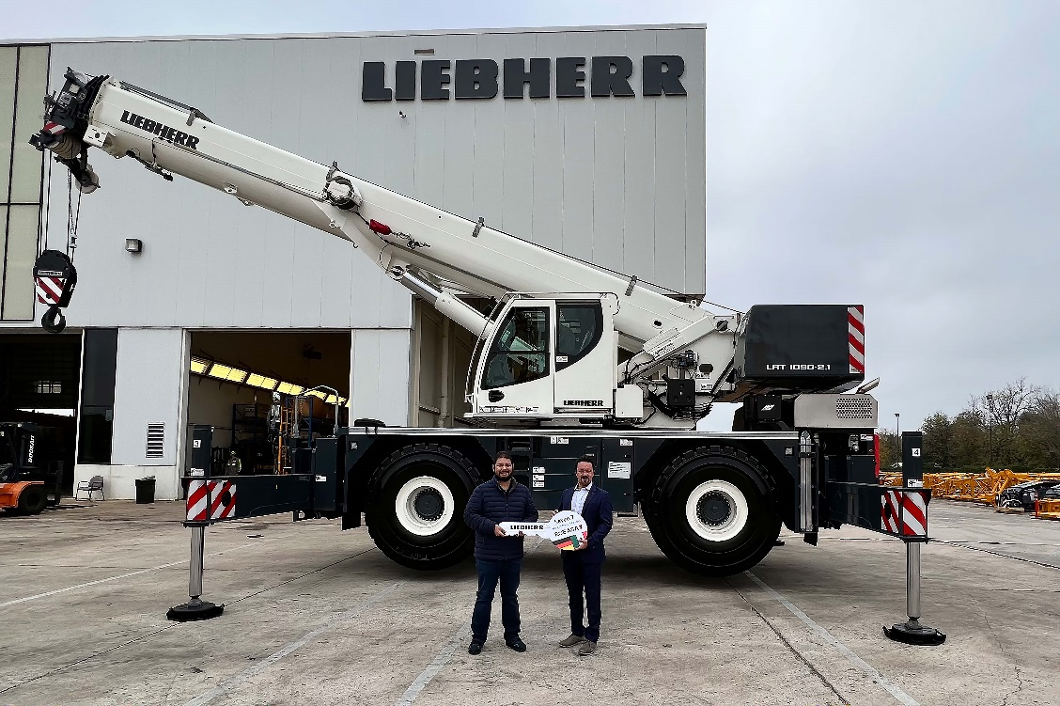
liebherr-ltm-handover-eseasa.jpg
Christian Tableros (right) from Liebherr Mexico at the symbolic handover of the keys to Aldo Santos from ESEASA.
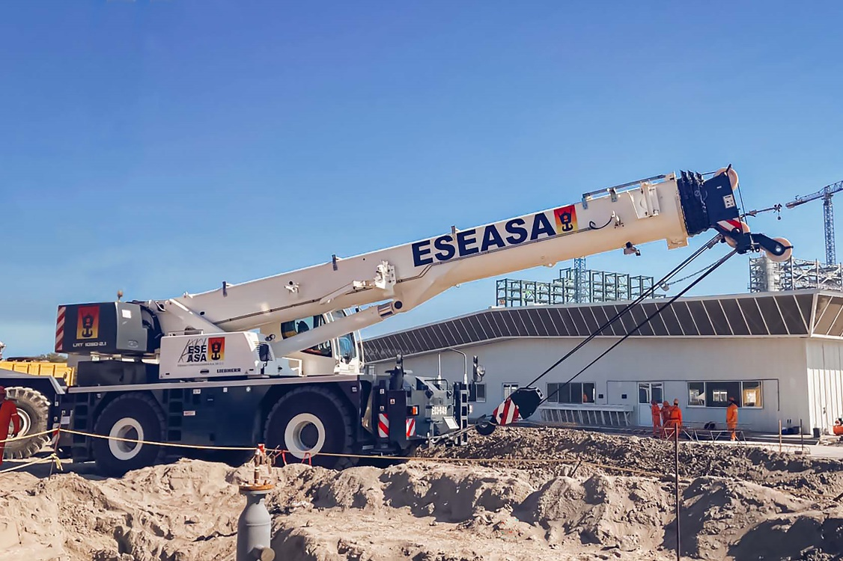
liebherr-ltm-handover-eseasa-2.jpg
Liebherr LRT 1090-2.1 in action on challenging terrain in Mexico.

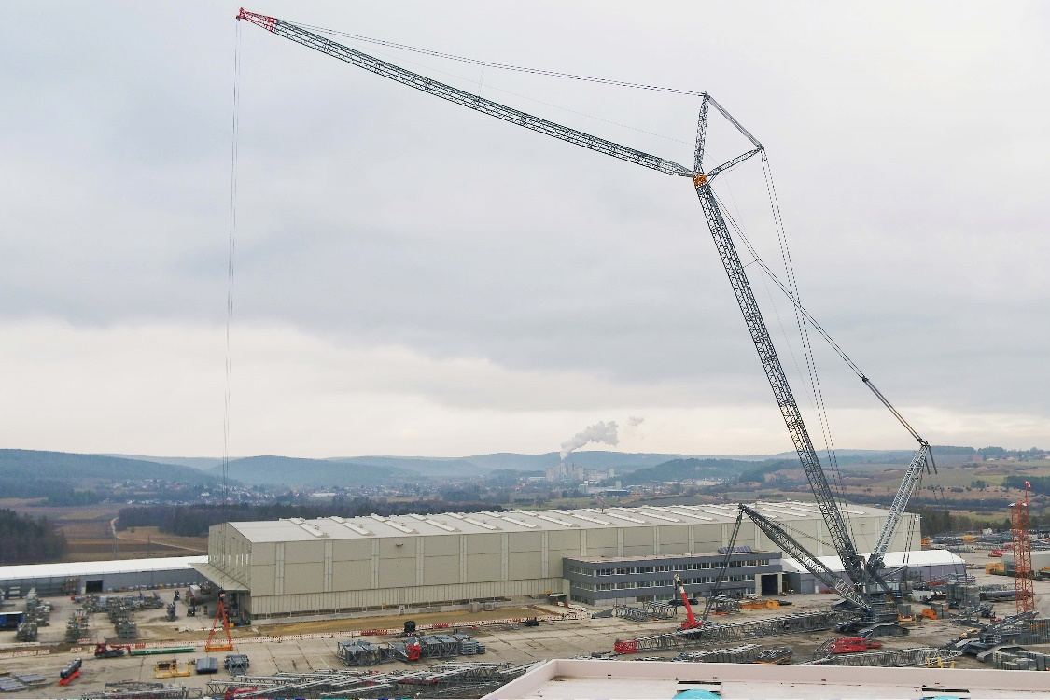
liebherr-ltm-handover-eseasa-3.jpg
Testing the new 114 metre luffing jib for the LR 11350 at Liebherr manufacturing plant in Ehingen.

Contacts
Wolfgang Beringer
Marketing and Communication
Phone: +49 7391/502 - 3663
Email: wolfgang.beringer@liebherr.com
Published by
Liebherr-Werk Ehingen GmbH
Ehingen (Donau) / Germany
www.liebherr.com

