Press release

SAEI and Liebherr deepen their collaboration

⸺
Saudia Aerospace Engineering Industries (SAEI) and Liebherr-Aerospace intensify their collaboration by renewing their current component service agreement and signing a new General Term Agreement for heat exchanger services.
Dubaï (United Arab Emirates), February 2022 – The first day of the 2022 MRO Middle East conference was marked for Liebherr by the confirmation of its further collaboration with Saudia Aerospace Engineering Industries (SAEI).
The cooperation between the two companies began in 2017, when SAEI selected Liebherr to repair the flight controls and air management equipment on-board the SAUDIA Airbus A320 and 32 A330 aircraft. In 2021, SAEI renewed its trust in the OEM with a multi-annual extension of this Components Service Agreement.
This long-term collaboration evolved now further with the signature of a new General Terms Agreement, through which SAEI will join Liebherr’s network for heat exchangers services. SAEI will thus have the in-house capabilities to handle heat exchanger tests or cleaning on behalf of Liebherr-Aerospace for all equipment operated in the Middle East region.
“SAEI is proud to expand our role in Liebherr-Aerospace ecosystem of partners. The establishment of heat exchanger capabilities, in accordance with OEM standards, provides SAEI with an opportunity to elevate the provision of service and add greater value. The ability to perform heat exchanger services in the Kingdom of Saudi Arabia provides an opportunity for airlines in the Middle East region to receive services locally, and benefit from the reduced turn-around time,” commented Captain Fahd H. Cynndy, Chief Executive Officer – Saudia Aerospace Engineering Industries (SAEI).
“We are very thrilled to count SAEI amongst our network of partners. This venture will avoid long haul transportation of equipment for processing in other regions. It will therefore contribute considerably towards reducing the carbon footprint, while ensuring that our high OEM service levels and standards are maintained for all our customers in the Middle East region,” pointed out Alex Vlielander, Chief Services Officer – Liebherr-Aerospace & Transportation SAS.

About Liebherr-Aerospace & Transportation
Liebherr-Aerospace & Transportation SAS, Toulouse (France), is one of eleven divisional control companies within the Liebherr Group and coordinates all activities in the aerospace and transportation systems sectors.
Liebherr-Aerospace is a leading supplier of systems for the aviation industry and has more than six decades of experience in this field. The range of aviation equipment produced by Liebherr for the civil and defense sectors includes flight control and actuation systems, gears and gearboxes, landing gear and air management systems as well as electronics. These systems are deployed in wide-bodied aircraft, single aisle and regional aircraft, business jets, fighter aircraft, defense transporters, defense training aircraft, civil and defense helicopters.
Liebherr’s aerospace and transportation systems division employs around 6,000 people. It has four aviation equipment production plants at Lindenberg (Germany), Toulouse (France), Guaratinguetá (Brazil) and Nizhny Novgorod (Russia). These production sites offer a worldwide service with additional customer service centers in Saline (Michigan/USA), Seattle (Washington/USA), Montreal (Canada), Hamburg (Germany), Moscow (Russia), Dubai (UAE), Bangalore (India), Singapore and Shanghai (People’s Republic of China).
About the Liebherr Group
The Liebherr Group is a family-run technology company with a highly diversified product portfolio. The company is one of the largest construction equipment manufacturers in the world. It also provides high-quality and user-oriented products and services in a wide range of other areas. The Liebherr Group includes over 140 companies across all continents. In 2020, it employed around 48,000 staff and achieved combined revenues of over 10.3 billion euros. Liebherr was founded in Kirchdorf an der Iller in Southern Germany in 1949. Since then, the employees have been pursuing the goal of achieving continuous technological innovation, and bringing industry-leading solutions to its customers.

Image
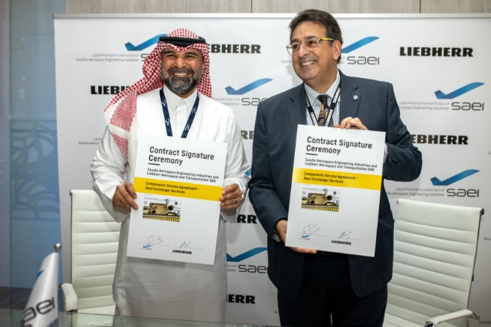
Fahd Hamzh Cynndy, CEO of SAEI (left) and Alex Vlielander, Chief Services Officer, Liebherr-Aerospace & Transportation SAS

Contact
Ute Braam
Corporate Communications
Phone: +49 8381 / 46 - 4403
E-Mail: ute.braam@liebherr.com

Published by
Liebherr-Aerospace & Transportation SAS
Toulouse / France
www.liebherr.com

