Press release

New alternative selected –

Ley-Krane decides on rope pull technology option for its new LTC 1050-3.1

⸺
Ley-Krane buys another Liebherr LTC 1050-3.1 and decides on the rope pull option for fast telescoping using familiar technology
This particularly compact crane with RemoteDrive and telescoping crane operator's cab can be used in extremely restricted areas
Liebherr impresses with the value retention of its products and top spare parts services and engineer availability
Ley-Krane GmbH & Co. KG has decided to buy a new LTC 1050-3.1 with rope pull technology for telescoping the boom. The crane contractor has already had good experience with this efficient crane, with the previous purchase featuring the TELEMATIK option. The fully equipped LTC 1050-3.1 compact crane can be manoeuvred in extremely restricted areas using RemoteDrive. A telescoping crane operator's cab delivers excellent visibility for the assembly process. Good customer care by Liebherr and efficient service make Ley a loyal Liebherr customer.
Ehingen (Donau) (Germany), 21 February 2022 – Ley-Krane GmbH & Co. KG has taken delivery of a new LTC 1050-3.1 at the Liebherr plant in Ehingen. This time, the Gummersbach-based company decided on the rope pull option for telescoping the boom. Ley already had one of these efficient crane models with the TELEMATIK boom in its fleet and it has proven its worth over a period of years due to its high lifting capacity. As a result of its good experience with the LTC 1050-3.1, Ley decided to buy another of these cranes. The new 50 tonne compact crane will replace a crane in the 40 tonne class from another manufacturer.
Alternative telescoping systems
The Liebherr LTC 1050-3.1 was originally designed with a 36 metre telescopic boom with the TELEMATIK high speed telescoping system, which delivers high lifting capacity and large radii. Since 2020, Liebherr has been offering an alternative in the form of rope pull technology, which has been in widespread use on other crane models for decades and is valued highly by operators. Customers can now choose between the TELEMATIK and rope pull options for the compact 50 tonne model. The two alternatives have their own advantages depending on the type of job. The rope pull mechanism is ideal for crane contractors who wish to use this powerful compact crane inside buildings. The synchronous telescoping of multiple telescopic sections on the 31 metre boom using a 2-way pulley block makes it faster than using TELEMATIK. High telescoping lifting capacities can also be achieved by the boom with the rope pull mechanism.
RemoteDrive for restricted conditions
When Ley decided to buy the new LTC 1050-3.1, the company also decided on the remote option for controlling the undercarriage. RemoteDrive enables the crane driver to position himself at any problem location and manoeuvre the crane safely even in extremely restricted conditions. The fine tuning between the remote control and manoeuvring the crane with millimetre precision enhances the safety of personnel, the crane and the surrounding area.
VarioBase® and telescoping crane operator’s cab for greater safety
The VarioBase® variable supporting base is another feature that enhances safety. “It takes the strain of the operator and enables hoists to be made which otherwise would not be possible in safety”, explains company owner Markus Ley. “The crane has a great engine and is very comfortable to drive. In our mountainous region, that gives the crane driver a real feeling of safety”, continues Ley. When fitted with the full range of equipment as purchased by Ley, the crane also has a crane operator's cab which can be telescoped up to an eye level of eight metres. This gives the crane operator excellent visibility during the set-up process and a good view of the job site combined with good ergonomy.
Experience makes Ley a loyal Liebherr customer
In the medium-sized family-run company, “the boss buys the cranes that he would like to work with himself”, says Markus Ley. He has had plenty experience of his own in the past, installing gantry cranes and crane tracks and is a loyal Liebherr customer. “We believe we get extraordinary support from the Liebherr plant in Ehingen. Top spare parts service, 100 % engineer availability when required and, of course, the fact that the products retain their value represent excellent benefits as far as we are concerned”, adds Ley.
Ley-Krane GmbH und Co. KG based in Gummersbach operates a fleet of over 300 working platforms and 17 mobile cranes with lifting capacities between 30 and 500 tonnes with its 31-strong workforce. Most of them were supplied by the Liebherr plants in Ehingen and Biberach. The family-run company was founded in 1850 and is now managed by the sixth generation of the same family.

About Liebherr-Werk Ehingen GmbH
Liebherr-Werk Ehingen GmbH is a leading manufacturer of mobile and crawler cranes. Its range of mobile cranes extends from 2-axle 35 tonne cranes to heavy duty cranes with a lifting capacity of 1200 tonnes and a 9-axle chassis. Its lattice boom cranes on mobile or crawler crane chassis deliver lifting capacities of up to 3000 tonnes. With universal boom systems and extensive additional equipment, they can be seen in action on construction sites throughout the world. The Ehingen site has a workforce of 3,500. Extensive, global service guarantees the high availability of Liebherr mobile and crawler cranes. In 2020, the Liebherr plant in Ehingen recorded a turnover of 2.03 billion euros.

About the Liebherr Group
The Liebherr Group is a family-run technology company with a highly diversified product portfolio. The company is one of the largest construction equipment manufacturers in the world. It also provides high-quality and user-oriented products and services in a wide range of other areas. The Liebherr Group includes over 140 companies across all continents. In 2020, it employed around 48,000 staff and achieved combined revenues of over 10.3 billion euros. Liebherr was founded in Kirchdorf an der Iller in Southern Germany in 1949. Since then, the employees have been pursuing the goal of achieving continuous technological innovation, and bringing industry-leading solutions to its customers.
Photograph:
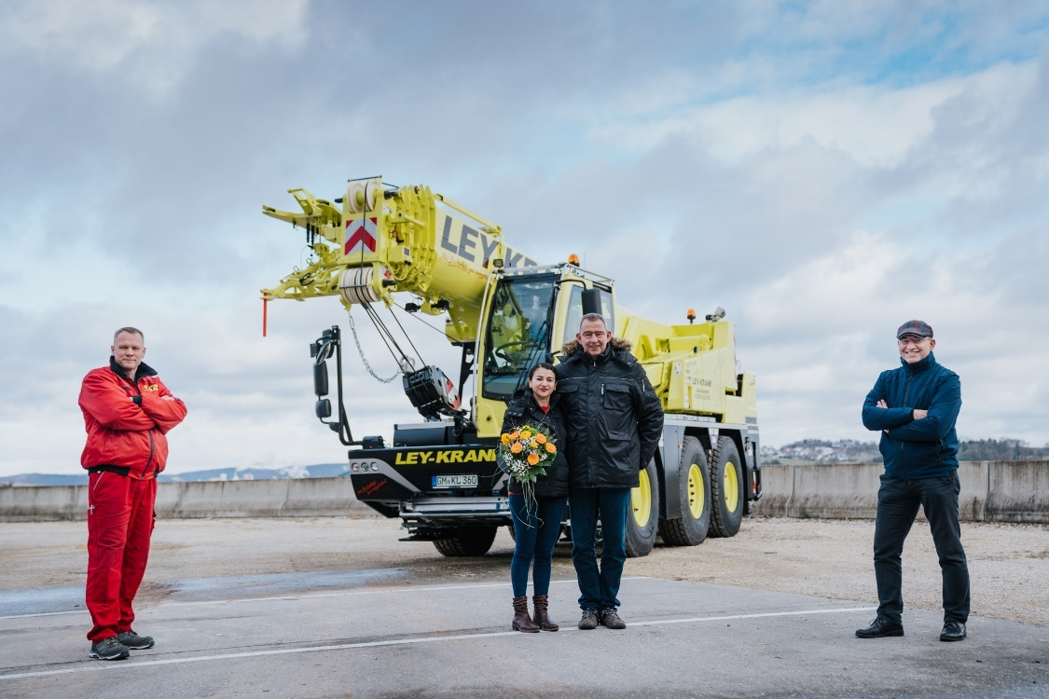
liebherr-ltc-1050-3-1-kranübergabe-ley.jpg
Crane handover at the Liebherr Plant in Ehingen (from left to right): Eugen Hirsekorn, Markus Ley, Francisca Helenice Ley (all from Ley-Krane GmbH und Co. KG), Erich Schneider (Liebherr-Werk Ehingen GmbH).

Contacts
Wolfgang Beringer
Marketing and Communication
Phone: +49 7391/502 - 3663
Email: wolfgang.beringer@liebherr.com
Published by
Liebherr-Werk Ehingen GmbH
Ehingen (Donau) / Germany
www.liebherr.com

