Press release

Liebherr signs agreement with Tigerair Taiwan on A320neo component support

⸺
Liebherr and Tigerair Taiwan have signed a long term customer service contract. Under this agreement, Liebherr-Aerospace will provide repair support services for a wide range of air conditioning and bleed systems components installed on 15 Airbus A320neo aircraft operated by the airline. Liebherr-Singapore, Liebherr-Aerospace’s dedicated service center for the Asia-Pacific region, will provide all material support and component maintenance services.
Singapore (Singapore), February 2022 – The agreement between the OEM Liebherr-Aerospace and the airline Tigerair Taiwan was signed during Singapore Airshow 2022.
“We are pleased to have signed this new agreement with Liebherr-Aerospace in order to gain their great support as they are one of the professionals in this industry. Leveraging Liebherr’s extensive experience in this field, its repair support service will be Tigerair Taiwan’s a reliable backing”, commented Dennis Lai, Chief Operations Officer at Tigerair Taiwan.
“This is a great step ahead for Liebherr-Aerospace in the Asia-Pacific region. We are excited and grateful to welcome Tigerair Taiwan among our customers and the opportunity to build a long lasting partnership. Being selected as one of their service providers is a strong proof of their trust in the high quality and efficiency of our people and service”, said Ekkehard Pracht, General Manager Aerospace at Liebherr Singapore.
Tigerair Taiwan is the only Taiwanese low-cost carrier based at Taoyuan International Airport. It is wholly-owned by China Airlines. Embedded in the network of the China Airlines’ group or airlines, it operates short and medium haul services to domestic and international destinations across East Asia and Oceania.

About Liebherr-Aerospace & Transportation
Liebherr-Aerospace & Transportation SAS, Toulouse (France), is one of eleven divisional control companies within the Liebherr Group and coordinates all activities in the aerospace and transportation systems sectors.
Liebherr-Aerospace is a leading supplier of systems for the aviation industry and has more than six decades of experience in this field. The range of aviation equipment produced by Liebherr for the civil and defense sectors includes flight control and actuation systems, gears and gearboxes, landing gear and air management systems as well as electronics. These systems are

deployed in wide-bodied aircraft, single aisle and regional aircraft, business jets, fighter aircraft, defense transporters, defense training aircraft as well as civil and defense helicopters.
Liebherr’s aerospace and transportation systems division employs around 6,000 people. It has four aviation equipment production plants at Lindenberg (Germany), Toulouse (France), Guaratinguetá (Brazil) and Nizhny Novgorod (Russia). These production sites offer a worldwide service with additional customer service centers in Saline (Michigan/USA), Seattle (Washington/USA), Montreal (Canada), Hamburg (Germany), Moscow (Russia), Dubai (UAE), Bangalore (India), Singapore and Shanghai (People’s Republic of China).

About the Liebherr Group
The Liebherr Group is a family-run technology company with a highly diversified product portfolio. The company is one of the largest construction equipment manufacturers in the world. It also provides high-quality and user-oriented products and services in a wide range of other areas. The Liebherr Group includes over 140 companies across all continents. In 2020, it employed around 48,000 staff and achieved combined revenues of over 10.3 billion euros. Liebherr was founded in Kirchdorf an der Iller in Southern Germany in 1949. Since then, the employees have been pursuing the goal of achieving continuous technological innovation, and bringing industry-leading solutions to its customers.

Image
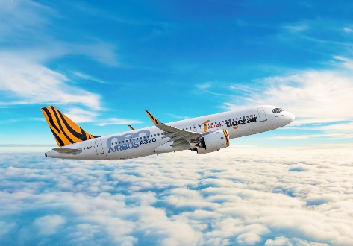
A320neo-Tigerair-Taiwan.jpg
Liebherr-Aerospace will provide repair support services for Tigerair Taiwan. - © Tigerair Taiwan/Airbus
Contact person
Ute Braam
Corporate Communications
Phone: +49 8381 / 46 - 4403
E-Mail: ute.braam@liebherr.com
Published by
Liebherr-Aerospace & Transportation SAS
Toulouse / France
www.liebherr.com

