Press information

The largest crane in the “Tough Ones” series: Liebherr presents its 470 EC-B Flat-Top crane

⸺
Impressive lifting capacities of up to 16 and 20 tonnes make the 470 EC-B the new star of the show
The tower crane is exceptionally economical to operate, assemble and transport
A comfortable cab and an intuitive operating system enable the crane operator to work safely and efficiently
Liebherr’s successful EC-B series has a strong new addition: the new 470 EC-B Flat-Top crane. With a maximum lifting capacity of 16 or 20 tonnes, this crane is now the largest in the “Tough Ones” family. From transport and assembly to operation on site, Liebherr’s new machine with steel rope design meets all the relevant requirements of a modern crane fleet.
Biberach/Riss (Germany), 1 February 2022 – The flagship crane with intelligent assistance systems offers a jib length of 80 metres. This reach can be increased to 83 metres by means of a jib extension, thereby breaking new ground in the competitive market. At a jib length of 80 metres, the 16-tonne version of the 470 EC-B has a jib head load capacity of up to 3,200 kilograms; the 20-tonne version impresses with a jib head load capacity of up to 3,000 kilograms. The jib can be divided into two-and-a-half metre sections so that it can be perfectly adapted to meet a variety of operational requirements. The 470 EC-B went on sale in January of this year.
Optimised for transport and assembly
The focus during development wasn’t only on performance but also on assembly and transport. As a result, the jib and counter-jib can be attached to the slewing platform easily, conveniently and safely. Liebherr’s proven quick assembly connections make it all possible. Only five trucks are needed to transport the slewing part with jib, including counter-ballast, to the construction site. This saves time and money, and also helps reduce emissions.
The 470 EC-B features a connection for both 24 HC 420 and 24 HC 630 tower systems. The 24 HC tower system is a perfect match for large cranes with high lifting capacities. Its compact dimensions allow individual elements to be moved cost-efficiently from A to B.
The 470 EC-B has been optimised for the 24 HC 420 tower system; together they are the most cost-effective combination for freestanding hook heights of up to 67.8 metres. The maximum freestanding hook height of up to 96 metres is achieved with the 24 HC 630 system.
Excellent overview of site and parameters for the crane operator
The top-slewing crane is available with one of three versions of the sophisticated LiCAB crane operator’s cab: LiCAB Basic, LiCAB Air or LiCAB AirPlus. All three offer a floor space of more than two square metres, an unrestricted view for precision lifting and an ergonomic control stand. These and other comfort features enable the crane operator to stay fully focused on the job at hand. Thanks to the cab’s extensive field of vision, the crane operator has a clear view of the site and the load to be lifted, which contributes to the safety of both operator and machine.
Also included in the cab is the newly developed twelve-inch display screen with intuitive operability. The Tower Crane Operating System (TC-OS) provides crane operators and assembly engineers with specific menus, an extensive choice of languages and user-friendly units of measurement. The intention is that every user should be able to find the parameters relevant to their work without difficulty. Users navigate their way through the streamlined menu structure via touchscreen. To maintain an overview during crane operation or scaling, display masks can be combined in various ways. The exceptional usability of the TC-OS means that training and familiarisation times are reduced.
LED advertising space lighting for a powerful promotional impact
LED advertising panel lighting can be configured to ensure a substantial long-distance effect and visibility, particularly at the onset of twilight and at night. With a total area of 8.6 square metres, the robust lighting is capable of delivering a powerful and effective promotional impact. The panels don’t have to be mounted separately during assembly and can remain in place on the counter-jib end section during transport. Signage is easily applied.
Flat-Top cranes equipped for a variety of applications
As they don’t have a tower head structure, several EC-B series Flat-Top cranes are able to work together safely on the same site, even in tight conditions. Transport, assembly, handling capacity and safety: EC-B cranes are specifically designed to meet the requirements of modern construction sites. They cover a wide performance spectrum, ranging from small city to large handling cranes. The new 470 EC-B completes the top end of Liebherr’s successful series, with the crane reflecting the construction industry’s trend towards ever heavier components.

Technical data 470 EC-B:
Maximum jib length: | up to 83 metres
Maximum load capacity: | 16 tonnes or 20 tonnes
Lifting capacity at jib head (80 metres): | 3,200 kilograms (16-tonne model); 3,000 kilograms (20-tonne model)
Lifting capacity at jib head (83 metres): | 2,400 kilograms (16-tonne model); 2,200 kilograms (20-tonne model)
Freestanding hook height: | up to 96 metres with the 24 HC 630 tower system

About the Liebherr Tower Cranes Division
More than seven decades of experience have made Liebherr a recognised specialist for lifting technology on all types of construction sites. The range of Liebherr Tower Cranes encompasses an extensive selection of high-quality tower cranes that are used worldwide. This includes fast-erecting, top-slewing, luffing jib and special-purpose cranes as well as mobile construction cranes. In addition to these products, Liebherr also offers a wide range of services that complete the company’s portfolio: Tower Crane Solutions, Tower Crane Customer Service and Tower Crane Center.
About the Liebherr Group
The Liebherr Group is a family-run technology company with a highly diversified product portfolio. The company is one of the world’s largest manufacturers of construction machinery. It also offers high-quality, user-oriented products and services in multiple other areas. Today, the group consists of more than 140 companies across all continents. In 2020, it employed around 48,000 people and generated a consolidated turnover of over 10.3 billion euros. Liebherr was founded in 1949, in Kirchdorf an der Iller in southern Germany. Ever since then, the company’s employees have been committed to satisfying customers with advanced solutions and to promoting technological progress.
Images

liebherr-470-ec-b-01.jpg
High lifting capacities: The new Liebherr 470 EC-B crane is available to order now as a 16-tonne and 20-tonne version.

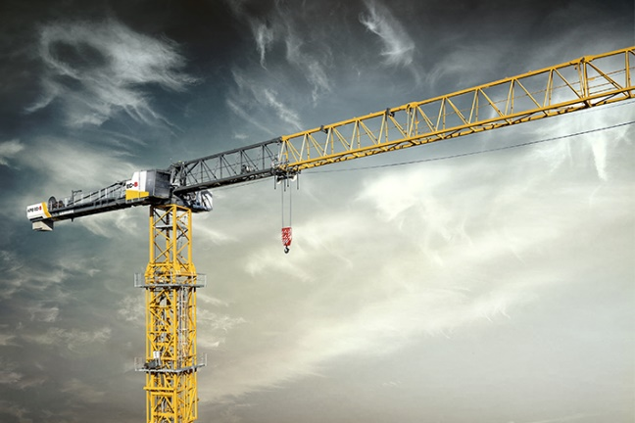
liebherr-470-ec-b-02.jpg
Depending on the tower system, the new 470 EC-B can reach a hook height of up to 96 metres in a freestanding position.
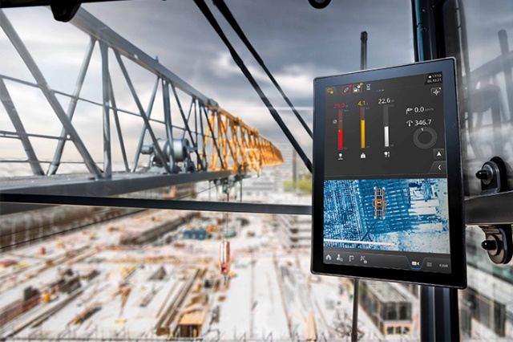
liebherr-470-ec-b-03.jpg
Clear overview: The Tower Crane Operating System (TC-OS) impresses with its streamlined menu structure on a twelve-inch multi-touch display.

Contact person
Fabian Eber
Global Communication
Telephone: +49 7351/41 - 4397
Email: fabian.eber@liebherr.com
Published by
Liebherr-Werk Biberach GmbH
Biberach / Germany
www.liebherr.com

