Press release

66 meter telescopic boom: Auto-Klug chooses Liebherr LTM 1150-5.3

⸺
Alfred Klug GmbH & Co. KG expands crane fleet with Liebherr LTM 1150-5.3
150-tonner closes gap in crane range
LTM 1150-5.3 scores with one of the longest booms in its crane class
The family-owned company Alfred Klug GmbH & Co. KG is expanding its crane range with a Liebherr LTM 1150-5.3 mobile crane. The 150-tonner replaces a 120-tonne crane in the fleet. An important decision criterion was the 66-meter telescopic boom, one of the longest in this crane class. Furthermore, the crane scores with strong lifting capacities with 9 tonnes basic ballast, which it carries with 12 tonnes axle load on public roads. In addition to Liebherr's reliability, the variable support VarioBase®, the ease of operation and the good and fast service were factors that led to the choice of a Liebherr crane.
Ehingen (Donau) (Germany), January 31, 2022 - Alfred Klug GmbH & Co. KG is expanding its crane range with an LTM 1150-5.3, which is destined for the Zwickau branch. There, the 150-tonner closes the gap between the 130- and 200-tonner in the company's crane range and is also the largest crane at the location. The crane's main areas of application will be transmission mast erection, concrete erection and transformer handling.
Werner Glück, owner and managing director of Alfred Klug GmbH & Co.KG, reports, "The 66-meter boom of the LTM 1150-5.3 was an important decision criterion for us." In addition to the strengths in the technical area, other advantages were important for the choice of a Liebherr crane: "Liebherr also scores with ease of operation, reliability, and good and fast availability with regard to service and spare parts," says Glück. Another factor was the VarioBase® variable outrigger base. It enables safe and flexible crane operations even under difficult conditions, such as confined working areas. The simple operation and load capacities calculated for the individual situation increase safety, which relieves the crane operator and increases efficiency.
Auto-Klug replaces a 120-tonner with this crane. In 1939, the company originated from a car recycling business. In the meantime, the size of the family-owned company with headquarters in Hof extends to eight locations in four German states.

About Liebherr-Werk Ehingen GmbH
Liebherr-Werk Ehingen GmbH is a leading manufacturer of mobile and crawler cranes. Its range of mobile cranes extends from 2-axle 35 tonne cranes to heavy duty cranes with a lifting capacity of 1200 tonnes and a 9-axle chassis. Its lattice boom cranes on mobile or crawler crane chassis deliver lifting capacities of up to 3000 tonnes. With universal boom systems and extensive additional equipment, they can be seen in action on construction sites throughout the world. The Ehingen site has a workforce of 3,500. Extensive, global service guarantees the high availability of Liebherr mobile and crawler cranes. In 2020, the Liebherr plant in Ehingen recorded a turnover of 2.03 billion euros.

About the Liebherr Group
The Liebherr Group is a family-run technology company with a highly diversified product portfolio. The company is one of the largest construction equipment manufacturers in the world. It also provides high-quality and user-oriented products and services in a wide range of other areas. The Liebherr Group includes over 140 companies across all continents. In 2020, it employed around 48,000 staff and achieved combined revenues of over 10.3 billion euros. Liebherr was founded in Kirchdorf an der Iller in Southern Germany in 1949. Since then, the employees have been pursuing the goal of achieving continuous technological innovation, and bringing industry-leading solutions to its customers.

Image:

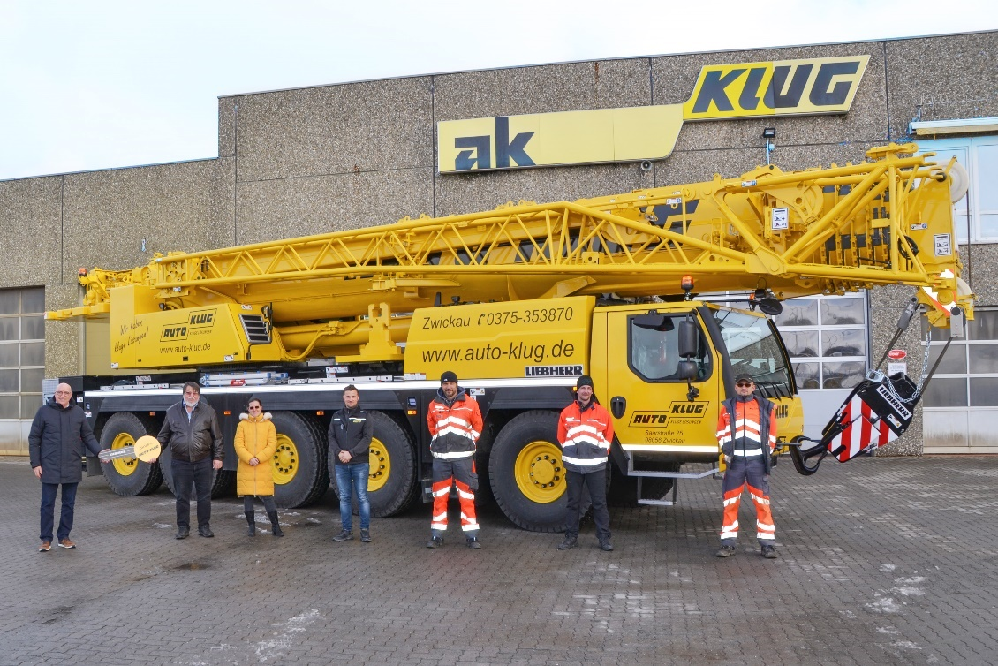
liebherr-ltm1150-5-3-klug.jpg
The team at Auto-Klug in Zwickau takes delivery of a new Liebherr LTM 1150-5.3 mobile crane. The locally applicable Corona specifications were met.

Contacts
Wolfgang Beringer
Marketing and Communication
Phone: +49 7391/502 - 3663
Email: wolfgang.beringer@liebherr.com
Published by
Liebherr-Werk Ehingen GmbH
Ehingen (Donau) / Germany
www.liebherr.com

