Press release

New customer – Levantek adds Liebherr LTM 1160-5.2 mobile crane to its fleet

⸺
Levantek buys its first mobile crane from Liebherr
The LTM 1160-5.2 is now the most powerful crane in the company’s fleet
High quality and performance were the main criteria behind the decision

Mexican crane contractor Levantek has taken delivery of its first Liebherr crane. The LTM 1160-5.2 all-terrain crane is now the company’s most powerful mobile crane. Rising demand from customers for greater hoisting capacities was the main factor behind the investment in the 180 tonne crane. The good reputation of the Liebherr brand and a visit by company owner Ferdinando Paez Trevino to the mobile crane production plant in Ehingen were the final steps in the decision-making process before the order was placed for the LTM 1160-5.2.
Ehingen (Donau) (Germany), 27 January 2022 – Ferdinando Paez Trevino's Olympic Group consists of three companies – metal construction, transport and the Levantek crane rental firm. Its purchase of the LTM 1160-5.2 sees Paez Trevino significantly strengthen its crane division, as to date its fleet consisted of truck cranes with a much lower lifting capacity. He explains: “Our investment in a 5-axle mobile crane was an important strategic decision for us. We also considered purchasing a used crane. Ultimately we decided on a new LTM 1160-5.2 because it meets the requirements of our customers in terms of performance and boom length very well.”
The LTM 1160-5.2 features a 62 metre telescopic boom. With its 10.8 m to 19 m long folding jib and additional telescopic boom extensions, it can achieve hoisting heights of up to 99 metres and radii of up to 78 metres. The great range and performance of the LTM 1160-5.2 were major criteria behind the decision by Paez Travino to buy it.
Apart from the technical performance data of the crane, a visit to the mobile crane manufacturing plant at Liebherr in Ehingen was the deciding factor. Christian Tableros, Manager of the Mobile Cranes Division at Liebherr México, says: “Ferdinando Paez Trevino was very interested in finding out how Liebherr builds mobile cranes. That is why we invited him to visit the plant in Ehingen.” Paez Trevino continues: “I was very impressed with the quality in the production at Liebherr. I have had good experience with “Made in Germany” products as many of my fleet of around 200 trucks come from Germany. That also made the decision in favour of Liebherr an easy one.”

About Liebherr Mexico, S. de R.L. de C.V.
Sales and service company Liebherr Mexico, S. de R.L. de C.V. first opened for business at the start of 2013. It is responsible for the direct sales and service of Liebherr mobile cranes in Mexico and other countries in Central America. By founding the company, Liebherr created a base to provide even better support for its customers in Mexico and Central America and make after-sales service, including the supply of spare parts, in the region even more efficient.
About Liebherr-Werk Ehingen GmbH
Liebherr-Werk Ehingen GmbH is a leading manufacturer of mobile and crawler cranes. Its range of mobile cranes extends from 2-axle 35 tonne cranes to heavy duty cranes with a lifting capacity of 1200 tonnes and a 9-axle chassis. Its lattice boom cranes on mobile or crawler crane chassis deliver lifting capacities of up to 3000 tonnes. With universal boom systems and extensive additional equipment, they can be seen in action on construction sites throughout the world. The Ehingen site has a workforce of 3,500. Extensive, global service guarantees the high availability of Liebherr mobile and crawler cranes. In 2020, the Liebherr plant in Ehingen recorded a turnover of 2.03 billion euros.

About the Liebherr Group

The Liebherr Group is a family-run technology company with a highly diversified product portfolio. The company is one of the largest construction equipment manufacturers in the world. It also provides high-quality and user-oriented products and services in a wide range of other areas. The Liebherr Group includes over 140 companies across all continents. In 2020, it employed around 48,000 staff and achieved combined revenues of over 10.3 billion euros. Liebherr was founded in Kirchdorf an der Iller in Southern Germany in 1949. Since then, the employees have been pursuing the goal of achieving continuous technological innovation, and bringing industry-leading solutions to its customers.

Photograph:
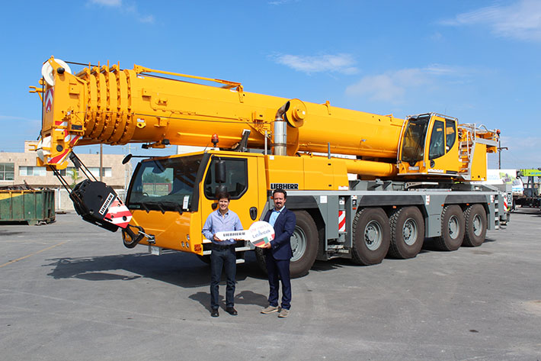
liebherr-ltm1160-5-2-levantek.jpg
From left to right: Fernando Paez Trevino (Levantek), Christian Tableros (Liebherr México). The locally applicable Corona specifications were complied with.

Contacts
Wolfgang Beringer
Marketing and Communication
Phone: +49 7391/502 - 3663
Email: wolfgang.beringer@liebherr.com
Published by
Liebherr-Werk Ehingen GmbH
Ehingen (Donau) / Germany
www.liebherr.com

