Press release

Liebherr showcases THP 80-LP Truck mounted concrete city pump at World of Concrete 2022 trade show

⸺
Liebherr USA, Co. Concrete Technology launches the THP 80-LP truck mounted concrete city pump. It is the latest product designed for the North American market. The THP 80-LP is the smallest in Liebherr’s expansive truck mounted pump product range. Powerful, versatile and compact, this latest model added to the Liebherr line up is on display at Liebherr booth W1364 at World of Concrete 2022.
Newport News, VA (USA), January 18, 2022 – The new THP 80-LP truck mounted concrete city pump is a compact and powerful pump designed specifically for the north American market. It is the smallest pump in the truck mounted concrete pump product line. It maintains the same high performance, quality, and offers many of the same features as the larger truck mounted concrete pumps. It is the perfect solution for jobs in urban environments, residential jobs and compact job sites where space is limited. THP 80-LP will be presented to the general public for the first time at World of Concrete 2022.
Liebherr’s new city pump fulfils an industry need for a reliable and flexible boomless pump truck for line pumping applications. The design and development of the THP80-LP city pump is a result of customer feedback and Liebherr’s many years of engineering and production. The City pump is the smallest in Liebherr’s line of concrete truck mounted pumps. It maintains many of the same features as the larger heavy weight truck mounted boom pumps, such as a 600 liter large capacity hopper.
Compact construction, lower weight
The THP 80-LP offers greater flexibility and mobility for operators to move around the job site. The total length of the new Liebherr city pump is around 28.4 ft. It is quick to set up and easy to control with an HBC option for the remote control. The truck features ample storage with wide spaces for the concrete tubes and accessories on the deck and plastic water tanks for saving weight.
The THP 80-LP is mounted on a two axle truck chassis flatbed chassis and weighs around 22,684 lbs which is significantly lighter than the truck mounted boom pumps. This is convenient for customers because it does not require a CDL to operate, which means there is more flexibility and allows more of their staff to operate the equipment.
High Performance
The pumping kit features an open loop hydraulic circuit that is the simple, reliable and powerful. This system is in line with the same quality and performance the boom pump models offer, it provides top performance with very low maintenance costs. Liebherr pump kits are robust, low stroking, low wear and easy to switch parts. The Liebherr city pump is designed to deliver high pumping performance. The suction inlet has a greater diameter than the cylinder itself, ensuring outstanding suction performance, even on extreme concrete types. With the split wear plates maintenance can be done quickly and easily. In addition, Liebherr offers a pumping kit option that allows high pressure application for extreme tasks. Operators can easily switch the hydraulic hoses on the pumping kit, allowing the machine to provide higher pressure on the concrete. This pump provides the standard hydraulic mounting with concrete pressure at cylinder rod side is 1088 psi (75bar), when switching connection, the concrete pressure at cylinder piston side is 1813 psi (125bar).
Concrete Technology Solutions
The new THP 80-LP is the latest addition to the rapidly expanding product portfolio of Liebherr truck mounted concrete pumps. The Liebherr Concrete Technology division provides a diverse range of concrete technology solutions, including the development and manufacturing of high-quality truck mixers, mixing plants and concrete pumps. The range is complemented by additional concrete products, including conveyor belts for truck mixers and plant control systems. Together these products are designed for cost-effective, trouble-free mixing, transportation and installation of concrete.

About Liebherr USA, Co.
Liebherr USA, Co. based in Newport News, VA provides sales and service on behalf of nine different Liebherr product segments: earthmoving, mining, mobile and crawler cranes, tower cranes, concrete technology, deep foundation machines, maritime cranes; components, and refrigeration and freezing.
About the Liebherr Group
The Liebherr Group is a family-run technology company with a highly diversified product portfolio. The company is one of the largest construction equipment manufacturers in the world. It also provides high-quality and user-oriented products and services in a wide range of other areas. The Liebherr Group includes over 140 companies across all continents. In 2020, it employed around 48,000 staff and achieved combined revenues of over 10.3 billion euros. Liebherr was founded in Kirchdorf an der Iller in Southern Germany in 1949. Since then, the employees have been pursuing the goal of achieving continuous technological innovation, and bringing industry-leading solutions to its customers.

Images
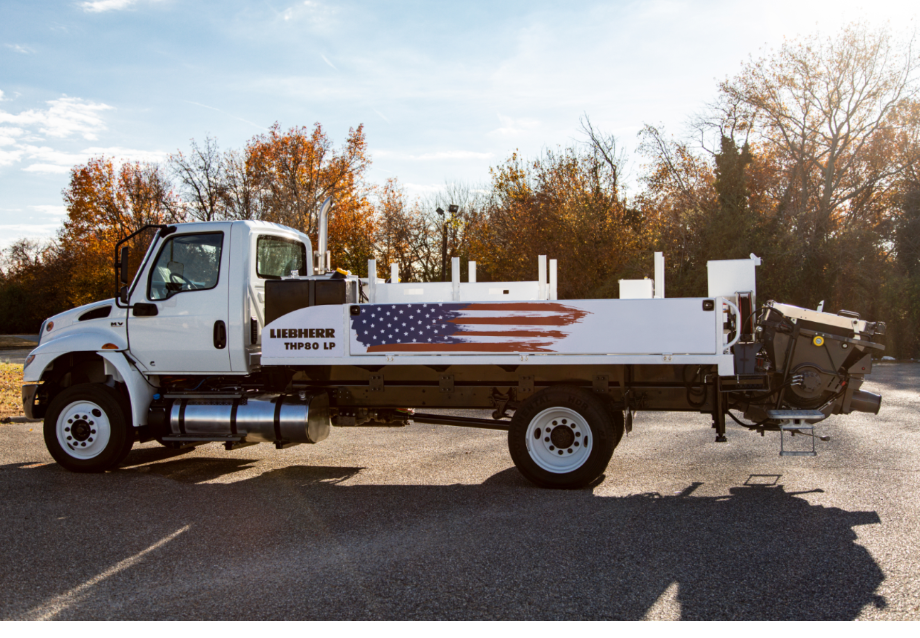
liebherr-press-release-Exterior_THP80_LP094_V2.jpg
Liebherr THP 80-LP Truck Mounted Concrete City pump

Contact person
Ana Cabiedes
General Manager, Marketing
Phone: 757-240-4250
E-mail: ana.cabiedes@liebherr.com
Published by
Liebherr USA, Co.
Newport News / USA
www.liebherr.com

