Press release

Three Liebherr Auto RMGs enter service at CSX Intermodal in North Carolina

⸺
Fully Automated RMGs work seven rail tracks, five wide container stacks and a truck transfer area
Supplied with Liebherr Remote Operator Stations for supervised moves and exception handling

Killarney (Ireland), January 2022 – Liebherr Container Cranes Ltd. are delighted to have handed over three fully automated rail mounted gantry cranes to the CSX Carolina Connector Intermodal Terminal (CCX) in Rocky Mount, North Carolina. The cabinless RMGs have been supplied with Liebherr Remote operator Stations (ROS) for supervised moves and exception handling.
Automated operations
The widespan Liebherr RMGs have a span of 165 ft. (50.292 m), a lift height over rail of 50 ft. (15.24 m) and cantilevered outreaches both sides with a safe working load of 40 long tons (40.6 tonnes). Within the span, the machines will work five rail lines and a four-high, five-wide container stack, with a further two rail lines under one of the cantilevers. Truck handling will take place under the other cantilever in a dedicated truck transfer area. Container handling on the stack is fully automated and in line with terminal safety procedures, picking and placing from the rail cars is carried out remotely using supervised moves. Truck handling employs a combination of manual and supervised moves. The RMGs will operate on both domestic 53’ wide top pick containers and ISO containers, handling single and double stacked rail cars.
Technology
An industrial data centre with redundant servers and a high speed fibre network anchor the automated crane operations and communications. A 3D measurement system scans the operational area, continuously creating and updating profiles of container stacks, railcars and hazards, providing key data for path planning and automatic operation. XYZ crane positioning is provided by Infrared spreader tracking, RFID gantry and trolley positioning technologies further supported by encoders.
A proprietary obstacle generation and monitoring system is at the heart of the cranes’ automation. Built by a team of Liebherr engineers and based on decades of automation expertise by the Liebherr Group, the system has been tailored to precise customer requirements. It works seamlessly together with the Tideworks TOS through a customer-specific interface.
For safety, a Yardeye system has been installed. This system monitors operational traffic, particularly pinmen vehicles in and around the RMG operational area allowing for safe operation. The system uses both GNSS and RFID, which provides for increased accuracy and redundancy, tracking the position, heading and velocity of equipped vehicles in the yard in real time.
Fast and precise operation reduces energy consumption
The new cranes bring state-of-the-art, emission-free container handling to CCX. In line with Liebherr’s long established simultaneous motion approach to container handling, the automated RMG includes 3 dimensional stack and train profiling allowing optimal path planning and the most productive and efficient spreader path rather than the traditional approach of square moves. This approach increases productivity and throughput and also results in a further reduction of energy consumption. The Liebherr drive system with active front end and simultaneous motion allows power usage to be optimised on the crane and regenerated energy fed back to the grid.
Liebherr’s eight-rope-reeving system is inherently stable and ensures precise and faster final positioning times whilst the micro-motion controls ensure smooth remote driver operation when placing containers onto trucks.
The CCX terminal is ideally positioned with over 5 million customers within a 120 mile radius and has exceptional connectivity being located in close proximity to I-95 highway and the growing Raleigh metro area. The new machines bring state-of-the-art freight handling to North Carolina whilst the electric cranes have zero local emissions.

About Liebherr Container Cranes
Liebherr Container Cranes Ltd. Is one of the world’s leading manufacturers of ship to shore container cranes, rail-mounted gantry cranes and rubber tyre gantry cranes. From a base in Killarney, Ireland, Liebherr Container Cranes Ltd designs, builds and exports container cranes worldwide. Founded in 1958 as the first Liebherr factory outside of Germany, today, container cranes manufactured by Liebherr in Ireland are renowned for their quality, longevity and productivity.
About the Liebherr Group
The Liebherr Group is a family-run technology company with a highly diversified product portfolio. The company is one of the largest construction equipment manufacturers in the world. It also provides high-quality and user-oriented products and services in a wide range of other areas. The Liebherr Group includes over 140 companies across all continents. In 2020, it employed around 48,000 staff and achieved combined revenues of over 10.3 billion euros. Liebherr was founded in Kirchdorf an der Iller in Southern Germany in 1949. Since then, the employees have been pursuing the goal of achieving continuous technological innovation, and bringing industry-leading solutions to its customers.
Images
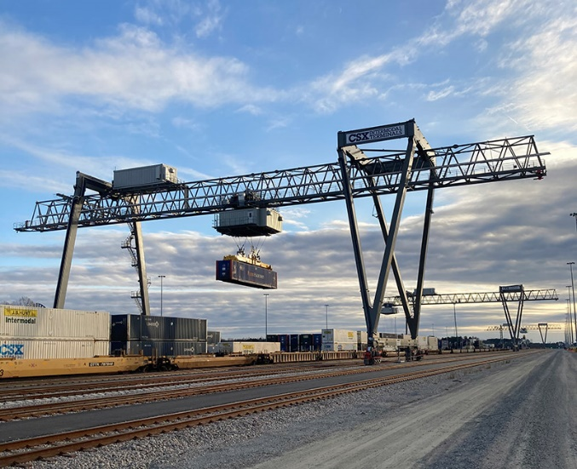
liebherr-RMGs-service-CSX-1.jpg
Three cabinless, automatic and remote controlled RMGs at the CSX Carolina Connector Intermodal Terminal (CCX) in Rocky Mount, North Carolina

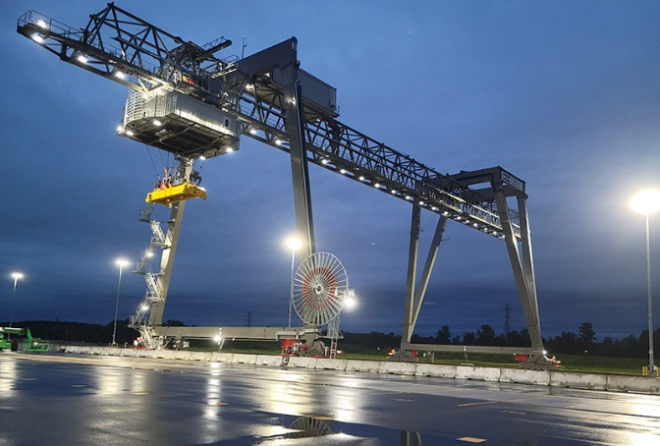
liebherr-RMGs-service-CSX-2jpg
One of the Liebherr automated RMGs at the CSX Carolina Connector Intermodal Terminal (CCX) in Rocky Mount, North Carolina
Contact
Trevor O’Donoghue
Marketing Manager
Telephone: +353 (0) 64 668 0459
email: trevor.odonoghue@liebherr.com
Published by
Liebherr Container Cranes Ltd.
Killarney / Ireland
www.liebherr.com

