Press release

Rising to meet global challenges: Liebherr launches three new wheel loaders

⸺
The Liebherr wheel loaders described here are only available outside of Europe and North America
Sustainable performance increase in the three new L 550, L 566 and L 580 wheel loaders
Three lift arm versions are available: Z-bar kinematics, industrial kinematics and High Lift lift arms
New electrohydraulic pilot control for increased safety and productivity
Since 2010, Liebherr has been offering a series of wheel loaders tailored to markets outside of Europe and North America. Now Liebherr is modernising the three largest wheel loaders in this series with the new L 550, L 566 and L 580 models. Increasing the tip load, bucket sizes and engine power are some of the most important innovations. The wheel loaders also feature a new electrohydraulic pilot control. This technology forms the basis for various intelligent features which increase safety and productivity during daily use.
Bischofshofen (Austria), 13 January 2022 – Liebherr has developed the three new models at the Bischofshofen plant, its long-standing Centre of Excellence for Wheel Loaders. Decades of experience in designing wheel loaders was one of the keys to success in the development process. “We also analysed our international customers’ demanding wheel loader operations over a long period. This included observing different mining operations around the world, some in Africa and South America, coal handling in India and timber work in Russia. Our customers’ experiences were crucial to the development of the new wheel loader series,” explains Wolfgang Rottensteiner, who is responsible for sales of the wheel loader series at Liebherr-Werk Bischofshofen GmbH.
Performance increases for the travel drive, lift arms and working hydraulics
The new L 550, L 566 and L 580 wheel loaders feature the proven hydrostatic Liebherr travel drive, which is renowned for its great efficiency. Thanks to increases in engine power – approximately 17% for the L 550 – the travel drive is even more powerful while maintaining the same low fuel consumption. This is advantageous when accelerating or penetrating material and lowers fleet fuel costs. Liebherr has installed the diesel engine in the rear, where it also acts as a counterweight thereby increasing the tip load for the wheel loaders.
Liebherr has three lift arm versions on offer for the new models. Firstly, the z-bar kinematics, which come to the fore particularly in the lower lifting range and for the break-out force. Secondly, the industrial kinematics, which have been designed for working with heavy working tools such as high dump buckets and log grapplers. Finally there are the High Lift lift arms – an extended version of the z-bar kinematics with the longest lift arms in this wheel loader segment. These ensure greater reach and more productive loading procedures at great heights, which is beneficial when loading railway wagons or lorries with high sides.
The working hydraulics of the wheel loaders will also impress customers with their larger components and new electrohydraulic pilot control. This technology also ensures responsive movements of the lift arms, independent of the size or weight of the working tool. Liebherr also offers a new, optional weighing device on the bases of the electrohydraulic pilot control. The assistance system works automatically as a check scale and provides real time information about the loading procedure. This data helps machine operators to precisely fill dumpers, lorries and railway wagons with the specified quantities and to avoid overfilling.
Increased safety thanks to the electrohydraulic pilot control and highly-durable components
The electrohydraulic pilot control enables operators to perform individual adjustments on the new wheel loaders. For example, they can set lift limitations and maximum tilt-out heights, thus reducing the risk of accidents in areas where space is restricted. The tilt-out speed can also be programmed to protect lift arm components and the installed equipment.
In addition to these optimisations for operating safety, Liebherr has also invested in the operational reliability of the new wheel loaders. Because they are faced with an abundance of challenges: Remote operating areas, extreme climates, demanding loading materials and multi-shift operation over a long period demand a high degree of reliability. For this reason, Liebherr has installed larger axles than were fitted on predecessor models. Liebherr has drawn on proven components from its other wheel loaders for the core components and steel construction. When maintenance and servicing are required, Liebherr supports its customers with a global sales and service network.
Modern wheel loader design ensures comfort and functionality
The modern design of the new L 550, L 566 and L 580 wheel loaders has particular functional advantages in addition to the bold new look. The clean lines on the rear as well as the large glass surfaces in the cab facilitate good all-round visibility. Furthermore, the new reversing camera, which is installed in a protected position in the engine bonnet, assists the machine operator to keep an eye on the area to the rear. Numerous details that have been seamlessly integrated in the wheel loaders’ exterior design make service work easier. For example, on the L 566 and L 580, the engine bonnet opens to the rear, making the diesel engine freely and safely accessible.
A sturdy cab access leads to the redesigned and spacious operator's cab. One of the special features of the cab is the height-adjustable 9-inch touch display with intuitive menu navigation. The high-resolution display provides a clear overview of all the wheel loader’s operating information. The Liebherr control lever enables the highly-sensitive control of work movements as part of the modern operating concept. Hydraulic working tools, such as the log grappler, can also be precisely controlled with the optional mini joystick on the control lever. The new electrohydraulic pilot control also makes an important contribution here. Large window surfaces and well-thought out storage areas complete the modern cab design.
Performance data for the new wheel loaders
Model: | L 550 | L 566 | L 580
Tip load: | 12,430 kg | 15,900 kg | 18,950 kg
Bucket capacity: | 3.4 m³ | 4.2 m³ | 5.2 m³
Operating mass: | 17,750 kg | 23,450 kg | 26,950 kg
The new wheel loaders meet the most recent emission regulations for the respective target region.

About the Liebherr Group
The Liebherr Group is a family-run technology company with a highly diversified product portfolio. The company is one of the largest construction equipment manufacturers in the world. It also provides high-quality and user-oriented products and services in a wide range of other areas. The Liebherr Group includes over 140 companies across all continents. In 2020, it employed around 48,000 staff and achieved combined revenues of over 10.3 billion euros. Liebherr was founded in Kirchdorf an der Iller in Southern Germany in 1949. Since then, the employees have been pursuing the goal of achieving continuous technological innovation, and bringing industry-leading solutions to its customers.

Images
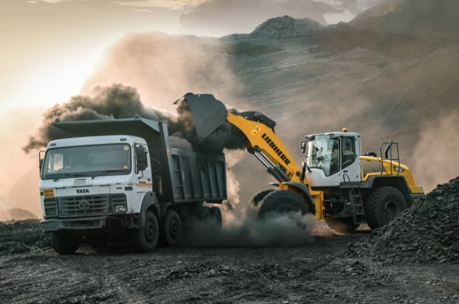
liebherr-wheel-loader-l550-coal-handling-india.jpg
A Liebherr L 550 wheel loader loads a lorry at a coal mine in India.

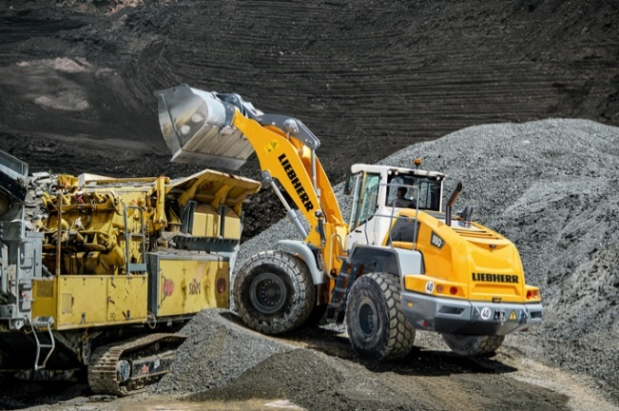
liebherr-wheel-loader-l550-feeding-crusher.jpg
A Liebherr L 550 wheel loader from the new series feeding a mobile crushing plant.

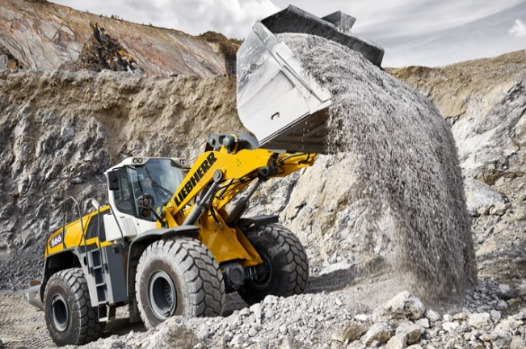
liebherr-wheel-loader-l566-quarry.jpg
The L 566 wheel loader is well prepared for global applications, for instance in the mining industry.

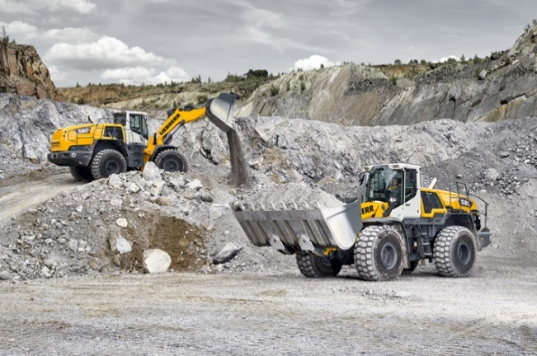
liebherr-wheel-loaders-l580-quarry.jpg
The L 580 is the largest model in Liebherr’s wheel loader series for markets outside of Europe and North America.

Contact
Martin Koller
Marketing and Public Relations
Phone: +43 50809 11475
E-mail: martin.koller.lbh@liebherr.com
Published by
Liebherr-Werk Bischofshofen GmbH
Bischofshofen/Austria
www.liebherr.com

