Press release

Liebherr presents new compact loader series with the new L 504 compact model

⸺
Please note: Liebherr compact loaders are not available in North-America
The L 504 compact loader: a new addition to the series
Liebherr’s L 506 and L 508 compact loaders feature numerous innovations
L 506 and L 508: Speeder version and High Lift lift arms optionally available
New cab design with even more glass for optimum visibility
Since their premiere in 2013, Liebherr’s compact loaders have been impressing customers as safe and reliable machines in a wide variety of industries. Liebherr has now overhauled its compact loaders and expanded the series with the L 504 model. The most important innovations include the redesigned operator's cab, which provides the operator with excellent visibility thanks to its generous use of glass. The optimised visibility of the lift arms also ensures an unobstructed view of the working attachment and therefore maximum safety. Due to customer demand, the L 506 and L 508 models are now available as Speeder variants for the first time ever. In this version, they can reach a top speed of 30 km/h.
Bischofshofen (Austria), 12 January 2022 – The new compact loader series comprises three models which have been optimally coordinated with one another. The new L 504 compact joins the company’s wheel loader range. Liebherr’s smallest wheel loader embodies the qualities of the larger Liebherr wheel loaders while also being an excellent value for the money. With numerous new features, the L 506 compact has consolidated its already strong position in the market. As is the case for the L 504, the machine height of the L 506 remains under 2.5 metres, making it easy to transport on a trailer. The new L 508 compact has become larger and wider than both of the other Liebherr compact loaders. Its powerful travel drive and high tipping load have received praise from customers.
Versatile and powerful: Intelligent solutions for the lift arms
The new compact loaders have robust lift arms with z-bar kinematics, which facilitates the use of a wide variety of attachments. Liebherr has optimised the parallel guidance for safe and precise operation when working with forks. This is critical, for instance, when transporting palettes with paving stones or decking tiles in garden and landscaping applications. To increase versatility even more, Liebherr offers High Lift lift arms for the L 506 and L 508 models on request. This is an extended version of the lift arms with a greater reach. This enables the compact loaders to also load taller transport vehicles.
Wheel loaders are confronted with a myriad of challenges when used in municipal services: Transporting materials with various buckets or forks, excavating with a 4 in 1 bucket, cleaning work with a sweeper, or winter services with a snow plough are just some examples of this. To ensure the mastery of this wide variety of applications, Liebherr offers its fully automatic quick coupler system LIKUFIX for the three compact loaders. LIKUFIX allows the machine operator to change between mechanical and hydraulic working tools from the cab within seconds at the touch of a button. This saves time and reduces the risk of accidents as the operator doesn't have to leave the cab when changing the equipment.
Comfortable and safe: New cab and functional design
Well thought-out solutions can also be found in the redesigned cab, which can be entered via a sturdy, reinforced step. Of particular note, Liebherr has increased the amount of glass throughout the cab. The windscreen now even reaches into the foot area of the operator's cab. This ensures better visibility in all directions, particularly of the attachment and in the articulation area. The rear screen is curved on the sides, enabling an unobstructed view of the rear area. The new compact loaders can be equipped with a backup camera on request, for even more safety when reversing.
Numerous details, such as the clearly-arranged control elements or the practical storage areas, increase comfort in the operator's cab. With the proven Liebherr control lever, the machine operator can operate the lift arms and the attachment safely. This also applies to the optional mini joystick on the control lever, which is used to control additional hydraulic functions. Optionally available is an infinitely-adjustable steering column; the display, standard on all machines, is also adjustable and located on the A pillar in the cab. These measures ensure simple and intuitive operation of the compact loader, which plays an important role, especially, for example, for rental construction machines.
Liebherr’s new compact loaders feature a modern and functional design. The engine bonnet has a dynamic and clean design, with great visibility from the cab. The lift arms have a tapered design, which optimises the view of the attachment and the material. The compact design with a low centre of gravity ensures optimum weight distribution on the new compact loaders. The result is high stability and safe, comfortable operation, day in and day out.
Performance data of the new compact loaders
Model: | L 504 compact | L 506 compact | L 508 compact
Tipping load: | 3,000 kg | 3,500 kg | 3,900 kg
Bucket capacity: | 0.7 m³ | 0.8 m³ | 1.0 m³
Operating weight: | 4,600 kg | 4,970 kg | 5,700 kg
Engine output: | 34 kW / 46 hp | 47.5 kW / 64 hp | 47.5 kW / 64 hp
All specifications refer to the standard version. The emissions are within the thresholds of the European stage V standards.

About Liebherr-Werk Bischofshofen GmbH
Liebherr-Werk Bischofshofen GmbH develops, produces and sells wheel loaders from the Liebherr Group. The plant in the state of Salzburger Land (Austria) has grown steadily over the decades thanks to sustainable innovations, creative solutions, and high-quality standards. The wheel loader range is constantly being expanded and includes different models in four different product groups: compact loaders, stereo loaders, medium, and large wheel loaders, which have impressive, innovative drive designs.
About the Liebherr Group
The Liebherr Group is a family-run technology company with a highly diverse product portfolio. The company is not only one of the largest construction equipment manufacturers in the world, it also provides high-quality and user-oriented products and services in a wide range of other areas. The Liebherr Group includes over 140 companies across all continents, employs around 48,000 staff, and in 2020 achieved combined revenues of over € 10.3 billion. Since its foundation in 1949 in Kirchdorf an der Iller in Southern Germany, Liebherr has been pursuing the goal of achieving continuous technological innovation and bringing industry-leading solutions to its customers.
Images
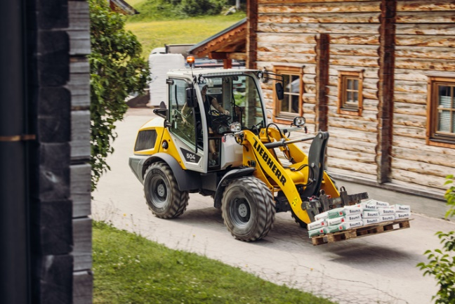
liebherr-compact-loader-l504.jpg
The Liebherr L 504 compact loader is the latest model in Liebherr’s wheel loader range.

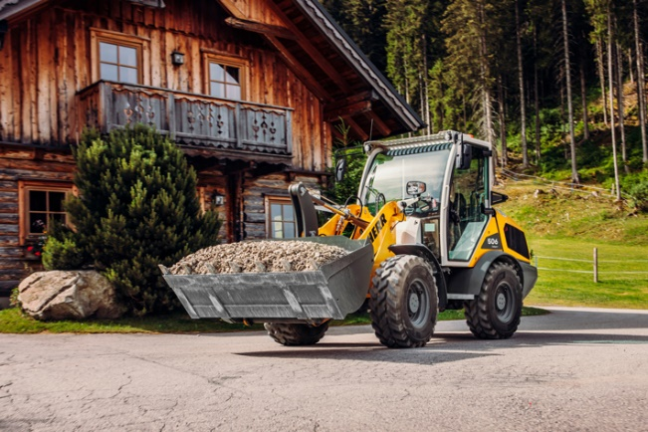
liebherr-compact-loader-l506.jpg
The new Speeder version of the Liebherr L 506 compact loader can achieve a top speed of 30 km/h.

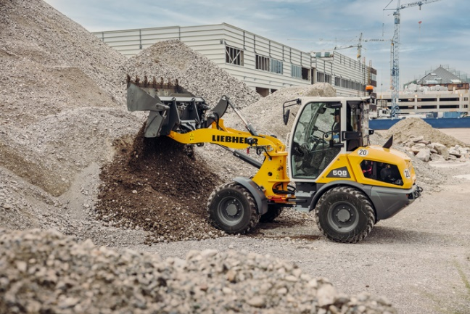
liebherr-compact-loader-l508.jpg
The new Liebherr L 508 compact loader on a construction site. The L 508 compact is now larger and wider.

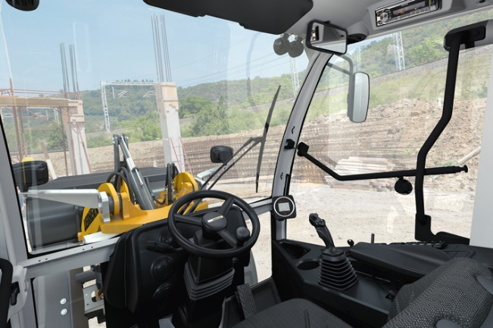
liebherr-compact-loaders-cabin.jpg
Optimum visibility: The new cab in Liebherr’s compact loaders, now with even more glass.

Contact
Martin Koller
Marketing and Public Relations
Phone: +43 50809 11475
Email: martin.koller.lbh@liebherr.com
Published by
Liebherr-Werk Bischofshofen GmbH
Bischofshofen/Austria
www.liebherr.com

