Press release

Number 27 in the company’s 27th year – Ullrich takes delivery of Liebherr LTM 1060-3.1

⸺
High performance and long boom for a wide range of jobs
LTM 1060-3.1 well suited for operations without additional ballast transports
Ullrich vehicle fleet to be expanded in an environmentally friendly and fuel-saving way

Ullrich Krane GmbH has taken delivery of a Liebherr LTM 1060-3.1 mobile crane. The 60 tonne machine will supplement the crane fleet in the segment between 50 and 90 tonnes. It is the 27th crane that the Chemnitz-based company has bought from Liebherr during its 27 year history. Ullrich has exclusively operated Liebherr mobile cranes since it opened for business.
Ehingen (Donau) (Germany), 22 December 2021 – “We have now closed the gap between 50 and 90 tonnes with the LTM 1060-3.1”, explains company proprietor Michael Ullrich. “We can use this compact 3-axle crane for a very wide range of jobs due to its high lifting capacity and its 48 metre telescopic boom.”
A folding jib enables the LTM 1060-3.1 to achieve hook heights of up to 63 metres and radii of up to 48 metres. On public roads it can carry up to 5.5 tonnes of ballast with an axle load of 12 tonnes. This means that it can complete the majority of its jobs without requiring additional ballast to be transported. The 3-axle crane achieves its maximum lifting capacity when set up with its complete counterweight of 12.8 tonnes.
Michael Ullrich reports: “We have had a long, constant partnership with Liebherr, always seeing eye to eye and dominated by a relationship based on trust. Furthermore, Liebherr supplies the very latest crane and drivetrain technology. The latest Liebherr engine technology enables us to modify our crane fleet to make it greener. Reducing fuel consumption and CO₂ emissions is one of our main challenges.”
Ullrich Krane GmbH was founded in 1994 and took delivery of four Liebherr mobile cranes in its very first year. Since then they have been joined by another 23 Liebherr cranes. This has also meant that the fleet has constantly been keep up to date. Currently the Ullrich fleet comprises eight mobile crane lifting capacities of up to 250 tonnes and six tractor units with low loaders.
The family-run company is looking at a change of generation in April 2022. “I am pleased that Holger Ludewig, who has been working for us as a dispatcher for 27 years, will become managing partner and take on responsibility for the company in this position. However, I am also planning to remain with the company,” adds Michael Ullrich.
About Liebherr-Werk Ehingen GmbH
Liebherr-Werk Ehingen GmbH is a leading manufacturer of mobile and crawler cranes. Its range of mobile cranes extends from 2-axle 35 tonne cranes to heavy duty cranes with a lifting capacity of 1200 tonnes and a 9-axle chassis. Its lattice boom cranes on mobile or crawler crane chassis deliver lifting capacities of up to 3000 tonnes. With universal boom systems and extensive additional equipment, they can be seen in action on construction sites throughout the world. The Ehingen site has a workforce of 3,500. Extensive, global service guarantees the high availability of Liebherr mobile and crawler cranes. In 2020, the Liebherr plant in Ehingen recorded a turnover of 2.03 billion euros.
About the Liebherr Group
The Liebherr Group is a family-run technology company with a widely diversified product range. The company is one of the largest manufacturers of construction machines in the world, but also supplies technically advanced, user-focused products and services in many other sectors. The group currently comprises more than 140 companies based in every continent of the world, has a workforce of around 48,000 and recorded a consolidated total turnover of more than 10.3 billion euros in 2020. Since it was founded in 1949 in Kirchdorf an der Iller in southern Germany, Liebherr’s aim has been to win customers by supplying high quality solutions and to contribute to technological progress.

Photograph:
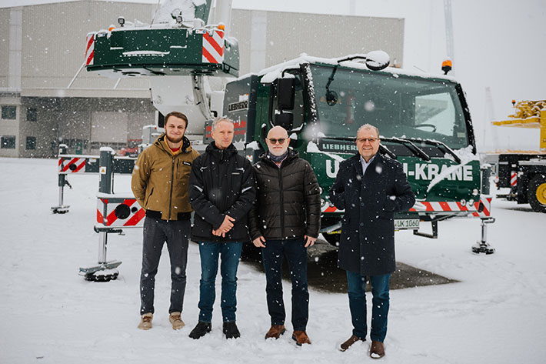
liebherr-ltm1070-3-1-ullrich.jpg
Winter crane handover in Ehingen – from left to right: Patrick Heilmann, Ulrich Rüdiger Pörschke, Michael Ullrich (all from Ullrich Krane GmbH), Burkhard Berndt (Liebherr-Werk Ehingen (GmbH). The local coronavirus regulations were satisfied at all times.

Contacts
Wolfgang Beringer
Marketing and Communication
Phone: +49 7391/502 - 3663
Email: wolfgang.beringer@liebherr.com
Published by
Liebherr-Werk Ehingen GmbH
Ehingen (Donau) / Germany
www.liebherr.com

