Press release

Fleet addition: new Liebherr LR 1700-1.0 crawler crane for Eurogrúas 2000
⸺
LR 1700-1.0 is an ideal addition to the Eurogrúas 2000 crane fleet
New 700-tonne crane goes directly from Liebherr's manufacturing plant in Ehingen for deployment at various wind farms in Germany.
LR 1700-1.0 combines the advantages of economical transport of 600-tonne class crawler cranes with the performance of 750-tonne class lattice boom cranes

Spanish crane and heavy lift company Eurogrúas 2000 has taken delivery of a new Liebherr LR 1700-1.0 crawler crane. The new 700-tonne crane replaces a 600-tonne crawler crane that the Spanish company mainly used in the wind power sector. Eurogruas 2000 chose the LR 1700-1.0 because "the machine fits perfectly with the requirements of this market in terms of the weight and height of the current wind turbines", says Javier Sato, partner of Eurogrúas 2000. The new investment goes hand in hand with the company's strategy of always keeping its machinery technically up-to-date.
Ehingen (Donau) (Germany), 17 December 2021 - Eurogrúas 2000 was looking for a crane that could meet the increasing demands of assembling modern wind turbines. Javier Sato says: "The LR 1700-1.0 is the ideal addition to our machine fleet. We have smaller narrow track cranes that are very well suited for certain types of wind power projects. As a larger model, we operate the Liebherr LR 1800-1.0 crawler crane. We needed a crane to fill the gap between 600- and 800-tonne cranes." The most important criteria in Eurogrúas 2000's decision for the LR 1700-1.0 were the Liebherr crawler crane's lifting capacity and boom length, as well as its innovative technology and compact design.
From the manufacturing plant directly to the wind farm
The Liebherr LR 1700-1.0 from Eurogrúas 2000, the first in Spain of this new model, went directly from the mobile crane factory in Ehingen to different wind farms spread across Germany, the first of which was located near Düsseldorf. There, the crane was responsible for the assembly of 20 wind turbines with a hub height of 161 metres and unit weights of up to 86 tonnes. "The fact that a company like Eurogrúas 2000 is awarded an international project of this kind, which involves working beyond the borders of its own country, is proof of the trust and recognition shown to us by a customer with whom we have had a business relationship for years and with whom we have already carried out other national and international projects. It is also confidence in the right choice of crane", reports Sato.
"When our client learned about the purchase of the Liebherr LR 1700-1.0 700-tonner, we jointly concluded that this was the right model for the job, as these are very specialised wind turbines that require certain performance specifications," Sato continues.
Eurogrúas 2000 relies on Liebherr as one of its flagship brands
Liebherr's LR 1700-1.0 combines the advantages of the economical transport of 600-tonne class crawler cranes with the performance of 750-tonne class lattice boom cranes and all the innovations of Liebherr's crawler crane developments in recent years. The successor model to the LR 1600/2 is based on its 600-tonne predecessor and has similar dimensions. The key to the higher performance of the new 700-tonne crane is the new base machine, which offers 10 to 15 percent more lifting capacity. In addition, the 3.5-metre wide H-lattice sections in the lower section of the main boom significantly improve the lateral stability of the entire system.
The Eurogrúas Group has relied on Liebherr cranes for years, as they offer state-of-the-art technology and excellent performance data for both industrial and wind power applications. The speed, efficiency and quality of Liebherr Ibérica's after-sales service are also major strengths that have led Eurogrúas to make Liebherr one of its flagship brands. The Eurogrúas Group has a fleet of 130 cranes, of which 113 units are from Liebherr.
About Eurogrúas
Eurogrúas 2000 was founded in 1997. It is a company that resulted from the merger of six companies with the aim of joining forces and shaping a crane and specialised transport company. Currently, the Eurogrúas Group is a leader in lifting, transport and heavy lift projects, based on providing technical solutions through continuous investment in human resources and equipment, guaranteeing its customers the best and most efficient service with the highest level of quality and safety. The Eurogrúas Group has 10 branches in Spain and one in Brazil.
About Liebherr Ibérica, S.L.
Liebherr Ibérica is the Spanish sales and service company of the Liebherr Group and was founded in 1988. Today, Liebherr Ibérica is responsible for the sales and after-sales service of the mobile crane, earthmoving machinery, mining, marine cran and concrete technology divisions.
About Liebherr-Werk Ehingen GmbH
Liebherr-Werk Ehingen GmbH is a leading manufacturer of mobile and crawler cranes. Its range of mobile cranes extends from 2-axle 35 tonne cranes to heavy duty cranes with a lifting capacity of 1200 tonnes and a 9-axle chassis. Its lattice boom cranes on mobile or crawler crane chassis deliver lifting capacities of up to 3000 tonnes. With universal boom systems and extensive additional equipment, they can be seen in action on construction sites throughout the world. The Ehingen site has a workforce of 3,600. Extensive, global service guarantees the high availability of Liebherr mobile and crawler cranes. In 2020, the Liebherr plant in Ehingen recorded a turnover of 2 billion euros.
About the Liebherr Group
The Liebherr Group is a family-run technology company with a widely diversified product range. The company is one of the largest manufacturers of construction machines in the world, but also supplies technically advanced, user-focused products and services in many other sectors. The group currently comprises more than 140 companies based in every continent of the world, has a workforce of around 48,000 and recorded a consolidated total turnover of more than 10.3 billion euros in 2020. Since it was founded in 1949 in Kirchdorf an der Iller in southern Germany, Liebherr’s aim has been to win customers by supplying high quality solutions and to contribute to technological progress.
Pictures:
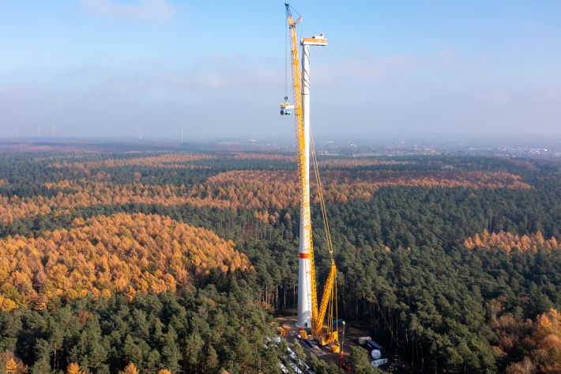
liebherr-lr1700-1-0-eurogruas-1.jpg
First use in Germany: The new LR 1700-1.0 proves itself in a wind farm close to Düsseldorf, Germany.

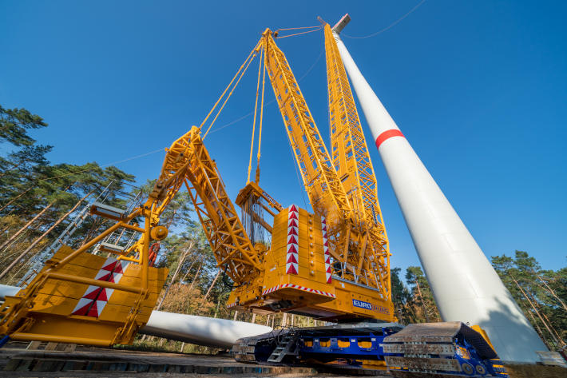
liebherr-lr1700-1-0-eurogruas-2.jpg
Innovative: Eurogrúas 2000 has ordered the LR 1700-1.0 with VarioTray and V-Frame.
Contact
Wolfgang Beringer
Marketing and Communication
Telefon: +49 7391/502 - 3663
E-Mail: wolfgang.beringer@liebherr.com
Published by
Liebherr-Werk Ehingen GmbH
Ehingen (Donau) / Deutschland
www.liebherr.com

