Press release

Most powerful crane in the fleet – Wasel extends crawler crane portfolio with LR 11000

⸺
The LR 11000 is the most powerful lattice boom crane in the Wasel fleet
Power in reserve for future wind power and industry requirements
Impressive quality and service from Liebherr
Wasel GmbH has taken delivery of a Liebherr LR 11000 crawler crane to add to its growing fleet of lattice boom cranes. The 1000 tonne crane is the fifth and most powerful lattice boom crane operated by the Bergheim-based company. The LR 11000 passed its first test with flying colours at a wind farm in North Rhine-Westphalia.
Ehingen (Donau) (Germany), 9 December 2021 – As recently as June this year, Wasel took delivery of an LR 1700-1.0, the latest crawler crane model from Liebherr. The LR 11000 provides even greater capacity. Matthias Wasel, who runs the business with his brother, Thomas, explains: “The lifting capacity requirements in industry and for public infrastructure projects are on the rise. The towers for wind turbines are also increasing in height all the time. That is why we decided to buy Liebherr’s 1000 tonne crane. It means that we are absolutely ready for the next generation of wind turbines.”
Thomas Wasel continues: “The LR 11000 is now the fifth large lattice boom crane in our fleet. All the cranes bear the Liebherr brand. We are impressed by Liebherr products, particularly its crawler cranes. The quality of both the products and Liebherr’s service is top class. It is, of course, also a benefit to stick with a single manufacturer for large cranes in terms of operation, transport and maintenance.”
Wasel is planning the first jobs for the LR 11000 assembling wind turbines and it will also be used later for jobs in industry.
First job with SL10DF2BV wind power system
For its first job, the new LR 11000 was transported to a wind farm in Coesfeld in North Rhine-Westphalia. The new flagship of the Wasel fleet had to prove itself by assembling a wind turbine with a hub height of 170 metres. Julian Schmidt, Technical Director at Wasel, takes up the story: “The powerful SL10 boom was an important criterion for the LR 11000. And we need all its power here at this wind farm. 136 tonnes including the hook block and fastening equipment had to be hoisted to an extreme height of 170 metres with a radius of 29 metres.”
For this job, the crane was set up with the special SL10DF2BV wind turbine system – 162 metre main boom, twelve metre fixed jib, 210 tonnes of turntable ballast, 90 tonnes of central ballast and 450 tonnes of derrick ballast. “The benefits of the V-Frame and VarioTray when working with suspended ballast in the wind industry were clearly demonstrated during this very first job,” continues Schmidt.
The V-frame ballast system is a hydraulically adjustable folding frame which enables the ballast radius of the LR 11000 to be infinitely adjusted between 13 and 30 metres. A rigid ballasting system is no longer required for large radii. VarioTray is a small ballast pallet, which can be unbolted quickly and easily when necessary. This avoids the need for the tiresome stacking and unstacking of ballast slabs. The large ballast pallet is only required to raise and lower the lattice boom.
Wasel employs more than 400 people and has a fleet of around 140 Liebherr mobile and crawler cranes. The customer focuses on providing hoisting and transport services. The company is also a Liebherr dealer for tower cranes and operates over 400 Liebherr tower cranes itself.
About Liebherr-Werk Ehingen GmbH
Liebherr-Werk Ehingen GmbH is a leading manufacturer of mobile and crawler cranes. Its range of mobile cranes extends from 2-axle 35 tonne cranes to heavy duty cranes with a lifting capacity of 1200 tonnes and a 9-axle chassis. Its lattice boom cranes on mobile or crawler crane chassis deliver lifting capacities of up to 3000 tonnes. With universal boom systems and extensive additional equipment, they can be seen in action on construction sites throughout the world. The Ehingen site has a workforce of 3,500. Extensive, global service guarantees the high availability of Liebherr mobile and crawler cranes. In 2020, the Liebherr plant in Ehingen recorded a turnover of 2.03 billion euros.
About the Liebherr Group
The Liebherr Group is a family-run technology company with a widely diversified product range. The company is one of the largest manufacturers of construction machines in the world, but also supplies technically advanced, user-focused products and services in many other sectors. The group currently comprises more than 140 companies based in every continent of the world, has a workforce of around 48,000 and recorded a consolidated total turnover of more than 10.3 billion euros in 2020. Since it was founded in 1949 in Kirchdorf an der Iller in southern Germany, Liebherr’s aim has been to win customers by supplying high quality solutions and to contribute to technological progress.
Photographs:
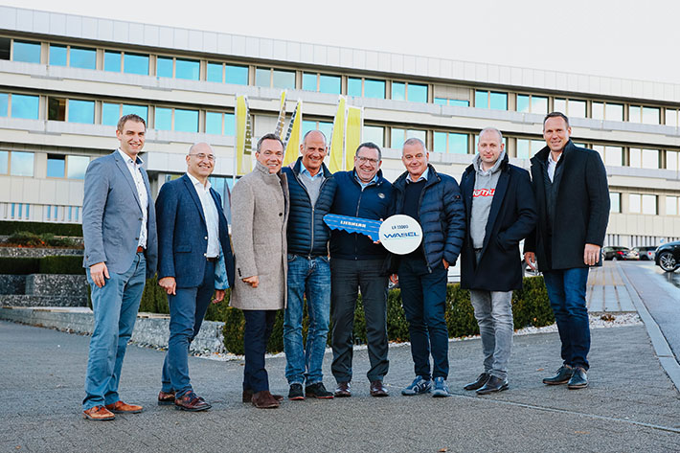
liebherr-lr11000-wasel-handover.jpg
Florian Maier, Erich Schneider (both from Liebherr-Werk Ehingen GmbH), Thomas Hagedorn (Hagedorn Holding GmbH), Matthias Wasel (Wasel GmbH), Christoph Kleiner (Liebherr-Werk Ehingen GmbH), Thomas Wasel (Wasel GmbH), Christian Hülsewig (Hagedorn Management GmbH), Dieter Walz (Liebherr-Werk Ehingen GmbH).
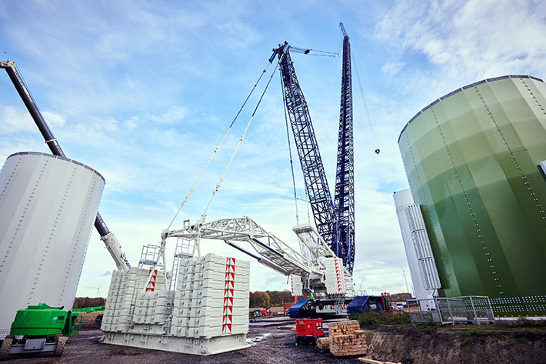
liebherr-lr11000-wasel-coesfeld-1.jpg
V-Frame – the folding frame adjusts the derrick ballast to maximum radius to raise the main boom.

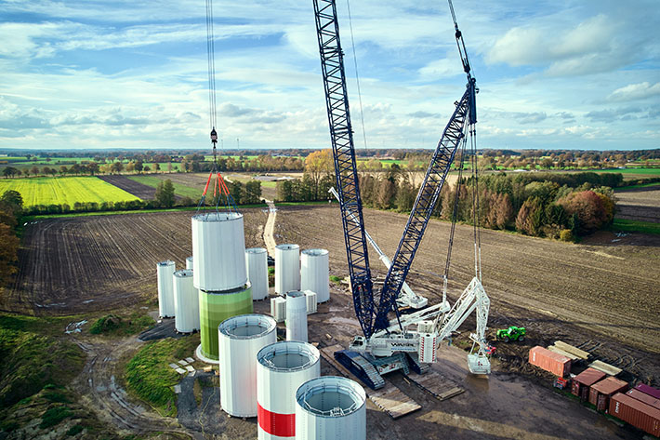
liebherr-lr11000-wasel-coesfeld-2.jpg
VarioTray – only part of the derrick ballast is required for the hoisting work. The ballast can be removed in a matter of minutes.
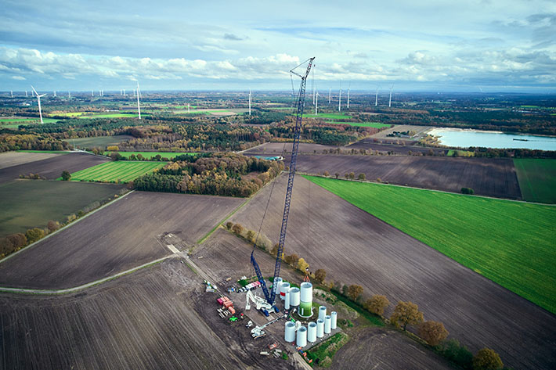
liebherr-lr11000-wasel-coesfeld-3.jpg
Birds eye view – the LR 11000 installs the lower components of the tower which will later project 170 metres into the air.
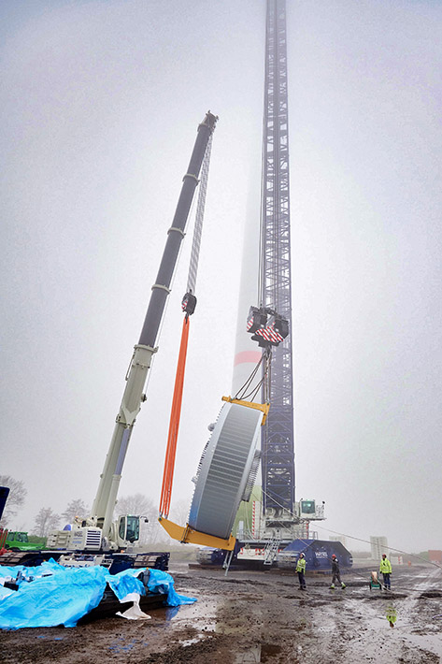
liebherr-lr11000-wasel-coesfeld-4.jpg
Support crane – an LTR 1220 hopes to turn the generator.
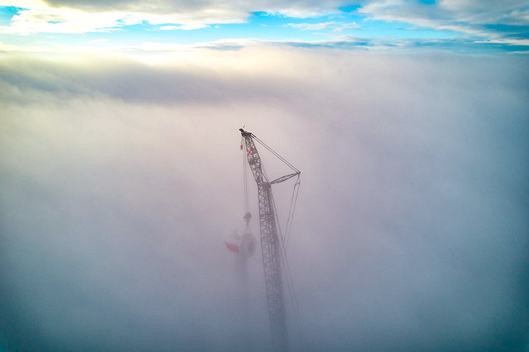
liebherr-lr11000-wasel-coesfeld-5.jpg
Into the clouds – installing the generator at a hub height of 170 metres.

Contacts
Wolfgang Beringer
Marketing and Communication
Phone: +49 7391/502 - 3663
Email: wolfgang.beringer@liebherr.com
Published by
Liebherr-Werk Ehingen GmbH
Ehingen (Donau) / Germany
www.liebherr.com

