Press release

Bridge building with AS Manutention’s new LTM 1750-9.1 mobile crane

⸺
AS Manutention’s new Liebherr LTM 1750-9.1 mobile crane installs pedestrian bridge in Amiens
New division – AS Manutention invests in 800 tonne heavy duty crane
Job successfully completed in Amiens, France – a new LTM 1750-9.1 from AS Manutention recently installed a pedestrian bridge. The pedestrian bridge was completed after just two days at the site. The investment in this Liebherr heavy duty crane with a lifting capacity of 800 tonnes, sees AS Manutention create a new division – ASM Heavy Lift.
Ehingen (Donau) (Germany), 8. December 2021 – “The LTM 1750-9.1 features particularly high lifting capacities, the very latest technology and enormous variability in use”, says Sébastien Aouni, Managing Director of AS Manutention, describing the benefits of his new crane. “We plan to use the 800 tonne crane in the chemical industry, wind power, bridge building and many other sectors.”
Challenging bridge installation job for the LTM 1750-9.1
Very little space was available for setting up the large crane. Smart set-up procedures, good planning and coordination within the team and the support of a Liebherr LTR 1060 telescopic crawler crane enabled the heavy duty crane to be set up smoothly. And at the end of the process the Liebherr crane stood ready for action with 154 tonnes of counterweight and a 13 metre fixed jib next to the River Somme in the Hortillonages in France, over which the new pedestrian bridge was to be installed.
First of all, the LTM 1750-9.1 installed caissons made of construction steel each measuring 20 metres in length and weighing around 20 tonnes. All the hoists were carried out using spreaders to minimise the pressure on the caissons. The maximum radius for hoisting the 20 tonne caissons was a massive 57 metres. Restricted visibility and the constricted site meant that the job was far from straightforward. The crane operator had to trust the messages he received by radio from the team for installing the caissons. The bridge was finally in situ after just two days at the site.
First investment in this class of crane
AS Manutention ordered the heavy duty crane with the complete range of TYV23EN equipment. Liebherr was able to add power to the LTM 1750-9.1 around two years ago using refined static calculation methods and a new luffing jib configuration. This means, for example, that the 800 tonne crane can achieve a lifting capacity of over 65 tonnes for erecting wind turbines with a hub height of 100 metres.
“The LTM 1750-9.1 is our first investment in this class of crane. Liebherr has been a reliable partner to us since the company was founded seven years ago. All our other mobile cranes were also supplied by Liebherr”, says Sébastien Aouni. The crane and haulage contractor is based in Biesheim in Alsace, whilst it also has sites in Strasbourg and Amiens. In addition to opening its ASM Heavy Lift Division, the company has also established its own design office to enable it to plan and complete projects precisely. The job carried out by the LTM 1750-9.1 in Amiens was also fully planned in advance by AS Manutention.
About Liebherr-Werk Ehingen GmbH
Liebherr-Werk Ehingen GmbH is a leading manufacturer of mobile and crawler cranes. Its range of mobile cranes extends from 2-axle 35 tonne cranes to heavy duty cranes with a lifting capacity of 1200 tonnes and a 9-axle chassis. Its lattice boom cranes on mobile or crawler crane chassis deliver lifting capacities of up to 3000 tonnes. With universal boom systems and extensive additional equipment, they can be seen in action on construction sites throughout the world. The Ehingen site has a workforce of 3,600. Extensive, global service guarantees the high availability of Liebherr mobile and crawler cranes. In 2020, the Liebherr plant in Ehingen recorded a turnover of 2 billion euros.
About the Liebherr Group
The Liebherr Group is a family-run technology company with a widely diversified product range. The company is one of the largest manufacturers of construction machines in the world, but also supplies technically advanced, user-focused products and services in many other sectors. The group currently comprises more than 140 companies based in every continent of the world, has a workforce of around 48,000 and recorded a consolidated total turnover of more than 10.3 billion euros in 2020. Since it was founded in 1949 in Kirchdorf an der Iller in southern Germany, Liebherr’s aim has been to win customers by supplying high quality solutions and to contribute to technological progress.

Photographs
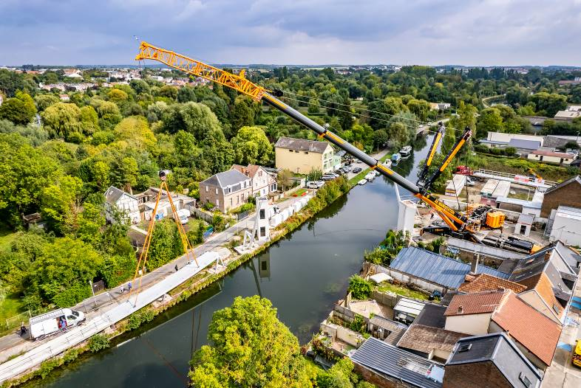
liebherr-ltm1750-9-1-as-manutention-01.jpg
AS Manutention’s LTM 1750-9.1 installed a pedestrian bridge in Amiens, France.

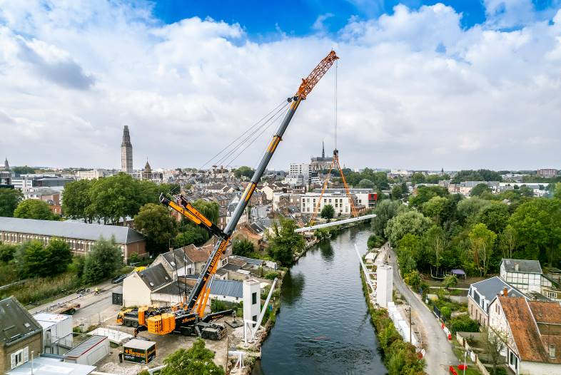
liebherr-ltm1750-9-1-as-manutention-02.jpg
The Liebherr 800 tonne crane was fitted with 154 tonnes of counterweight and a 13 metre fixed jib for this job.

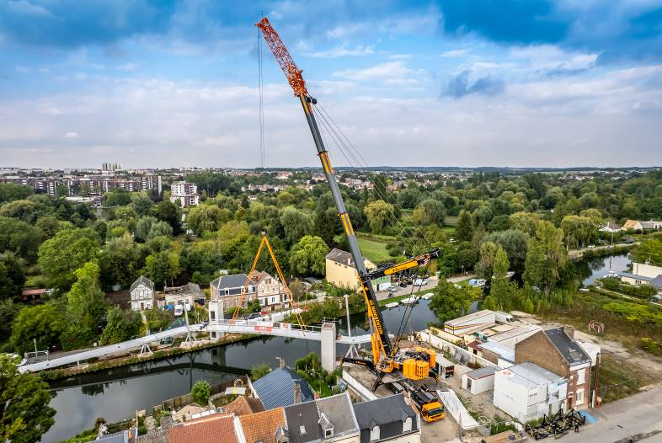
liebherr-ltm1750-9-1-as-manutention-03.jpg
The 9-axle crane from AS Manutention installed the new pedestrian bridge in the space of just two days at the site.

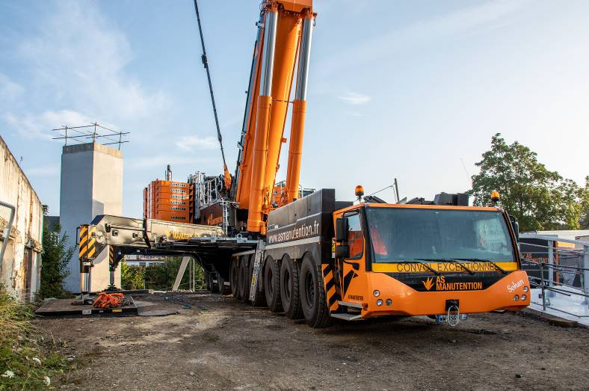
liebherr-ltm1750-9-1-as-manutention-04.jpg
Smart set-up procedures coupled with good planning and coordination within the AS Manutention team enabled the heavy duty crane to be set up in constricted conditions.

Contacts
Wolfgang Beringer
Marketing and Communication
Phone: +49 7391/502-3663
Email: wolfgang.beringer@liebherr.com
Published by
Liebherr-Werk Ehingen GmbH
Ehingen (Donau) / Germany
www.liebherr.com

