Press information

Acciaierie d'Italia places major order of four Liebherr LPS 800s

⸺
Liebherr and the leading Italian steel company Acciaierie d'Italia closed a deal about four large portal cranes type LPS 800 for the commercial port of Taranto
The four units ordered are completely electrically driven and can thus ensure emission-free cargo handling
The new bulk machines are equipped with the Liebherr hybrid drive Pactronic and with the intelligent grabbing technology Liebherr SmartGrip
The leading steel manufacturer in Italy, Acciaierie d'Italia recently signed a contract with Liebherr about four new LPS 800 portal cranes for handling raw materials for steel production. The LPS 800 is the strongest and largest portal crane in the Liebherr portfolio. The four units operate 100% on electric power and thus enable emission-free bulk handling. They also have the Liebherr hybrid system Pactronic installed, which gives the crane additional power when needed.
Rostock (Germany), December 2021 – In the city of Taranto, Acciaierie d'Italia operates a large and strategically placed steel mill that is the centre of its business. The site is to be further equipped with the latest crane technology for handling raw materials represented by the largest and strongest Liebherr portal crane of the type LPS 800.
“Our unique technical solutions around this project made the difference. These four gigantic portal cranes run 100% electrically and thus enable emission-free material handling. Acciaierie d'Italia also secures an unrivalled handling performance in the MHC market with the four LPS 800s. We are looking forward to this exciting partnership,” says Andreas Müller, Liebherr Sales Director for Mobile Harbour Cranes.
LPS 800 - Portal solution
The LHM 800 is the largest and most powerful model in the mobile harbour crane product range. Currently, over 20 units in the mobile version are in use with various customers worldwide. The long-proven design and reliability of the LHM 800 speak for themselves. Acciaierie d'Italia has ordered a customized portal version of the 800 model. Detaching the crane substructure via a portal has various advantages. The crane can move along the quay edge on the already installed rail and at the same time, the space under the portal can be used. With its portal crane models, Liebherr offers a unique combination of proven Liebherr harbour crane technology and space-saving installation on rail-mounted gantries.
“Acciaierie d'Italia is a major player in the European steel business. We are proud that they have chosen the market leader in mobile harbour crane technology – Liebherr. With Mac Port Group they have a

competent and local contact on site. We will support them in all service matters and ensure maximum availability of the equipment,” comments Matteo Bilotti, Managing Director Mac Port.
Sustainable features
The four LPS 800 of Acciaierie d'Italia have a 4-rope configuration with a maximum lifting capacity of up to 144 tonnes. All machines are equipped exclusively with an e-drive and can thus operate without local emissions. This is in line with the current trend, which shows a clear shift in drives towards electric. The cranes are also equipped with the Pactronic hybrid power booster developed by Liebherr. The Pactronic is an additional pressure storage that accumulates sink energy or excess energy from the electric drive and returns it to the closed hydraulic circuit in the form of pressure when required. This allows the power in the lifting process to be increased. Moreover, surplus energy is not wasted but fed back into the circuit and used efficiently. These features make the LPS 800 the best performing machine in bulk handling. Handling rates of 2000 tonnes per hour are possible.
Driver training for more safety
In order to prepare both the crane operators and the technical staff of Acciaierie d'Italia in the period until delivery, various training options are currently being discussed. Liebherr's own LiSIM simulator will certainly be used in the process. Technical service training at the maritime headquarters in Rostock, Germany, is also conceivable for optimum preparation for the future handling equipment. Liebherr is able to accompany the entire acquisition process, from individual technical solutions to delivery and training.

About Liebherr-MCCtec Rostock GmbH
Liebherr-MCCtec Rostock GmbH is one of the leading European manufacturers of maritime handling solutions. The product range includes ship, mobile harbour and offshore cranes. Reach stackers and components for container cranes are also included in the product portfolio.
About the Liebherr Group
The Liebherr Group is a family-run technology company with a broadly diversified product range. The company is one of the world's largest manufacturers of construction machinery, but also offers high-quality, user-oriented products and services in many other areas. Today, the group comprises more than 140 companies on all continents, employs around 48,000 people and generated total consolidated sales of more than EUR 10.3 billion in 2020. Since its foundation in 1949 in Kirchdorf an der Iller in southern Germany, Liebherr has pursued the goal of convincing its customers with sophisticated solutions and contributing to technological progress.
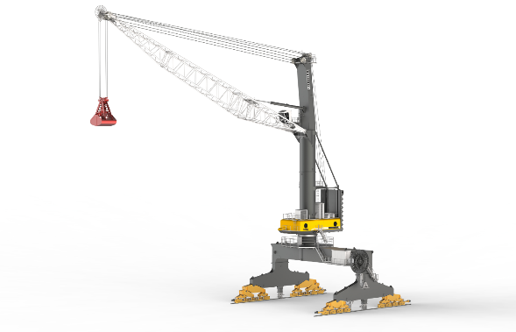
Images
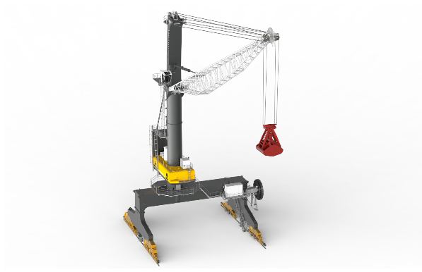
liebherr-lps-800-Acciaierie-d'Italia-1.jpg
Liebherr and the leading Italian steel company Acciaierie d'Italia closed a deal about four large portal cranes type LPS 800 for the commercial port of Taranto.
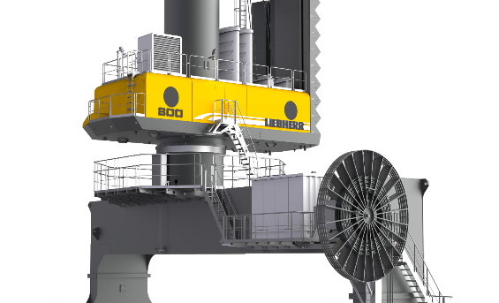
liebherr-lps-800-Acciaierie-d'Italia-2.jpg
The four units ordered are completely electrically driven and can thus ensure emission-free cargo handling.
liebherr-lps-800-Acciaierie-d'Italia-3.jpg
The new bulk machines are equipped with the Liebherr hybrid drive Pactronic and with the intelligent grabbing technology Liebherr SmartGrip.

Contact
Philipp Helberg
Tel: +49 381 6006 5024
Email: philipp.helberg@liebherr.com
Published by
Liebherr-MCCtec Rostock GmbH
Rostock / Germany
www.liebherr.com

