Press release

Night shift at the steelworks

⸺
Tandem hoist by two Liebherr-LG 1750 cranes at ArcelorMittal in Eisenhüttenstadt
Nolte Auto-Krane hoists gantry crane with a gross weight of 620 tonnes
The change of position will ensure the crane system has a longer service life
Modification of a large crane system at the ArcelorMittal steelworks in Eisenhüttenstadt – crane rental contractor H.-J. Nolte Auto-Krane based in Hanover travelled to the German-Polish border region with two Liebherr LG 1750 cranes. These powerful lattice boom mobile cranes had to hoist a gantry crane to enable a second gantry crane to be rolled past underneath it. The total gross load case for the tandem hoist was 620 tonnes.
Ehingen (Donau) (Germany), 1 December 2021 - As part of an upgrade at the converter steelworks operated by steel manufacturer ArcelorMittal in Eisenhüttenstadt, a heavyweight modification had to be completed to a large gantry crane system. The position of two cranes for transporting so-called ladles, giant containers for annealing pig iron, had to be swapped as a result of the fact that they had suffered different levels of wear.
Jürgen Peters, who planned the job for Nolte Auto-Krane at the steelworks, took two of the three large Liebherr LG 1750 lattice boom mobile cranes from the company’s fleet to handle the hoisting work. The cranes were each set up with a 70 metre main boom and derrick boom, equipped with 460 and 470 tonnes of ballast and positioned on either side of the crane track, which was around 30 metres off the floor. The operator console and trolley system for the gantry crane had to be removed before the tandem hoist could be tackled. “The preparations on the gantry crane required a great deal more time than we thought,” says Peters, “but we nevertheless managed to complete the work during the scheduled converter downtime.”
Changing positions for a longer service life
The two red lattice boom craned were not able to hoist the gantry crane out of the rails and lift it around ten metres into the air until around midnight, several hours later than planned. After the second crane had been moved under the load, the two crane operators from Nolte had to lower the load carefully onto the crane rails. Changing the positions of the two gantry cranes will ensure that the whole system has a longer service life. The crane which has previously been exposed to higher loads will be exposed to lower stresses in its future position, and vice versa.
ArcelorMittal manufactures high quality flat steel bars in Eisenhüttenstadt for the automotive and household appliances industries. The Brandenburg steelworks currently employs around 2700 people. The ironworks and the neighbouring town for the workforce were originally founded in 1950 with the name Eisenhüttenkombinat Ost.
About Liebherr-Werk Ehingen GmbH
Liebherr-Werk Ehingen GmbH is a leading manufacturer of mobile and crawler cranes. Its range of mobile cranes extends from 2-axle 35 tonne cranes to heavy duty cranes with a lifting capacity of 1200 tonnes and a 9-axle chassis. Its lattice boom cranes on mobile or crawler crane chassis deliver lifting capacities of up to 3000 tonnes. With universal boom systems and extensive additional equipment, they can be seen in action on construction sites throughout the world. The Ehingen site has a workforce of 3,500. Extensive, global service guarantees the high availability of Liebherr mobile and crawler cranes. In 2020, the Liebherr plant in Ehingen recorded a turnover of 2.03 billion euros.
About the Liebherr Group
The Liebherr Group is a family-run technology company with a widely diversified product range. The company is one of the largest manufacturers of construction machines in the world, but also supplies technically advanced, user-focused products and services in many other sectors. The group currently comprises more than 140 companies based in every continent of the world, has a workforce of around 48,000 and recorded a consolidated total turnover of more than 10.3 billion euros in 2020. Since it was founded in 1949 in Kirchdorf an der Iller in southern Germany, Liebherr’s aim has been to win customers by supplying high quality solutions and to contribute to technological progress.

Photographs:
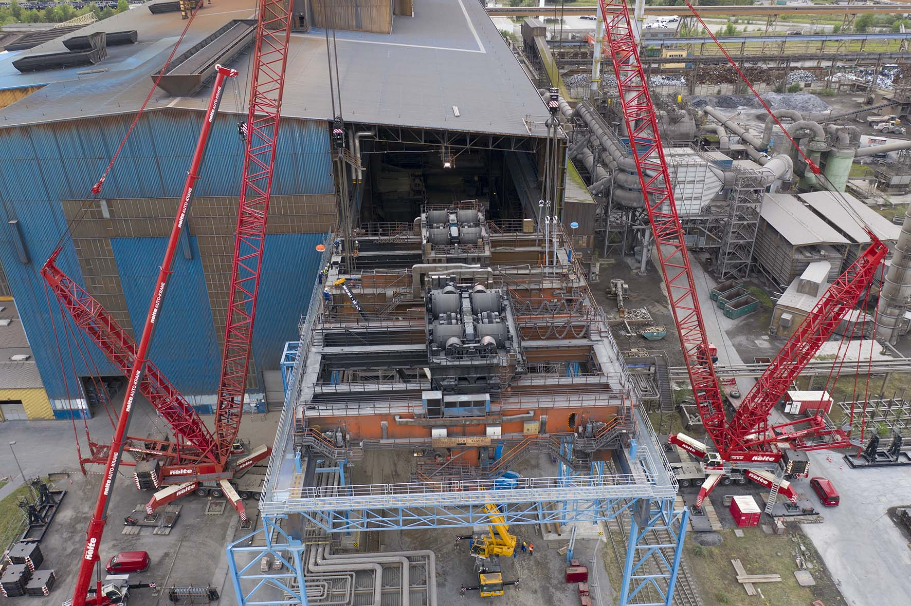
liebherr-lg-1750-nolte-1.jpg
Twins – the two LG 1750 were set up with identical configurations to hoist the gantry crane.

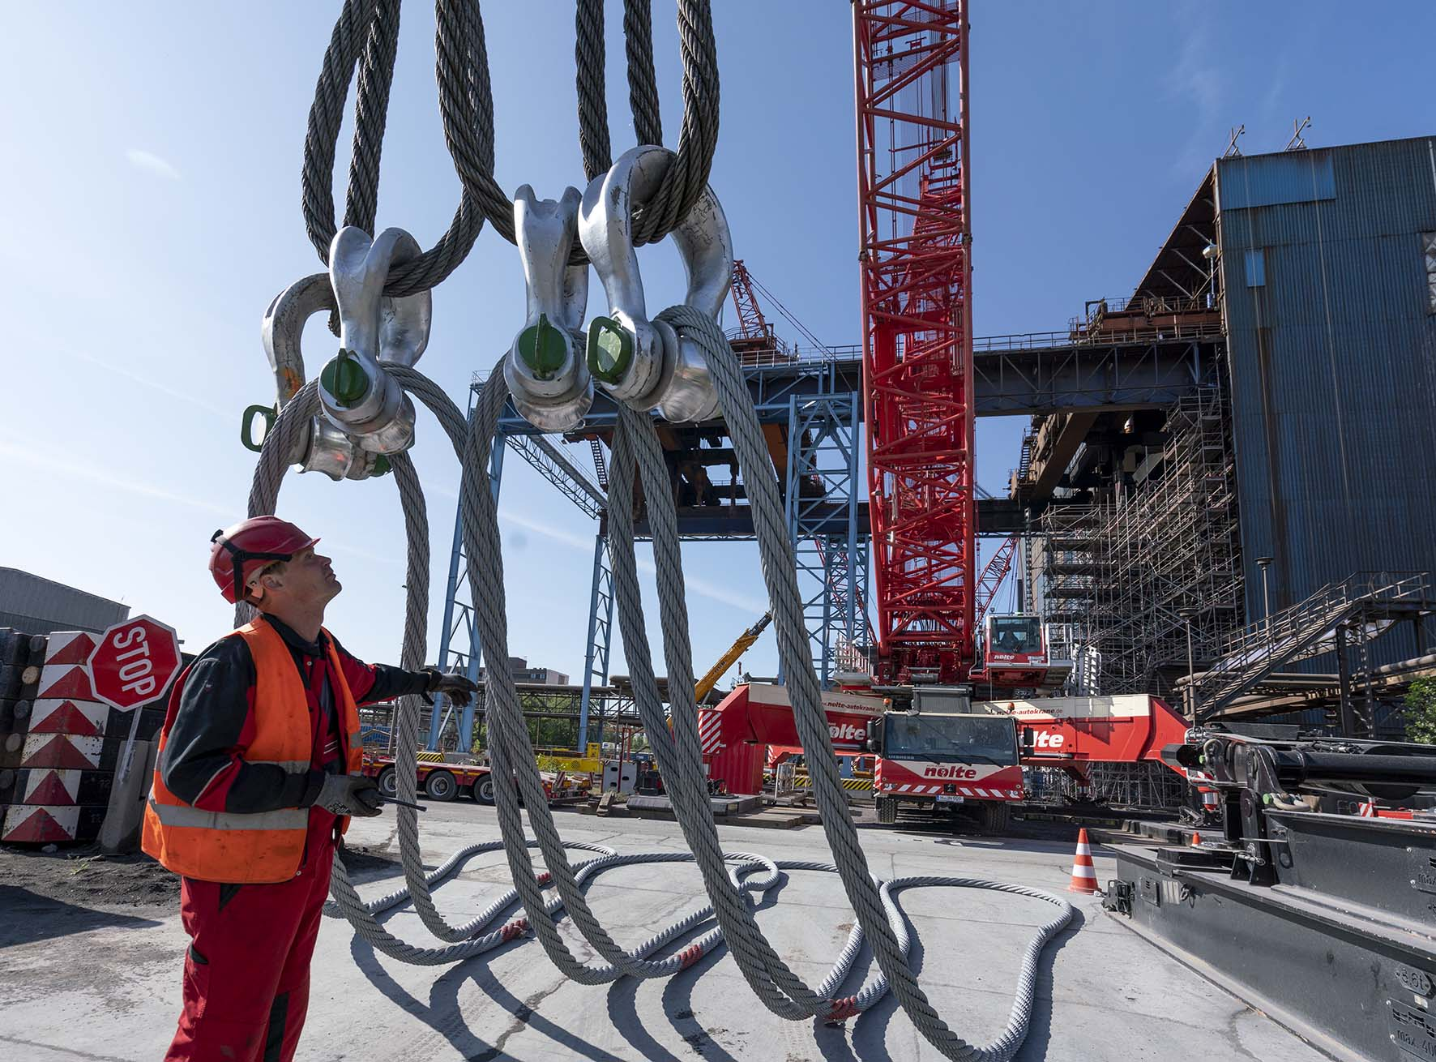
liebherr-lg-1750-nolte-2.jpg
Powerful – the steel ropes as thick as a man’s arm and large shackle are checked before being fastened into place for the tandem hoist.

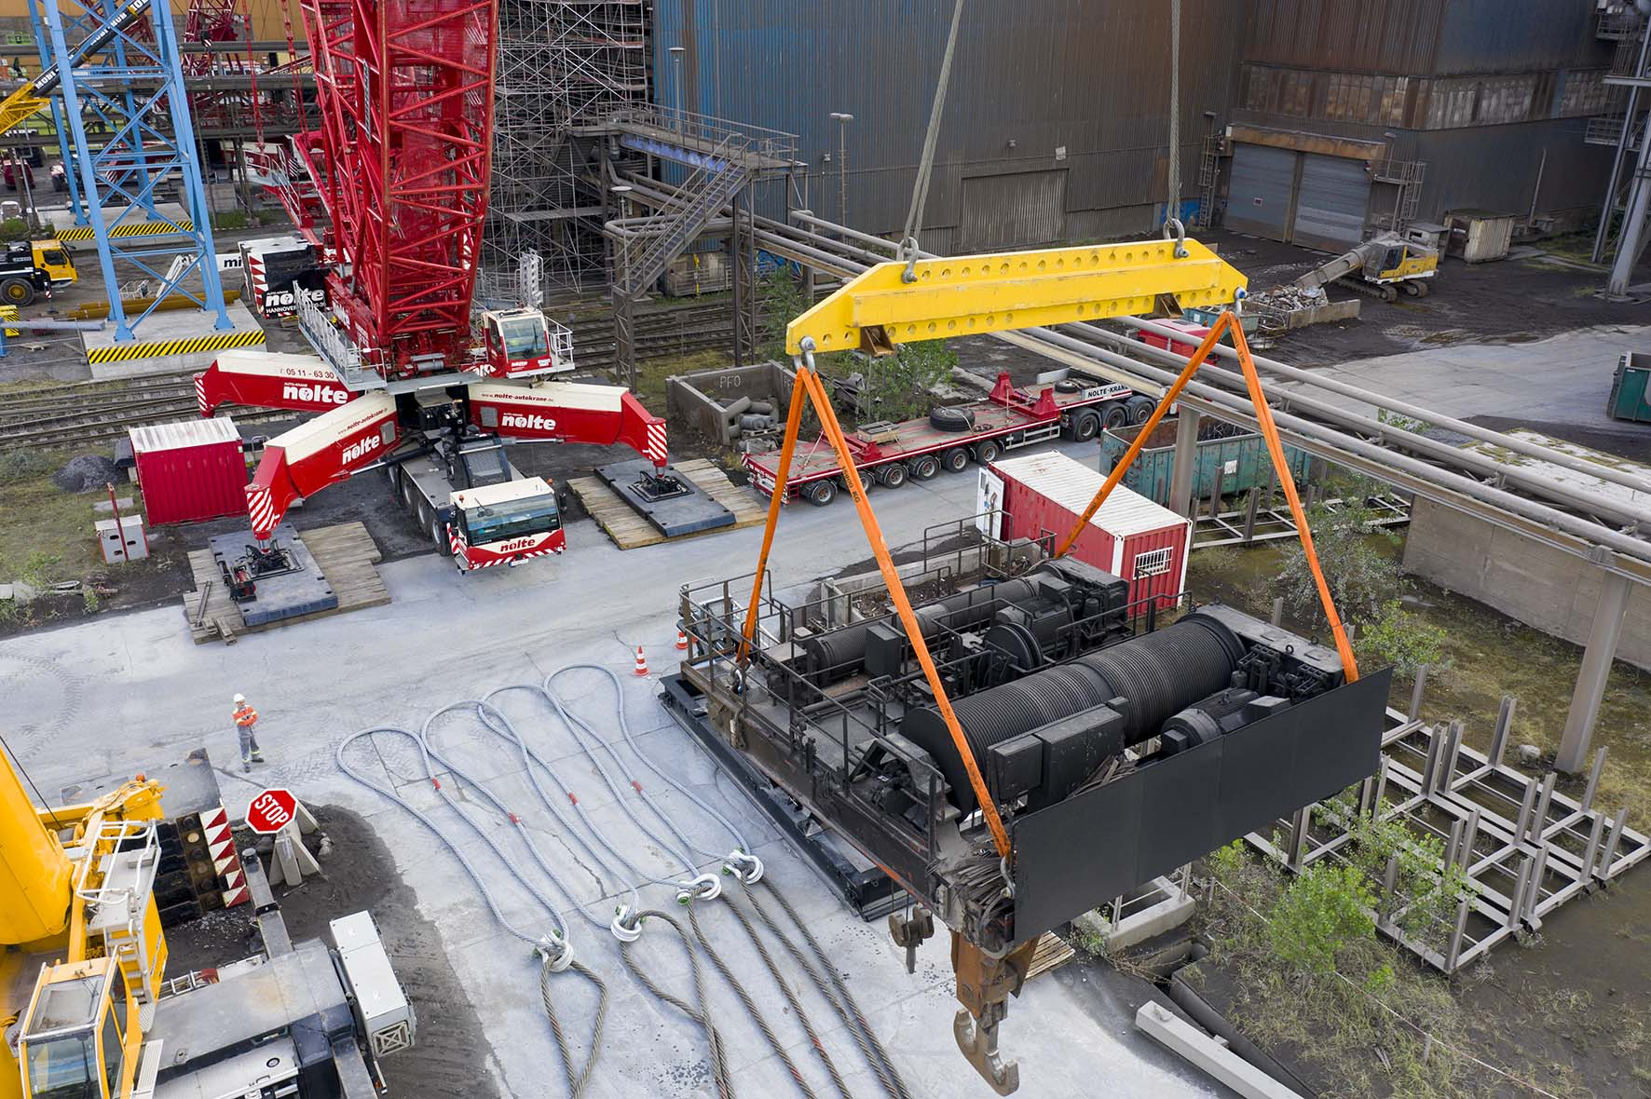
liebherr-lg-1750-nolte-3.jpg
In the way – a trolley system with a small hoist unit had to be removed before the gantry crane could be relocated.

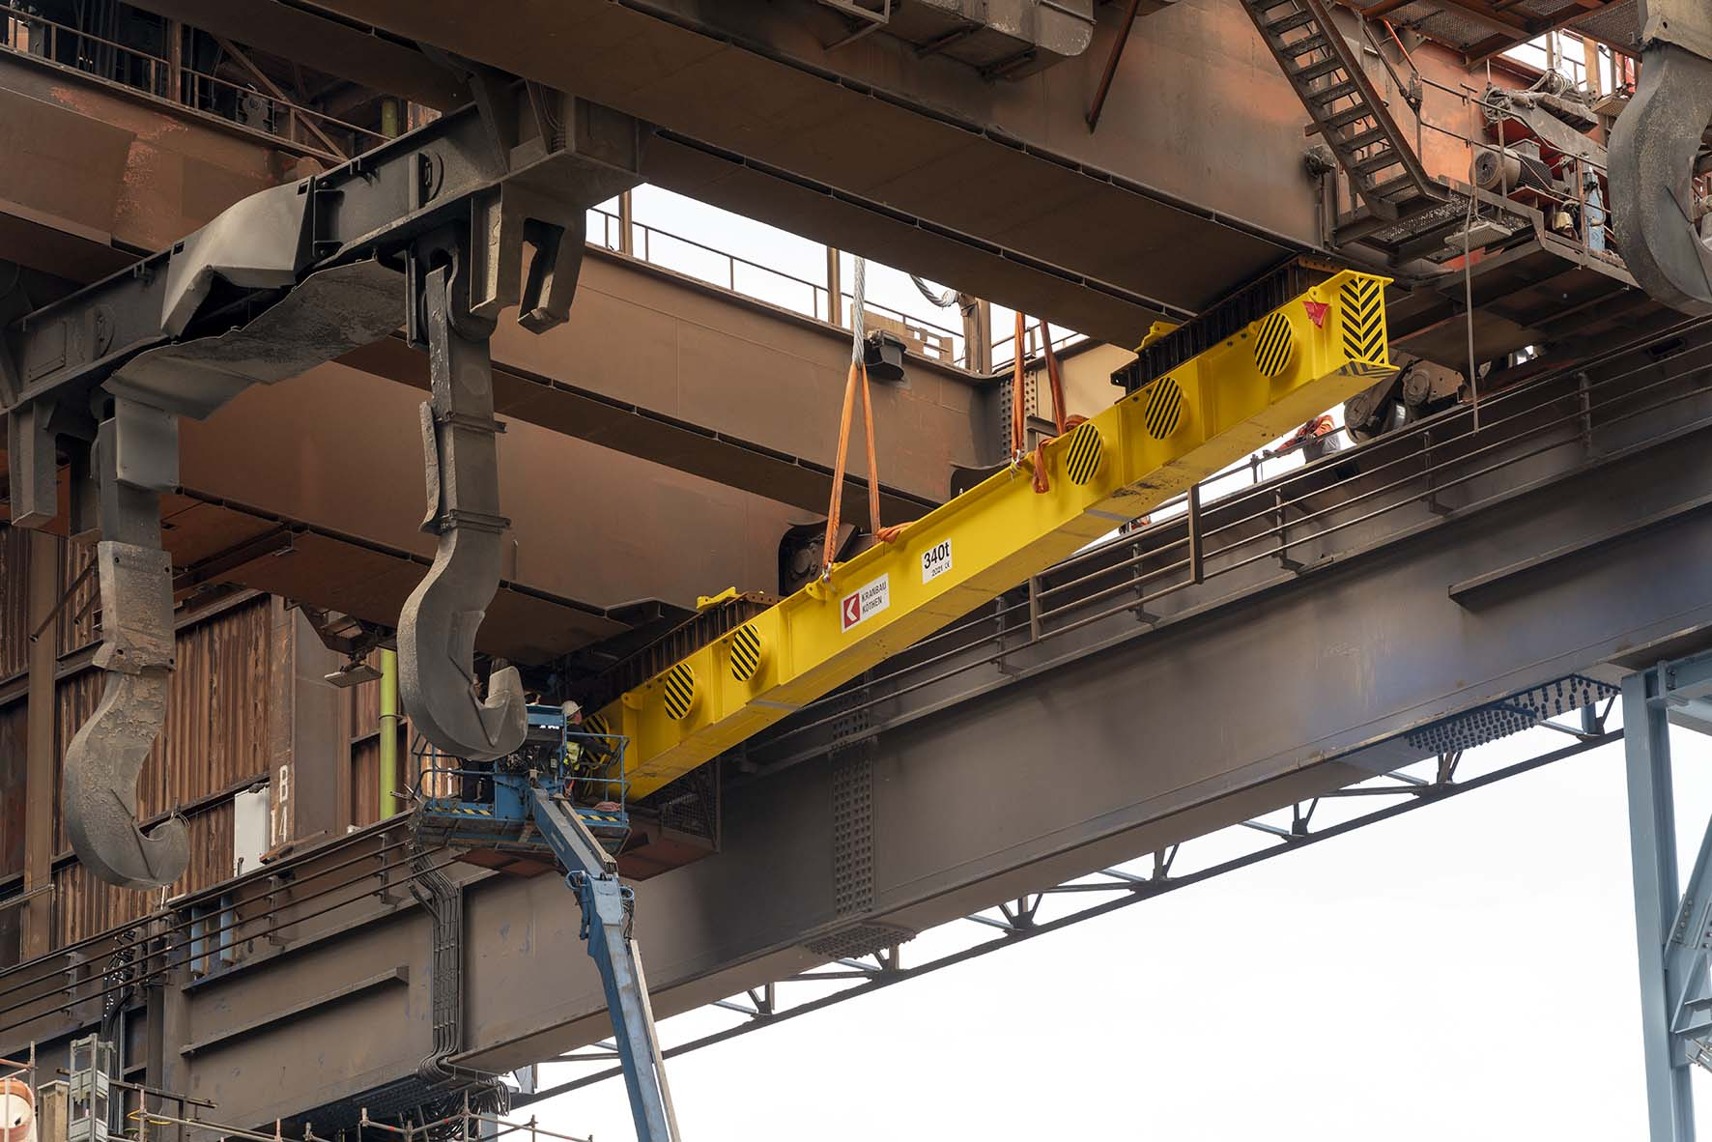
liebherr-lg-1750-nolte-4.jpg
Tricky – massive steel girders are installed at a height of 30 metres under the two main supports. The fastening points for the two LG 1750 lattice boom mobile cranes can be seen quite clearly.

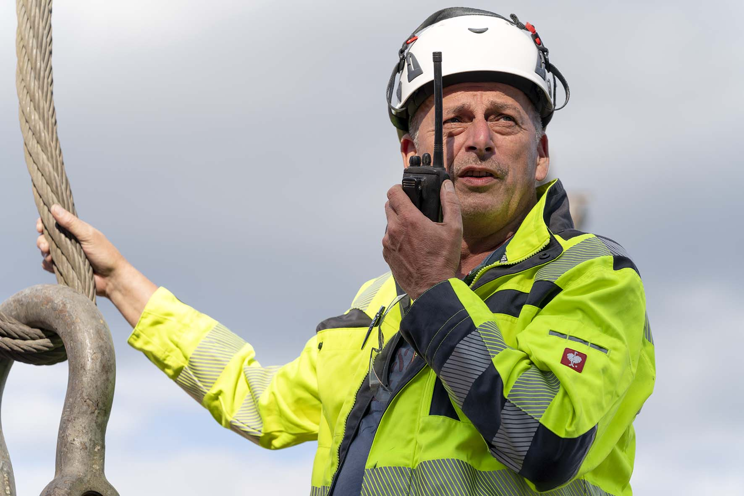
liebherr-lg-1750-nolte-5.jpg
Out and out – Jürgen Peters manages the really big crane jobs for Nolte Auto-Krane. He was also involved in Eisenhüttenstadt.

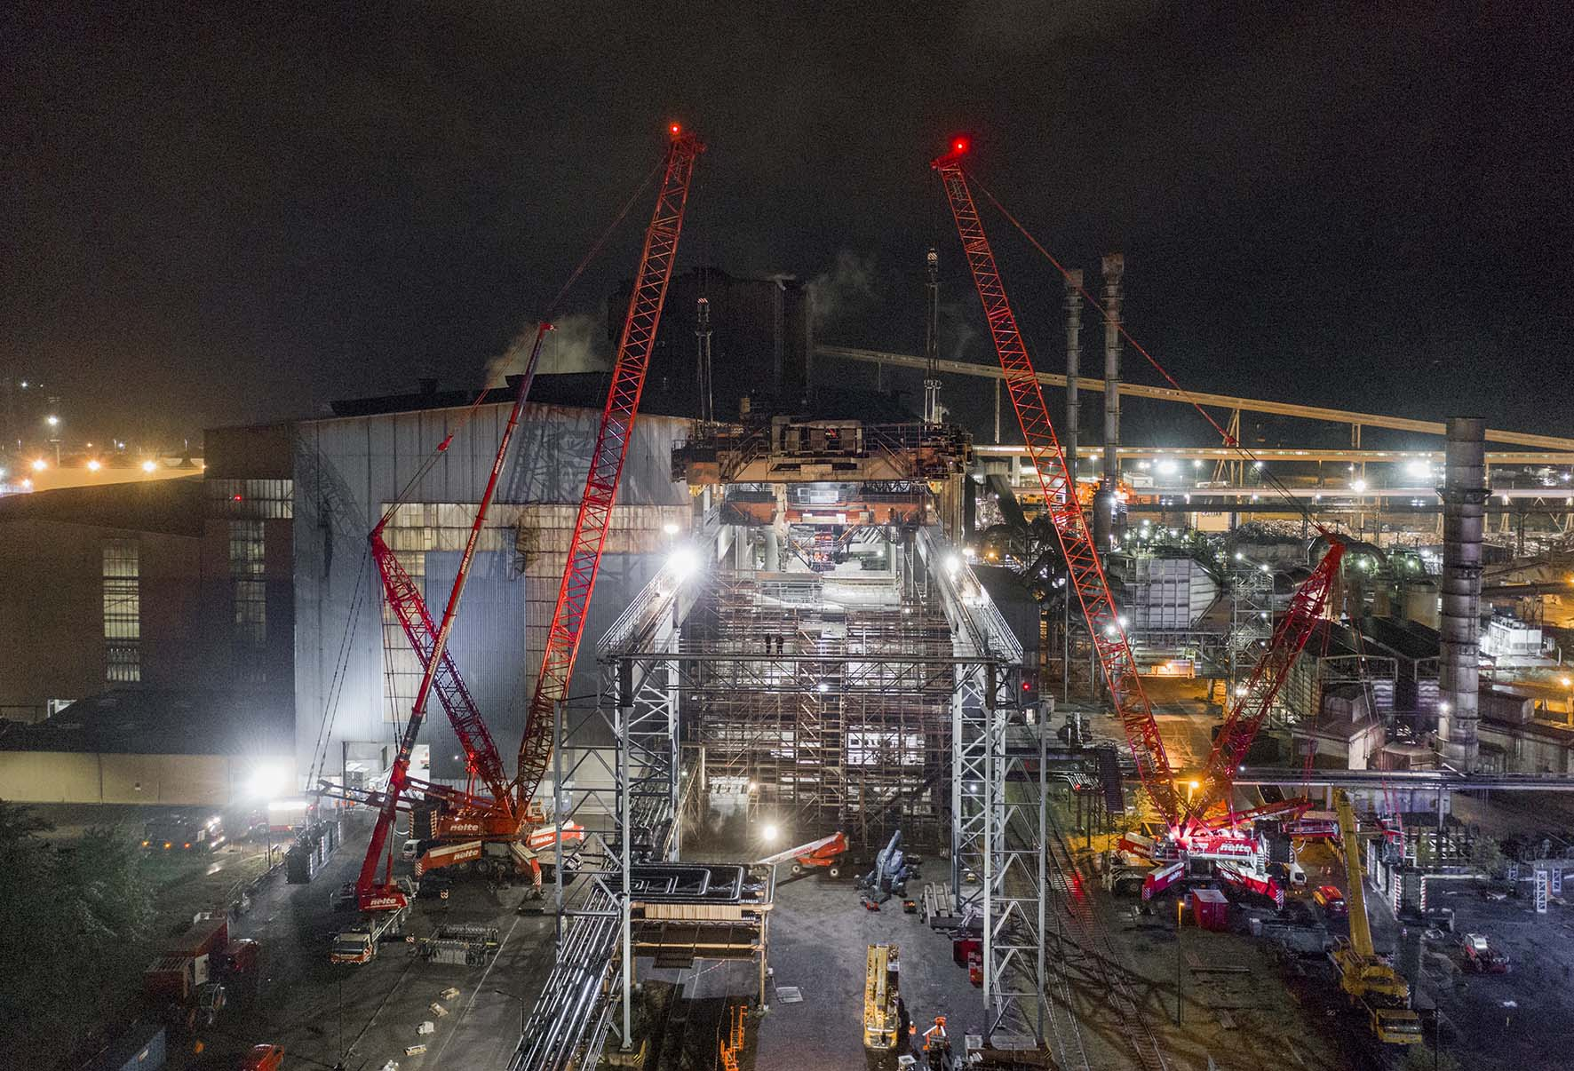
liebherr-lg-1750-nolte-6.jpg
Midnight – finally the second gantry crane can be moved under its twin after the latter had been hoisted ten metres into the air. Switching positions will give the whole system a longer service life.

Contacts
Wolfgang Beringer
Marketing and Communication
Phone: +49 7391/502 - 3663
Email: wolfgang.beringer@liebherr.com

Published by
Liebherr-Werk Ehingen GmbH
Ehingen (Donau) / Germany
www.liebherr.com

