Press release

Closing the gap – Colonia takes delivery of Liebherr LTM 1110-5.1 mobile crane

⸺
110 tonne crane closes the gap between 100 and 130 tonne mobile cranes in the fleet
High performance, boom length and compact dimensions were the main reasons behind the purchase
Long term partnership with Liebherr
Colonia Spezialfahrzeuge Gottfried Schönges GmbH & Co. KG has taken delivery of a new Liebherr LTM 1110-5.1 mobile crane. The Cologne-based company will use the new 110 tonne crane to replace an LTM 1100/1, thus closing a gap between 100 and 130 tonne machines in its fleet. The successful combination of performance, compact dimensions and length was behind the decision to buy the LTM 1110-5.1.
Ehingen (Donau), (Germany), 30 November 2021 – Colonia Managing Director Jürgen Oprée explains: “The LTM 1110-5.1 delivers excellent lifting capacity values using the counterweights it carries on the road. That is a major benefit for us because we can obtain annual road licences for our main catchment area for vehicles with a gross weight of up to 60 tonnes.” With a length of 60 metres, the telescopic boom on the LTM 1110-5.1 is one of the longest in its crane class. With a 12 tonne axle load and a gross weight of 60 tonnes, the Liebherr 110 tonne crane can carry up to 13.1 tonnes of counterweight on public roads. That is an outstanding value in the 5-axle class. It means that crane operators can complete the vast majority of crane jobs at low cost without having to transport additional ballast.
In addition to performance, Oprée also mentions the length of the telescopic boom and the compact design of the LTM 1110-5.1 as the main factors behind his company choosing the Liebherr 5-axle crane. “We are located in the middle of the chemicals belt around Cologne, Leverkusen, Dormagen and Krefeld and our cranes are often used for maintenance work in chemical plants, some of which are rather aged. The LTM 1110-5.1 stands out for these jobs due to its high performance, long telescopic boom and excellent manoeuvrability”, says Oprée.
Details solutions to make crane operator’s life easier are also important to the Colonia Managing Director: “On the new crane, Liebherr has made sure that there is plenty of storage space for fastening equipment and accessories”. Colonia has had a close business relationship with Liebherr for many years and the mobile crane fleet is dominated by the Liebherr brand. “Liebherr cranes are very user-friendly and in addition the support and service are excellent,” continues Oprée.
Colonia Spezialfahrzeuge celebrated its 75th anniversary a year ago. It all started in 1945 with a trailer built in-house and a tractor vehicle. The company bought its first mobile cranes in the 1960s. In 2020, Colonia entered the crawler crane class with the purchase of a Liebherr LR 1800-1.0. Today, the company has a 220-strong workforce providing heavy haulage and crane rental services as well as industrial installation and towing services.
About Liebherr-Werk Ehingen GmbH
Liebherr-Werk Ehingen GmbH is a leading manufacturer of mobile and crawler cranes. Its range of mobile cranes extends from 2-axle 35 tonne cranes to heavy duty cranes with a lifting capacity of 1200 tonnes and a 9-axle chassis. Its lattice boom cranes on mobile or crawler crane chassis deliver lifting capacities of up to 3000 tonnes. With universal boom systems and extensive additional equipment, they can be seen in action on construction sites throughout the world. The Ehingen site has a workforce of 3,500. Extensive, global service guarantees the high availability of Liebherr mobile and crawler cranes. In 2020, the Liebherr plant in Ehingen recorded a turnover of 2.03 billion euros.
About the Liebherr Group
The Liebherr Group is a family-run technology company with a widely diversified product range. The company is one of the largest manufacturers of construction machines in the world, but also supplies technically advanced, user-focused products and services in many other sectors. The group currently comprises more than 140 companies based in every continent of the world, has a workforce of around 48,000 and recorded a consolidated total turnover of more than 10.3 billion euros in 2020. Since it was founded in 1949 in Kirchdorf an der Iller in southern Germany, Liebherr’s aim has been to win customers by supplying high quality solutions and to contribute to technological progress.

Photograph:
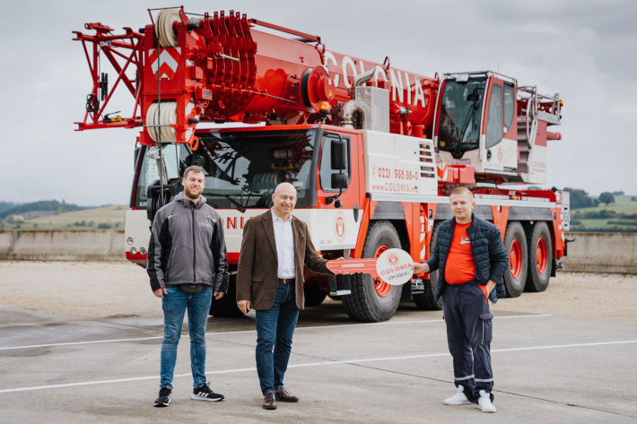
liebherr-ltm1110-5-1-colonia-handover.jpg
Crane handover at the Liebherr plant in Ehingen: From left to right: Aaron Golke (Colonia Spezialfahrzeuge, Erich Schneider (Liebherr-Werk Ehingen GmbH), Adrian Karol Konczak (Colonia Spezialfahrzeuge). The local coronavirus regulations were satisfied at all times.

Contacts
Wolfgang Beringer
Marketing and Communication
Phone: +49 7391/502 - 3663
Email: wolfgang.beringer@liebherr.com
Published by
Liebherr-Werk Ehingen GmbH
Ehingen (Donau) / Germany
www.liebherr.com

