Press release

Liebherr-Aerospace to Supply Heat Exchangers for Space Inspire Telecommunication Satellites

⸺
Liebherr-Aerospace signed a contract with European space manufacturer Thales Alenia Space to provide heat exchangers for an innovative thermal control device of Space Inspire, short for “INstant SPace In-orbit REconfiguration”.
Toulouse (France), 25 November 2021 – Liebherr-Aerospace Toulouse SAS, based in Toulouse (France), and Thales Alenia Space, a joint venture between Thales (67 %) and Leonardo (33 %), have signed a contract in which Liebherr will be the supplier of exchangers for Space Inspire.
Space Inspire is Thales Alenia Space’s new product line of telecommunications satellites, developed with the support of French and European Space Agencies CNES and ESA that will allow seamless telecommunication mission and services reconfiguration, instant in-orbit adjustment to the demand, unprecedented flexibility for video broadcasting and broadband connectivity services. Space Inspire is part of the new satellite family of Software Defined Satellites (SDS). Onboard Space Inspire is an innovative thermal control concept using several types of exchangers.
With the support of the French Plan d’Investissements d’Avenir (PIA) led by the Centre National d’Etudes Spatiales and in collaboration with Thales Alenia Space, Liebherr-Aerospace has been investing in Research and Development of brand-new heat exchangers that meet the extreme demands of Space Inspire. Such demands include the ability to operate for at least 15 years without any type of maintenance while in space. This means that they must be completely free from leakage, extremely reliable - even during a rocket launch - and be able to operate flawlessly during this long period at high heat-exchange performances.
The thermal control sub-system function on a satellite is to maintain electronics payload installed in the satellite in a specific temperature range. Exchangers ensure the collection of the electronics power and its distribution to thermal radiators.

Since the partnership with Thales Alenia Space and Centre National d’Etudes Spatiales (CNES) was formed last year, Liebherr-Aerospace’s new exchangers have come a long way, passing thermal performance and mechanical robustness standards, with an enhanced design and weight optimization.
The telecommunication satellite fast-moving market is increasingly demanding in terms of reliability, high quality control and cost competitiveness. Liebherr has developed a whole new industrial manufacturing process that is both innovative and highly repeatable to be able to serially produce exchangers that meet such demands, focusing on reducing weight and cost while further increasing reliability.
Liebherr-Aerospace continues to invest in innovative heat exchangers aiming to further optimize thermal performances, weight, and cost from which not only geostationary telecommunication satellites, but also satellite constellations and manned space stations will benefit.

About Thales Alenia Space
Drawing on over 40 years of experience and a unique combination of skills, expertise and cultures, Thales Alenia Space delivers cost-effective solutions for telecommunications, navigation, Earth observation, environmental management, exploration, science and orbital infrastructures. Governments and private industry alike count on Thales Alenia Space to design satellite-based systems that provide anytime, anywhere connections and positioning, monitor our planet, enhance management of its resources, and explore our Solar System and beyond. Thales Alenia Space sees space as a new horizon, helping to build a better, more sustainable life on Earth. A joint venture between Thales (67%) and Leonardo (33%), Thales Alenia Space also teams up with Telespazio to form the parent companies’ Space Alliance, which offers a complete range of services. Thales Alenia Space posted consolidated revenues of approximately 1.85 billion euros in 2020 and has around 7,700 employees in 18 sites in 11 countries across Europe and a plant in the USA. www.thalesaleniaspace.com
About Liebherr-Aerospace & Transportation SAS
Liebherr-Aerospace & Transportation SAS, Toulouse (France), is one of eleven divisional control companies within the Liebherr Group and coordinates all activities in the aerospace and transportation systems sectors.
Liebherr-Aerospace is a leading supplier of systems for the aviation industry and has more than six decades of experience in this field. The range of aviation equipment produced by Liebherr for the civil and military sectors includes flight control and actuation systems, gears and gearboxes, landing gear and air management systems as well as electronics. These systems are deployed in wide-bodied aircraft, single aisle and regional aircraft, business jets, combat aircraft, military transporters, military training aircraft, civil helicopters and combat helicopters.
Liebherr’s aerospace and transportation systems division employs around 6,000 people. It has four aviation equipment production plants at Lindenberg (Germany), Toulouse (France), Guaratinguetá (Brazil) and Nizhny Novgorod (Russia). These production sites offer a worldwide service with additional customer service centers in Saline (Michigan/USA), Seattle (Washington/USA), Montreal (Canada), Hamburg (Germany), Moscow (Russia), Dubai (UAE), Bangalore (India), Singapore and Shanghai (People’s Republic of China).

About the Liebherr Group
The Liebherr Group is a family-run technology company with a highly diversified product portfolio. The company is one of the largest construction equipment manufacturers in the world. It also provides high-quality and user-oriented products and services in a wide range of other areas. The Liebherr Group includes over 140 companies across all continents. In 2020, it employed around 48,000 staff and achieved combined revenues of over 10.3 billion euros. Liebherr was founded in Kirchdorf an der Iller in Southern Germany in 1949. Since then, the employees have been pursuing the goal of achieving continuous technological innovation, and bringing industry-leading solutions to its customers.

Image
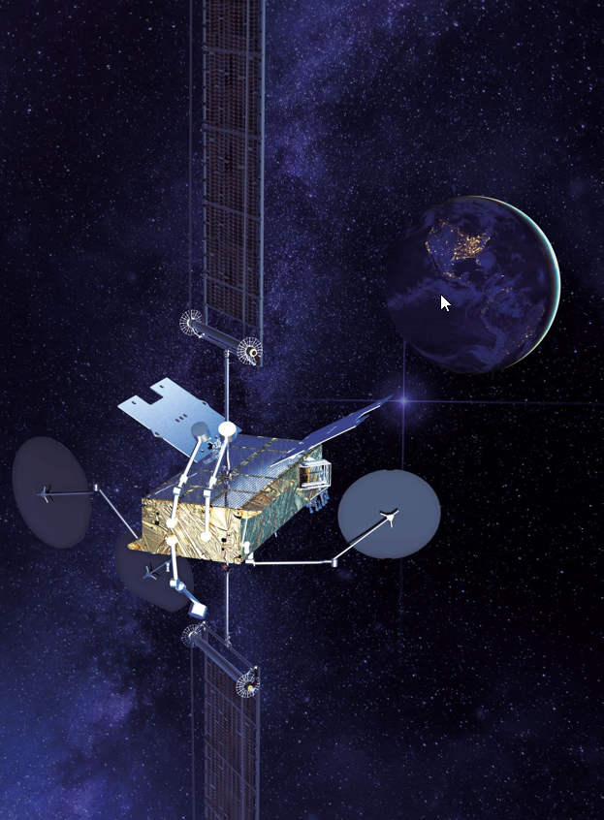
Thales-Space Inspire 2 light-copyright-Thales-Alenia-Space-Nov2021.jpg
Liebherr supplies exchangers for Space Inspire telecommunication satellites. - © Thales Alenia Space

Contact
Ute Braam
Corporate Communication
Phone: +49 8381 / 46 - 4403
E-Mail: ute.braam@liebherr.com
Published by
Liebherr-Aerospace & Transportation SAS
Toulouse / France
www.liebherr.com

