Press release

New cranes to celebrate company anniversary – Hanyš updates fleet with Liebherr cranes

⸺
Czech crane rental contractor Hanyš places order for 18 cranes from Ehingen
The first cranes will be delivered in the company’s 30th anniversary year
Liebherr and Hanyš have had a partnership for over 27 years
By the end of 2021, Czech crane rental and heavy haulage contractor Hanyš will have almost 100 Liebherr cranes at its yard. And the fleet will continue to grow – 18 more Liebherr cranes will be added in the year of the company’s 30th anniversary.
Ehingen (Donau) (Germany), 24 November 2021 – 30 years ago, on 4 July 1991, the Hanyš family started its crane rental business in the Czech capital Prague. Today, Hanyš has 20 sites in Czechia and one in Slovakia offering crane and heavy haulage services. Additional Czech sites will be added starting in 2022. And the crane rental contractor needs new machines for them. 18 Liebherr cranes will shortly be updating and strengthening the fleet, representing the largest order in Hanyš corporate history. The range extends from the 30 tonne LTM 1030-2.1 to an LG 1750 lattice boom mobile crane. All the cranes will be delivered over the next few months.
It all started with an LTM 1070/1
“After I officially founded Hanyš in July 1991, my first crane was an AD 20. The truck-mounted crane on a Tatra chassis had a lifting capacity of 20 tonnes. We quickly added a second crane, and AD 28, followed by a Coles 64 T. And then I saw a Liebherr LTM 1070/1 for the very first time. It was an accident-damaged crane which was standing in the yard at KLIMEX CZ. I decided I had to stop and take a closer look at that crane”, says Rostislav Hanyš, founder and proprietor of Hanyš. “At the time, we took back the all-terrain crane as an accident-damaged crane, we repaired it and finally sold it to Hanyš”, says Karel Kladiva, the proprietor of Liebherr dealer KLIMEX CZ. “That marked the start of our partnership, which continues today and is growing ever closer”, continues Hanyš. “It quickly became clear to me that Liebherr is the number one in the market for mobile and crawler cranes. And I want to be the leading crane rental contractor in Czechia. If you want to be number one, you need top quality machinery and equipment. That is why the LTM 1070/1 marked the start of our partnership – and today we have lots of cranes, almost all of them supplied by Liebherr.”

Hanyš relies on both time-tested and new Liebherr technology
There are plenty of bestsellers among the 18 models – proven LTM models such as the LTM 1030-2.1, the bestselling all-terrain crane in the world, the LTM 1055-3.2 and the LTM 1070-4.2. The LTC 1050-3.1 is the outstanding machine in the compact crane class, whilst the LTR 1060 takes the honours among telescopic crawler cranes. But Hanyš is also very interested in acquiring the very latest technology. The order also includes the LTM 1120-4.1, which was first unveiled in 2020, and the LTM 1230-5.1, which was demonstrated for the first time at the Bauma in 2019. The new large order will not only extend the fleet but, in some cases, it also includes replacements for old cranes. “We want to provide our customers with top technology at all times. We need good cranes for that, which is why we are continually upgrading our fleet. We now have almost 100 Liebherr cranes in our fleet, operating throughout Czechia and Slovakia”, says Milan Hanyš, who now manages the company alongside his father. Over the last five years, Hanyš has taken delivery of around 60 Liebherr cranes.
Fleet dominated by Liebherr
Today, the fleet comprises 108 cranes, 98 percent have been supplied by Liebherr. In addition to telescopic cranes with lifting capacities between 30 and 500 tonnes, from the LTM 1030-2.1 to the LTM 1500-8.1, Hanyš has also been working with three Liebherr crawler cranes since 2016 – an LR 1750, an LG 1550 and, now also an LG 1750, which was delivered this year to supplement the company’s portfolio of lattice boom cranes. The main reason behind the range of Liebherr cranes is ensuring customer satisfaction, for which Hanyš needs machines which ooze quality, high standards and safety. Hanyš has a total workforce of over 220 people located at its sites throughout Czechia. In addition to crane work, they also provide heavy haulage services using the company’s own fleet of 30 vehicles.
About Liebherr-Werk Ehingen GmbH
Liebherr-Werk Ehingen GmbH is a leading manufacturer of mobile and crawler cranes. Its range of mobile cranes extends from 2-axle 35 tonne cranes to heavy duty cranes with a lifting capacity of 1200 tonnes and a 9-axle chassis. Its lattice boom cranes on mobile or crawler crane chassis deliver lifting capacities of up to 3000 tonnes. With universal boom systems and extensive additional equipment, they can be seen in action on construction sites throughout the world. The Ehingen site has a workforce of 3,500. Extensive, global service guarantees the high availability of Liebherr mobile and crawler cranes. In 2020, the Liebherr plant in Ehingen recorded a turnover of 2.03 billion euros.
About the Liebherr Group
The Liebherr Group is a family-run technology company with a widely diversified product range. The company is one of the largest manufacturers of construction machines in the world, but also supplies technically advanced, user-focused products and services in many other sectors. The group currently comprises more than 140 companies based in every continent of the world, has a workforce of around 48,000 and recorded a consolidated total turnover of more than 10.3 billion euros in 2020. Since it was founded in 1949 in Kirchdorf an der Iller in southern Germany, Liebherr’s aim has been to win customers by supplying high quality solutions and to contribute to technological progress.

Photograph
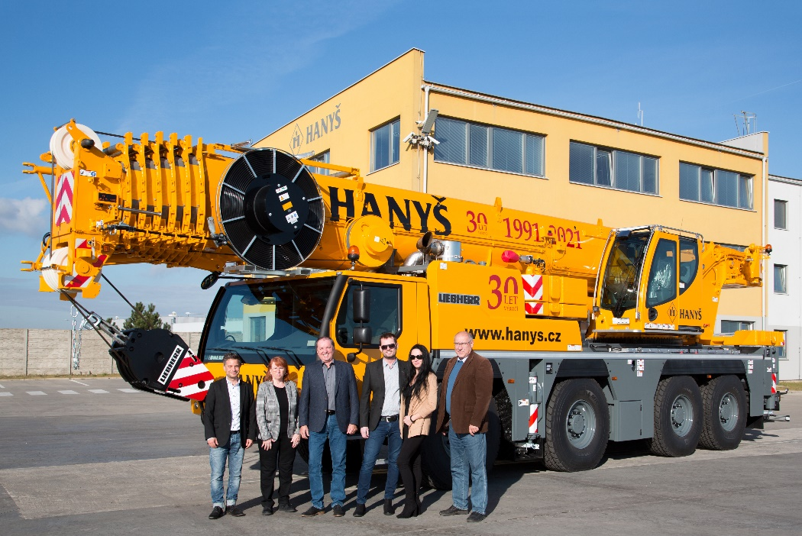
liebherr-hanys.jpg
Handover in Ehingen – Hanyš takes delivery of additional Liebherr cranes for its fleet, (from left to right): Thomas Fiesel (Liebherr-Werk Ehingen GmbH), Alena Hanyšová, Rostislav Hanyš, Milan Hanyš, Jitka Hanyšová (alle Hanyš), Karel Kladiva (KLIMEX CZ). The locally applicable Corona specifications were complied with.

Contacts
Wolfgang Beringer
Marketing and Communication
Phone: +49 7391/502 - 3663
Email: wolfgang.beringer@liebherr.com
Published by
Liebherr-Werk Ehingen GmbH
Ehingen (Donau) / Germany
www.liebherr.com

