Press release

Successful in Latin America – high number of Liebherr mobile cranes heading for Chile

⸺
Mobile cranes in high demand for mining and wind power
In 2021, Liebherr has delivered an above average number of mobile cranes to Chile
Being close to customers and outstanding service in Latin America pay dividends
There is high demand for mobile cranes in Latin America for the mining industry and for erecting wind turbines. Liebherr is based close to its customers in the region and also delivers reliable after sales service. The global market leader has delivered an above average number of mobile cranes to Chile this year, in particular.
Ehingen (Donau) (Germany), 16 November 2021 – Chile is one of the leading economies in Latin America and one of the largest raw materials producers in the world. Felix Mussotter, who is responsible for Latin America in his role as Sales Representative for Liebherr-Werk Ehingen GmbH, says: “Chile has 40 % of the established copper reserves in the world. It has the largest copper mine in the world. In addition, Chile is increasingly turning to renewable energy. This means that there is a wide range of applications for mobile cranes, for example for assembling and servicing large mining machines and for erecting wind turbines. Sales of mobile cranes in Chile is above average this year.”
Special challenges
Chile is a country full of geographical peculiarities. Only 120 kilometres wide on average, it reaches a north-south extension of over 4,200 kilometres with deserts, forests and eternal ice. The majority of the country consists of mountains up to 6900 metres in height. Fitted with special equipment, Liebherr machines and cranes have to satisfy high requirements, such as working at high altitudes and in extremely low temperatures.
“We are naturally delighted with all the orders, but it is a genuine logistical challenge to ship so many cranes at the same time – starting from the shipping company to handing them over to the customer”, says Hubertus von Sperber, Head of the Mobile Crane Division at Liebherr in Chile.

Local service and innovative products for customers throughout Chile
Liebherr attaches particular value to close contacts with its South American customers and providing them with local support. Von Sperber continues: “Our customers appreciate the direct support from Liebherr. We keep spare parts in stock in the individual countries and the service technicians are trained at Liebherr, i.e. directly by the crane manufacturer. That enables us to enter into long term partnerships with our customers.”
Daniel Vega, owner of crane rental company MPM based in the capital, Santiago de Chile confirms this: “Local service from Liebherr is very important. That is why Liebherr is an important strategic partner for us.” MPM bought its first new Liebherr mobile crane in 2017. “Today we have ten mobile cranes with lifting capacities between 100 and 1200 tonnes. We prefer Liebherr cranes as a result of their high safety standards, progressive crane technology and their reliability.”
Family-run Burger Grúas is also based in Santiago de Chile and operates 30 Liebherr mobile cranes with lifting capacities between 50 and 700 tonnes. Company owner Raul Burger says: “Our fleet is mainly composed of Liebherr cranes and we use them in various projects from mining and industry to renewable energy. Once again this year, we have made some big investments – we have bought an LTM 1650-8.1, two LTM 1230-5.1s, three LTM 1120-4.1s and an LTM 1060-3.1. Our aim is to provide our customers with the best possible service. That means we require the latest and most innovative technology available on the market.”
Liebherr has had a close partnership with Grúas Desmadryl based in Santiago de Chile since 2006. Company owner Enrique Desmadryl says: “Currently our fleet consists of 22 cranes, including the LRT 1100-2.1 rough terrain crane and the 9-axle LTM 1750-9.1 mobile crane. We decided on Liebherr as a result of its innovative products and progressive crane technology as well as the superb support its service team provides. These points are essential for us to enable us to be there all the time for our customers and react to their needs quickly.”
Liebherr in Chile
Being close to the customer and providing reliable after sales service are important factors behind Liebherr’s global success. Liebherr has a tight network of service outlets in Latin America as well. Liebherr employs more than 400 people in Chile. The majority of them are based in the workshops at large copper mines providing maintenance services for Liebherr dump trucks and mining excavators. Liebherr Chile S.p.A. based in the capital Santiago is responsible for the sales and service of mining machines, maritime cranes, tower cranes as well as mobile and crawler cranes in Chile and neighbouring markets. The company has a customer service centre specially for mobile and crawler cranes In the north of the capital near the international airport and right on the motorway. In addition, Liebherr provides service to its mining customers from La Negra, another site in the north of the country.
About Liebherr-Werk Ehingen GmbH
Liebherr-Werk Ehingen GmbH is a leading manufacturer of mobile and crawler cranes. Its range of mobile cranes extends from 2-axle 35 tonne cranes to heavy duty cranes with a lifting capacity of 1200 tonnes and a 9-axle chassis. Its lattice boom cranes on mobile or crawler crane chassis deliver lifting capacities of up to 3000 tonnes. With universal boom systems and extensive additional equipment, they can be seen in action on construction sites throughout the world. The Ehingen site has a workforce of 3,500. Extensive, global service guarantees the high availability of Liebherr mobile and crawler cranes. In 2020, the Liebherr plant in Ehingen recorded a turnover of 2.03 billion euros.
About the Liebherr Group
The Liebherr Group is a family-run technology company with a widely diversified product range. The company is one of the largest manufacturers of construction machines in the world. However, it also supplies high quality, user-focused products and services in many other sectors. The group currently comprises more than 140 companies based in every continent of the world. In 2020, it had a workforce of around 48,000 and recorded a consolidated total turnover of more than 10.3 billion euros. The company was founded in 1949 in Kirchdorf an der Iller in southern Germany. Since then, its,aim has been to win customers by supplying high quality solutions and to contribute to technological progress.

Photographs
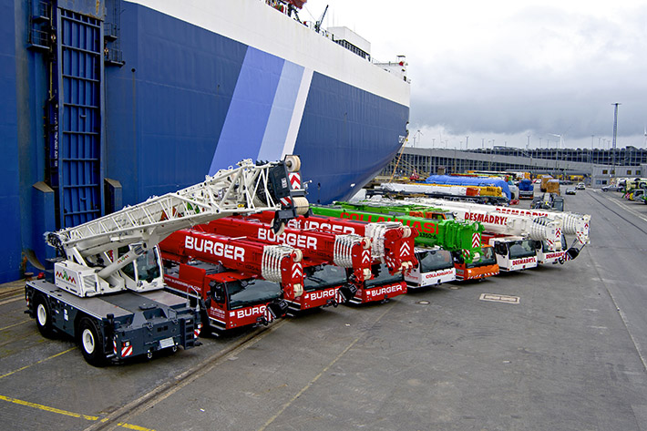
liebherr-mobile-cranes-chile1.jpg
Liebherr mobile cranes wait at the port of Bremerhaven to be shipped to Chile.

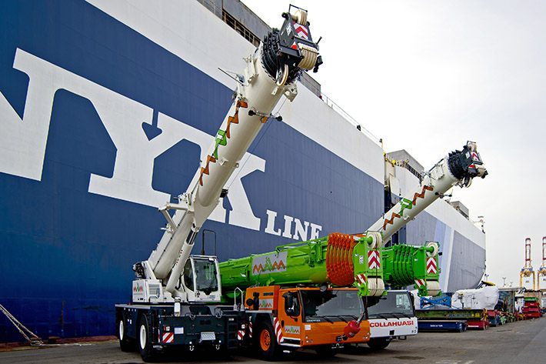
liebherr-mobile-cranes-chile2.jpg
All-terrain and rough terrain cranes are used widely in mining and in the regenerative energy sector in Latin America.

Contacts
Wolfgang Beringer
Marketing and Communication
Phone: +49 7391/502 - 3663
Email: wolfgang.beringer@liebherr.com

Published by
Liebherr-Werk Ehingen GmbH
Ehingen (Donau) / Germany
www.liebherr.com

