Press information

CMI Energia acquires first LR 1600/2 in Honduras

⸺
Expanded maintenance capabilities in Central America
LR 1600/2 rounds up the fleet of Liebherr cranes in CMI Energia
Quick setup and high flexibility of the crawler crane are key points for CMI Energia's operations
Being the first Liebherr crawler crane for CMI Energia, the LR 1600/2 will play an important role for the central american energy company. Already owning a small fleet of Liebherr LTM mobile cranes, the 600 t crawler will be used for maintenace work in wind parks as well as for repowering and new installation of wind turbines in Central America.
Ehingen (Donau) (Germany), 12. November 2021 – The 600 t crawler crane is the new highlight in the crane fleet of CMI Energia in Honduras. Beeing tasked with maintenance, repowering and the installation of new wind turbines, the LR 1600/2 will play a major role in the further development of CMI Energia. As a crane of this class is not currently available in the region, CMI decided to invest in a used Liebherr crawler crane to ensure a quick and flexible solution for the many wind power installations.
Key arguments for the LR 1600/2
As larger cranes are needed to take over all the maintenance jobs in the existing wind farms in Honduras, but also to install new wind turbines, the decision to buy a 600 t crawler crane was not an easy one for CMI Energia. Already owning a small fleet of two LTM 1050-3.1, a LTM 1350-6.1 and a LTM 1500-8.1, the Liebherr brand was already quite familiar for CMI Energia. “Being a brand with high prestige in providing perfect solutions for the wind industry and based on our previous experiences with the Liebherr after sales in our region, we based our decision on trust and a well-established partnership”, explains Jay Gallegos, CEO, CMI Energia.
“With this type of crane, we can react quickly and efficiently to the maintenance needs of our assets in the region. This type of crane has not been not easily available to us before, and the costs to ship such a crane in for a job are very high”, Gallegos continues: “The flexibility of adapting this crane to the different needs of maneuvers with wind turbines and the robustness to safely carry out these maneuvers, even in moderate wind conditions are most important to us. Therefore we’ve opted for an used LR 1600/2, knowing about the great service and well established Liebherr people also in the used crane business”, explains Gallegos.

Ready to turn the key
Beeing well looked after by the Liebherr used crane experts, the LR 1600/2 was purchased with a SL3 boom configuration. “This is a very well established, flexible and safe configuration for wind power jobs”, explains Jens Könneker, product manager crawler cranes at the Liebherr plant in Ehingen. In addition, a derrick boom system and an extra counterweight tray was delivered to CMI Energia to allow the service of even the larger turbines in CMI’s portfolio.
Employing roughly 400 people in the Energy Business Unit, CMI Energia is one of the largest private renewable energy companies in Central America and the Caribbean. The main focus of CMI Energia is the development, operation and maintenance of renewable energy assets.
About Liebherr-Werk Ehingen GmbH
Liebherr-Werk Ehingen GmbH is a leading manufacturer of mobile and crawler cranes. Its range of mobile cranes extends from 2-axle 35 tonne cranes to heavy duty cranes with a lifting capacity of 1200 tonnes and a 9-axle chassis. Its lattice boom cranes on mobile or crawler crane chassis deliver lifting capacities of up to 3000 tonnes. With universal boom systems and extensive additional equipment, they can be seen in action on construction sites throughout the world. The Ehingen site has a workforce of 3,600. Extensive, global service guarantees the high availability of Liebherr mobile and crawler cranes. In 2020, the Liebherr plant in Ehingen recorded a turnover of 2 billion euros.
About the Liebherr Group
The Liebherr Group is a family-run technology company with a widely diversified product range. The company is one of the largest manufacturers of construction machines in the world, but also supplies technically advanced, user-focused products and services in many other sectors. The group currently comprises more than 140 companies based in every continent of the world, has a workforce of around 48,000 and recorded a consolidated total turnover of more than 10.3 billion euros in 2020. Since it was founded in 1949 in Kirchdorf an der Iller in southern Germany, Liebherr’s aim has been to win customers by supplying high quality solutions and to contribute to technological progress.
Pictures
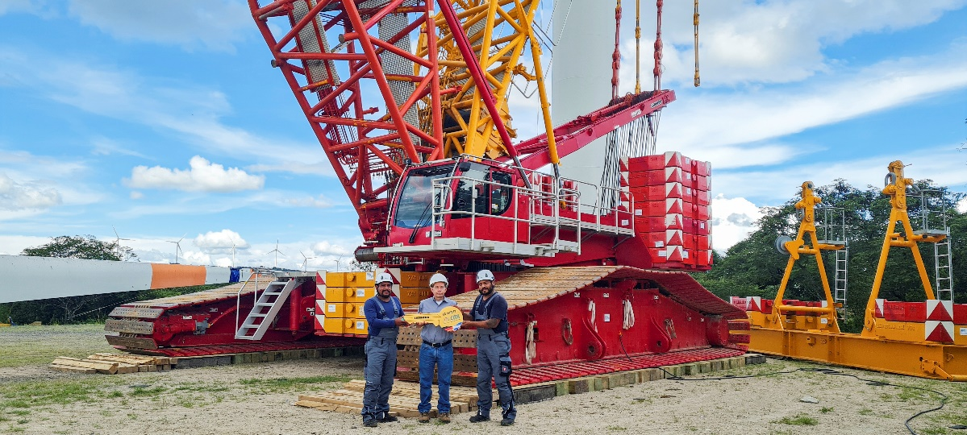
liebherr-lr1600-2-handover-honduras-1.jpg
From left to right: Roberto Flores (field technician Liebherr-Mexico), Santos del Cid (CMI Honduras), Carlos Fermin (field technician Liebherr-Mexico) at the handover of the LR 1600/2 in Honduras. The locally applicable Corona specifications were complied with.

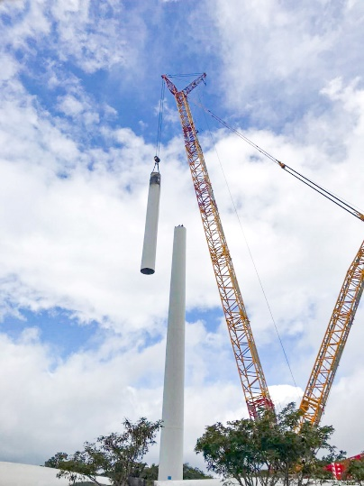
liebherr-lr1600-2-handover-honduras-2.jpg
First job: The new LR 1600/2 from CMI Energia will have its place in the wind power industry in Central America.

Contact
Wolfgang Beringer
Marketing and Communication
Telefon: +49 7391/502 - 3663
E-Mail: wolfgang.beringer@liebherr.com

Published by
Liebherr-Werk Ehingen GmbH
Ehingen (Donau) / Deutschland
www.liebherr.com

