Press release

Premiere in Canada – Guay takes delivery of its first two LTM 1110-5.1 mobile cranes
⸺
LTM 1110-5.1 replaces 120 tonne (135 US-tons) mobile cranes
Powerful 60 meter (187 ft) telescopic boom, VarioBase®Plus technologie and suitable axle load were the main criteria behind the purchase decision
The Liebherr team is always close at hand and provides outstanding service
Crane and heavy haulage contractor Guay Inc. has taken delivery of two Liebherr LTM 1110-5.1 cranes. They are the first cranes of this type in Canada. The 60 meter (197 ft) telescopic boom and high lifting capacities of the Liebherr 110 tonne (125 US-tons) machine were important criteria behind the Québec-based company buying the cranes. The new cranes will replace ageing 120 tonne (135 US-tons) cranes in Guay’s fleet, which comprises more than 500 cranes of different types.
Ehingen (Donau) (Germany), 10 November 2021 – The design of the Liebherr LTM 1110-5.1 has some features which are perfect for the Province of Quebec. Guillaume Gagnon, Vice-Presidentat Guay explains: “In our market, a 110 tonne (125 US-tons) crane is the largest mobile crane in which an apprentice can work as the second man in the crane alongside the operator. In addition, the axle loads and the weight distribution of the LTM 1110-5.1 are absolutely perfect and mean that we don’t have to use a boom dolly.”
A long boom system twinned with high lifting capacities was also one of the reasons for Guay to make the purchase. “We can cover a similar range of work with the LTM 1110-5.1 as with our 120 tonne (135 US-tons) crane, and its main boom is 60 meters (197 ft) long, which is normally one that only larger cranes can match. Its capacity of 110 tonnes (125 US-tons) makes this the perfect crane for us to recruit new apprentices for our team”, says Gagnon.
Guay is planning to use the new crane, among other things, in the centre of Montreal for hoisting work involving great heights and ranges. With the VarioBase®Plus variable supporting base, it can also be used on sites where there is restricted space for erecting the crane. VarioBase®Plus not only generates greater safety levels, but also allows higher lifting capacities, particularly when working above the outriggers.

The LTM 1110-5.1 in figures
The LTM 1110-5.1 achieves axle loads of 12 tonnes (26,400 lb) with 13.4 tonnes (29,500 lb) of ballast, but can also be driven with a gross weight of less than 48 tonnes (105,800 lb) with a maximum axle load of 10 tonnes (22,000 lb). Even with maximum ballast of 29 tonnes (63,900 lb), its axle load remains below 16 tonnes (35,300 lb). A quick-change system for the ballast slabs ensures maximum flexibility for changing the crane’s set-up. Although the new LTM 1110-5.1 is such a lightweight construction that it achieves a gross weight of 48 tonnes (105,800 lb) , its 60 meters (197 ft) telescopic boom and maximum ballast of just 29 tonnes (63,900 lb) enable it to rival the performance of similar mobile cranes on the market.
The telescopic boom on the LTM 1110- 5.1 is one of the longest in its crane class. In addition, it can be supplied with a 10.8 to 19 meters (35 to 62 ft) folding jib. Two 7-meters (23 ft) lattice sections can also be installed to extend the telescopic boom to achieve the maximum hook height. This means that the LTM 1110-5.1 mobile crane can nominally achieve the same system length as larger cranes.
About Guay Inc.
The company has a 500-strong workforce and operates more than 500 cranes of various types. The very first Liebherr mobile crane that Guay bought was also the largest in the Liebherr portfolio, an LTM 11200-9.1, followed by an LTM 1500-8.1 and smaller LTM cranes. The number of Liebherr cranes is growing steadily. Guay has already ordered two more LTM 1110-5.1 models. “Liebherr products are reliable and have some of the most advanced technologies available on all-terrain cranes. We received fantastic support from Liebherr Canada, the sales team and from the service team”, explains Gagnon.
Guay Inc. is one of the largest privately owned crane contractors in North America with more than 20 branches in the Province of Quebec. After 58 years, company founder Jean-Marc Baronet is still the owner and still has the same passion for investing in new equipment and providing his customers with the best cranes on the market.

About Liebherr-Werk Ehingen GmbH
Liebherr-Werk Ehingen GmbH is a leading manufacturer of mobile and crawler cranes. Its range of mobile cranes extends from 2-axle 35 tonne cranes to heavy duty cranes with a lifting capacity of 1200 tonnes and a 9-axle chassis. Its lattice boom cranes on mobile or crawler crane chassis deliver lifting capacities of up to 3000 tonnes. With universal boom systems and extensive additional equipment, they can be seen in action on construction sites throughout the world. The Ehingen site has a workforce of 3,500. Extensive, global service guarantees the high availability of Liebherr mobile and crawler cranes. In 2020, the Liebherr plant in Ehingen recorded a turnover of 2.03 billion euros.
About the Liebherr Group
The Liebherr Group is a family-run technology company with a widely diversified product range. The company is one of the largest manufacturers of construction machines in the world, but also supplies technically advanced, user-focused products and services in many other sectors. The group currently comprises more than 140 companies based in every continent of the world, has a workforce of around 48,000 and recorded a consolidated total turnover of more than 10.3 billion euros in 2020. Since it was founded in 1949 in Kirchdorf an der Iller in southern Germany, Liebherr’s aim has been to win customers by supplying high quality solutions and to contribute to technological progress.

Photograph
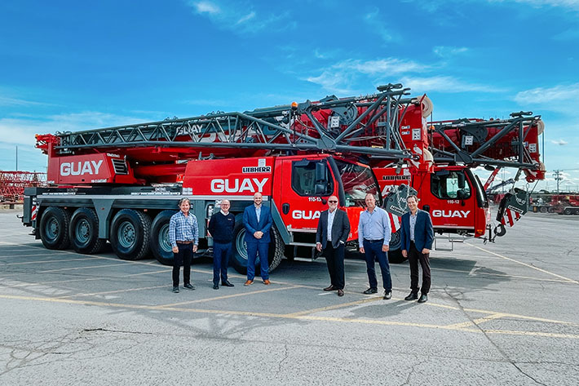
liebherr-ltm1110-5-1-guay-handover.jpg
From left to right: Lee Spalding, Kyle Jardine (both from Liebherr-Canada Ltd), Jean-Francois Houde, Michel Riverin, Eric Beauvais, Guillaume Gagnon (all from Guay Inc.). The locally applicable Corona specifications were complied with.

Contact person
Wolfgang Beringer
Marketing and Communication
Phone: +49 7391/502 - 3663
Email: wolfgang.beringer@liebherr.com

Published by
Liebherr-Werk Ehingen GmbH
Ehingen (Donau) / Germany
www.liebherr.com

