Press release

Jubilee: Excavator marking 60 years of Liebherr in France handed over to the Chavaz Père et Fils company

⸺
Special design : The R 960 SME with a design from the sixties
A decision of convinction
Chavaz Père et Fils, a company in the quarrying industry for generations
An R 960 SME designed in a 1960s “vintage” style was handed over to Chavaz, a customer specialising in quarrying. This special model, produced at Liebherr’s historic site in France, celebrates the brand’s 60 years in the country.
Colmar (France), 28 October 2021 – The handover of the R 960 SME crawler excavator to our long-standing client Chavaz Père et Fils marks Liebherr’s 60 years in France. At the avenue Joseph Rey in Colmar since 1961, this site is synonymous with local and national expertise in the development and production of the Liebherr Group’s earthmoving crawler excavators for the whole world.
A special design for a jubilee
The 60th anniversary of Liebherr in France is highlighted by the special design of this R 960 SME crawler excavator. With a “vintage” look, the Chavaz Père et Fils crawler excavator sports 1960sAgainst a grey background, the retro-modern fusion depicts the philosophy of the Liebherr brand, a company that is innovative while also proud of its origins and roots.
Emphatically “Made in France”, this very special 60 tonne machine’s components are painted in the colours of the country where it was manufactured. The excavator’s counterweight, undercarriage and uppercarriage have a blue, white and red trim, as an indispensable and yet subtle celebration of 60 years of French quality.
“60” is a key number for this event – referring not only to the weight in tons of the machine and the decade of Liebherr’s arrival in France but also to how many years Liebherr has been in the country. That is why this number appears right in the centre of the excavator, on the counterweight, where it nestles among the French national colours.
A decision of conviction
In search of expertise and flawless quality, Chavaz Père et Fils, a company specialising in quarrying, puts its faith in Liebherr. This Liebherr customer based in the Haute-Savoie area carries out multiple activities including pick-up, loading and direct materials extraction. The customer attaches great importance to the innovation and performance of the machine.
Chavaz Père et Fils’s choice was no accident. Already the owner of an R 964 having proved itself in over 16,000 hours of use, the customer is making a repeat purchase from Liebherr. The reliability of Liebherr’s products, along with the total package of services offered by the company and its distributor Tecmat convinced.
The SME range for challenging applications
Including excavators from 42 to 100 tonnes, the SME range features four specialised models for quarrying applications. All variants have reinforced undercarriages for increased robustness, with integrated components from models higher up the standard range. In the case of the R 960 SME excavator for Chavaz Père et Fils, these components come from the 70 tonne R 966 HD excavator.
For quarrying applications and use of the larger-capacity buckets required, SME crawler excavators come equipped with a heavy counterweight. This keeps the machine stable, making it more comfortable for the operator. In line with Liebherr’s philosophy, the excavator’s movement kinematics and special SME cylinders offer more powerful digging and breakout forces that are unrivalled in this machine category on the market.
Chavaz down through the generations
Truly a family business, Chavaz began its quarrying activities on the frontier with Switzerland. Initially involved in agriculture, the company branched out into extraction work at the Mont Salève quarries in the mid-1800s.
A few hundred years later, the Chavaz brothers’ business presence would span both sides of the frontier. Over time, the company grew to become a major player in quarrying, offering a variety of quarry materials and gravels in the Geneva area.
Today, the company is engaged in a variety of sectors that complement each other, such as sale and transport of materials recycled from construction waste, sale and transport of special materials to trade and retail customers, and solutions for managing material excavated during earthmoving and waste from demolition work.

About the Liebherr Group
The Liebherr Group is a family-run technology company with a highly diversified product portfolio. The company is one of the largest construction equipment manufacturers in the world. It also provides high-quality and user-oriented products and services in a wide range of other areas. The Liebherr Group includes over 140 companies across all continents. In 2020, it employed around 48,000 staff and achieved combined revenues of over 10.3 billion euros. Liebherr was founded in Kirchdorf an der Iller in Southern Germany in 1949. Since then, the employees have been pursuing the goal of achieving continuous technological innovation, and bringing industry-leading solutions to its customers.

Images
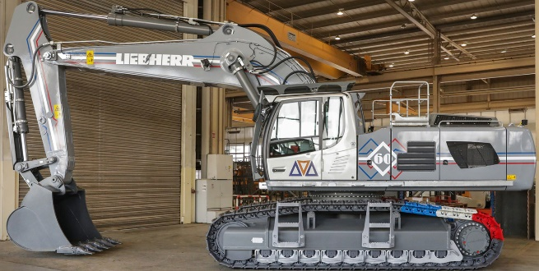
liebherr-crawler-excavator-r-960-chavaz-1.jpg
The 60th anniversary of Liebherr in France is highlighted by the special design of this R 960 SME crawler excavator.

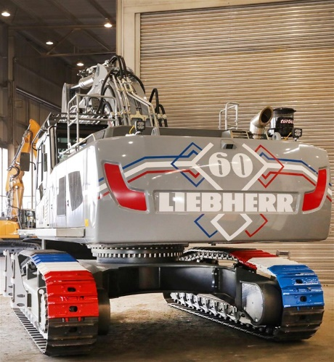
liebherr-crawler-excavator-r-960-chavaz-2.jpg
“60” is a key number for this event – referring not only to the weight in tons of the machine and the decade of Liebherr’s arrival in France but also to how many years Liebherr has been in the country.

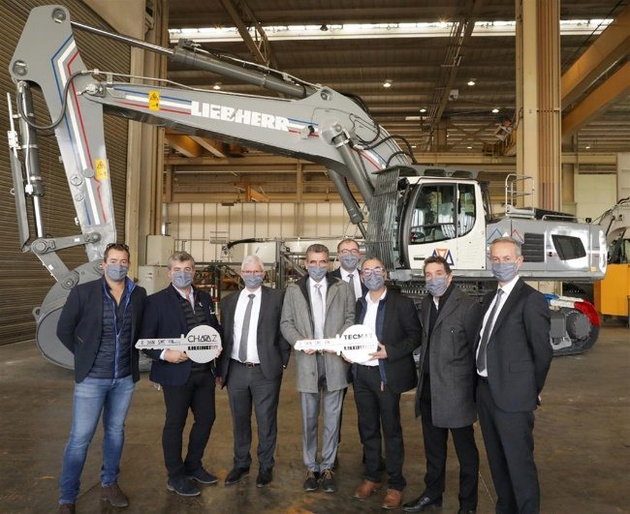
liebherr-crawler-excavator-r-960-chavaz-3.jpg
From left to right : John Chavaz, Laurent Chavaz, Martin Schickel (Liebherr-France SAS), Franck Lafabrie (Tecmat Service, David Diss (Liebherr-France SAS), François Novel (Tecmat Service), Ludovic Badey (Tecmat Service), Christophe Sanchez (Liebherr-France SAS). The locally applicable Corona specifications were complied with.

Contact
Alban Villaumé
Marketing Manager
Phone: +0033 89 21 36 09
E-Mail: alban.villaume@liebherr.com
Published by
Liebherr-France SAS
Colmar / France
www.liebherr.com

