Press release

Elephant rescue in the River Wupper – LTF 1045-4.1 hoists Tuffi back onto her plinth

⸺

Wilden Kran-Vermietung GmbH uses LTF 1045-4.1 to hoist elephant sturgeon stone back into position
The sculpture was torn out of its anchoring in the July floods
Sturgeon stones improve the river’s own dynamic
The “Tuffi” elephant sturgeon stone has been back on its plinth since the end of September. The floods in July had torn the sculpture out of its anchoring in the River Wupper. Wilden Kran-Vermietung GmbH supported the rescue action using a Liebherr LTF 1045-4.1 truck mounted telescopic crane. It hoisted the artwork weighing 3.5 tonne and measuring 1.8 metres in height out of the water and put back in its original position in the river below the Wuppertal suspension railway.
Ehingen (Donau) (Germany), 12 October 2021 – Since 2019, there have been several odd-looking, immobile figures in the River Wupper. Sturgeon stones designed by various artists decorate the renaturated River Wupper to remind everybody, at least in part, of the town’s history. Above all, however, they have a practical purpose as they help the river’s own dynamic, support oxygen enrichment and also catch dead wood. The idea was initiated by the Verein Neue Ufer Wuppertal (Wuppertal New Riverbank Association). It started in April 2019 with “Lucky the Salmon”, to remind people of the successful restoration of the once dead industrial river into a living waterway full of fish. This was followed in 2020 by “Tuffi the Elephant” and “Bobby the Beaver”.
The Tuffi artwork was positioned in the River Wupper in the approximate position where a four-year old elephant once landed. Tuffi was travelling in the Wuppertal suspension railway for publicity purposes for a circus on a normal scheduled trip on 21 July 1950. In a panic she broke through the external wall of the cabin, jumped down ten metres and landed unharmed on her rear end in a mud pool in the Wupper.
During the serious Wupper floods in July, the sculpture was carried several metres downstream. It was probably levered out of position by a tree trunk. After a search lasting several days, Tuffi was discovered, fortunately almost unscathed. The boreholes in the plinth were rinsed out using a drain cleaning truck from the Wuppertal municipal works department. Stainless steel pins were then inserted into them so that Tuffi could be hoisted back onto the plinth.
Kranverleih Wilden provided assistance with this work as the company had spontaneously offered its assistance to the New Riverbank Association immediately after the floods. The work took place shortly after midnight and finished on schedule before 5 o’clock so as not to interfere with traffic on the suspension railway. Using a Liebherr LTF 1045-4.1 truck mounted telescopic crane, the members of the rescue team hoisted the sculpture and returned it to its original position in the river. The time had been selected for safety reasons because the suspension railway travels directly above the River Wupper. It meant that the power in the rails above where the crane was operating could be switched off whilst the suspension railway was not operating. To provide Tuffi with greater protection in the future, the LTF 1045-4.1 inserted several quarry stones upstream in the river to reduce the water pressure on the sculpture.
About Liebherr-Werk Ehingen GmbH
Liebherr-Werk Ehingen GmbH is a leading manufacturer of mobile and crawler cranes. Its range of mobile cranes extends from 2-axle 35 tonne cranes to heavy duty cranes with a lifting capacity of 1200 tonnes and a 9-axle chassis. Its lattice boom cranes on mobile or crawler crane chassis deliver lifting capacities of up to 3000 tonnes. With universal boom systems and extensive additional equipment, they can be seen in action on construction sites throughout the world. The Ehingen site has a workforce of 3,500. Extensive, global service guarantees the high availability of Liebherr mobile and crawler cranes. In 2020, the Liebherr plant in Ehingen recorded a turnover of 2.03 billion euros.
About the Liebherr Group
The Liebherr Group is a family-run technology company with a widely diversified product range. The company is one of the largest manufacturers of construction machines in the world, but also supplies technically advanced, user-focused products and services in many other sectors. The group currently comprises more than 140 companies based in every continent of the world, has a workforce of around 48,000 and recorded a consolidated total turnover of more than 10.3 billion euros in 2020. Since it was founded in 1949 in Kirchdorf an der Iller in southern Germany, Liebherr’s aim has been to win customers by supplying high quality solutions and to contribute to technological progress.

Photographs
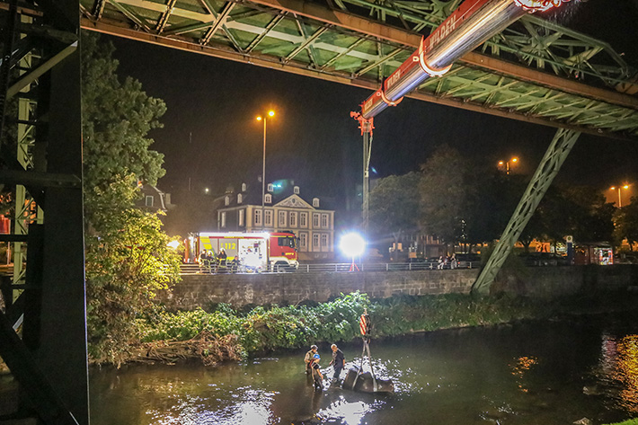
liebherr-ltf1045-4.1-wilden-tuffi1.jpg
Found and rescued – the elephant sturgeon stone had been dragged several metres downstream in the July floods.

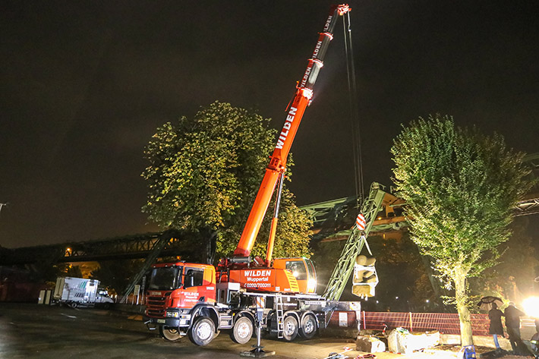
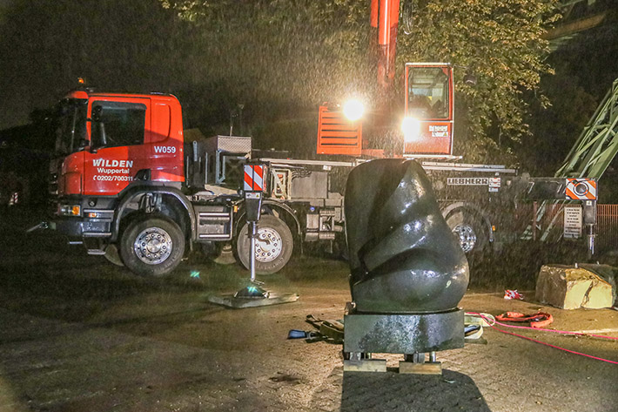
liebherr-ltf1045-4.1-wilden-tuffi2.jpg
Ear problem – fortunately, the artwork had only suffered minor damage.

liebherr-ltf1045-4.1-wilden-tuffi3.jpg
On the hook – the LTF 1045-4.1 hoists the gentle giant back into the River Wupper.

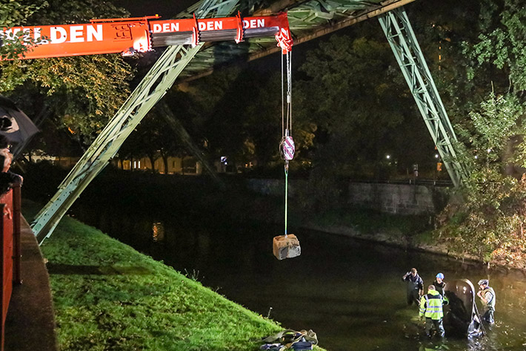
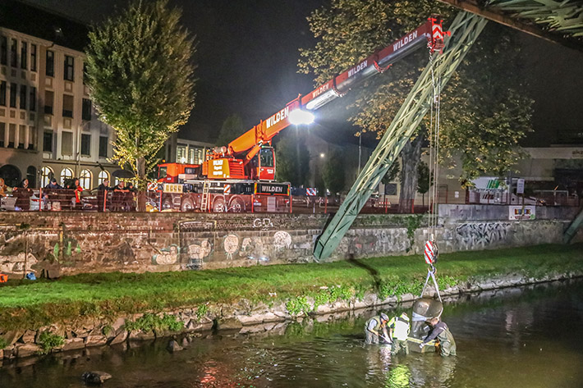
liebherr-ltf1045-4.1-wilden-tuffi4.jpg
Back home – Tuffi is carefully mounted back on its original plinth.
liebherr-ltf1045-4.1-wilden-tuffi5.jpg
Better protected – quarry stones will reduce the water pressure on the female elephant in the future.

Contact person
Wolfgang Beringer
Marketing and Communication
Phone: +49 7391/502 - 3663
Email: wolfgang.beringer@liebherr.com

Published by
Liebherr-Werk Ehingen GmbH
Ehingen (Donau) / Germany
www.liebherr.com

