Press release

Turn two into three

⸺
Corporación Navios replaced reliable Liebherr long duty cycle crane after more than 100,000 operating hours
New permanently installed harbour crane is the third FCC 300 for the long-term customer
The new crane will be used for increasing soy handling in the next few years

Uruguayan company Corporación Navios replaced a Liebherr long duty cycle crane with a permanently installed harbour crane type FCC 300. The recently erected harbour crane will be used for dry bulk handling of barges in hoppers at the terminal in Nueva Palmira, Uruguay. The now total of three harbour cranes is expected to increase the terminal's handling rates and generate operating synergies, as the crane operators will work with the same type of crane on all operations.
Rostock (Germany), October 2021 - Corporación Navios has been working with Liebherr cranes for 30 years. The Liebherr products are used to handle bulk cargo on the narrow pier. For terminals with little space but a high workload, the space-saving design of the Fixed Cargo Cranes series by Liebherr is the perfect solution. This has been demonstrated over the past six years: Between 600 and 700 tonnes of iron were handled per hour throughout this time. They were supported by a Liebherr HS 871 HD long duty cycle crane, which is now being replaced by a FCC 300, the third of its kind at the terminal. With over 100,000 operating hours, the long duty cycle crane is a symbol for the successful and reliable cooperation between Corporación Navios and Liebherr. In the course of this, the customer's renewed decision in favour of a Liebherr maritime crane is a sign of trust.
Outstanding experience values as the basis for the renewed purchase decision
„With the investment in another FCC 300, we are taking a decisive step towards higher turnover rates“, says Rosina Lurato, Project and Certification Manager of Corporación Navios, “we handle around five million tonnes of dry cargo per year and need fast as well as reliable equipment. Based on our positive experience with the two permanently installed cargo cranes, it was quickly clear to us that another crane of the same type was the right choice."
About half of the five million tonnes are exported from Uruguay, the other half is imported dry cargo from other countries. The FCCs handle various grains such as soy, maize and wheat, as well as minerals such as iron and manganese. The new FCC 300 is mainly used for soy handling and can handle up to 1,000 tonnes of soy per hour. The soy from Paraguay, Bolivia and Brazil is loaded onto overseas ships at the terminal and transported to Europe, Africa and the Far East.

Space-saving design and use of synergy effects
In addition, to the space-saving design, the higher handling capacity was also a decisive feature for choosing the third permanently installed harbour crane. Furthermore, the higher flexibility due to the interchangeability of the grabs played an important role. With the two FCCs already in place, the crane operators now always work with the same type of equipment. This increases safety during operations and facilitates routine operation. Another advantage of the identical cranes is a more efficient maintenance and procurement of spare parts. All three units can be maintained in one service loop. Also, the Liebherr engineers from Argentina can train and specialise the customer's maintenance personnel on the FCC 300. This enables them to check certain aspects of the crane’s everyday operations independently. In case of urgent service needs by the customer, the Liebherr specialists can be on-site in just two hours.

About Corporación Navios
Corporación Navios is part of Navios South American Logistics Inc. (“Navios Logistics”) which is one of the largest logistics companies in the Hidrovia region of South America, serving the storage and marine transportation needs of its customers through port terminal, river barge and costal cabotage operations. Navios Logistics business is focused on two key transportation markets in South America: the Hidrovia region river system and the cabotage trade along the eastern coast of South America.

About Liebherr-MCCtec Rostock GmbH
Liebherr-MCCtec Rostock GmbH is one of the leading European manufacturers of maritime material handling solutions. The product range includes ship, mobile harbour and offshore cranes. Reachstackers and components for container cranes are also included in the product portfolio.
About the Liebherr Group
The Liebherr Group is a family-run technology company with a broadly diversified product range. The company is one of the world's largest manufacturers of construction machinery, but also offers high-quality, user-oriented products and services in many other areas. Today, the group comprises more than 140 companies on all continents, employs around 48,000 people and generated a consolidated total turnover of more than 10.3 billion Euros in 2020. Since its foundation in 1949 in Kirchdorf an der Iller in southern Germany, Liebherr has pursued the goal of convincing its customers with sophisticated solutions and contributing to technological progress.
Images
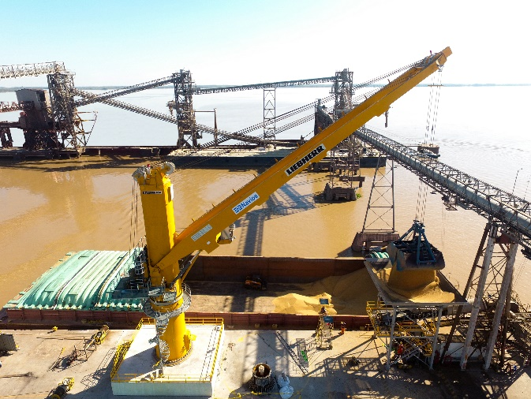
liebherr-fcc300-fixed-cargo-crane-corporacion-navios.jpg
The newly installed fixed cargo crane handling bulk cargo at the terminal in Nueva Palmira, Uruguay.

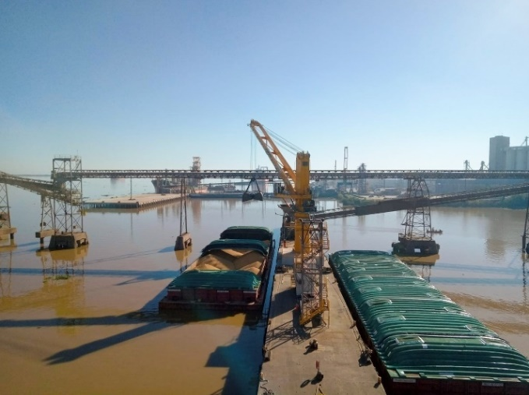
liebherr-fcc300-fixed-cargo-crane-corporacion-navios-2.jpg
Due to the narrow jetty of the terminal, the space-saving design of the FCC 300 by Liebherr is the perfect solution.

Contact person
Stefan Fröbe
Marketing Manager Maritime Cranes
Phone: +49 381 6006 5025
E-Mail: stefan.froebe@liebherr.com
Published by
Liebherr-MCCtec Rostock GmbH
Rostock / Germany
www.liebherr.com

