Press release

More power in the Caribbean: Força strengthens crane fleet with Liebherr LTM 1400-7.1

⸺
Força relies on Liebherr to buy used cranes
LTM 1400-7.1 significantly strengthens the range of services offered by the Caribbean company
Wide range of boom combinations suitable for a broad spectrum of applications
The crane and heavy haulage company Força Diseño & Ingenieria SRL from the Dominican Republic has almost doubled its range of lifting power for crane work: a new addition to the fleet is an LTM 1400-7.1 with a maximum lifting capacity of 400 tonnes. Previously, the 220-tonne LTM 1220-5.2 was the company's most powerful crane. Força now operates one of the largest mobile cranes in the entire Caribbean.
Ehingen (Germany), 17 September 2021 – Within the past year, Força has acquired six used Liebherr cranes, including two Liebherr LTM 1130-5.1, one LTM 1200-5.1 and one LTM 1220-5.2. The company has again placed its trust in crane manufacturer Liebherr for its latest investment, the LTM 1400-7.1. Company owner Jhon Modesto explains: "With Liebherr we have the opportunity to buy used cranes that have been technically tested and are in perfect condition or have been repaired by Liebherr. Based on our good experience, we have again purchased directly from Liebherr. With the new 400-tonne crane, we are expanding our product range significantly upwards. This makes us the market leader both in the Dominican Republic and throughout the Caribbean."
Força cites the compact design of the 7-axle crane, its easy manoeuvrability and adjustable counterweight radius, as well as the wide range of boom combinations as important criteria in its decision to buy the LTM 1400-7.1. For example, the company purchased the crane with complete equipment such as telescopic boom guying, fixed and luffing lattice jib. Força is thus ideally equipped for the planned operations in the fields of steel construction, power plant construction, wind power and mining.
"At Liebherr we find the right cranes with the equipment we need for our requirements. The quality is excellent”, Modesto reports.
In addition to crane rental, Força also offers heavy haulage and operates as a civil engineering company. Therefore, with around 90 employees, the company also operates numerous heavy-duty vehicles and construction machinery in addition to 20 all-terrain and truck cranes.

About Liebherr-Werk Ehingen GmbH
Liebherr-Werk Ehingen GmbH is a leading manufacturer of mobile and crawler cranes. Its range of mobile cranes extends from 2-axle 35 tonne cranes to heavy duty cranes with a lifting capacity of 1200 tonnes and a 9-axle chassis. Its lattice boom cranes on mobile or crawler crane chassis deliver lifting capacities of up to 3000 tonnes. With universal boom systems and extensive additional equipment, they can be seen in action on construction sites throughout the world. The Ehingen site has a workforce of 3,600. Extensive, global service guarantees the high availability of Liebherr mobile and crawler cranes. In 2020, the Liebherr plant in Ehingen recorded a turnover of 2 billion euros.
About the Liebherr Group
The Liebherr Group is a family-run technology company with a widely diversified product range. The company is one of the largest manufacturers of construction machines in the world, but also supplies technically advanced, user-focused products and services in many other sectors. The group currently comprises more than 140 companies based in every continent of the world, has a workforce of around 48,000 and recorded a consolidated total turnover of more than 10.3 billion euros in 2020. Since it was founded in 1949 in Kirchdorf an der Iller in southern Germany, Liebherr’s aim has been to win customers by supplying high quality solutions and to contribute to technological progress.

Picture:
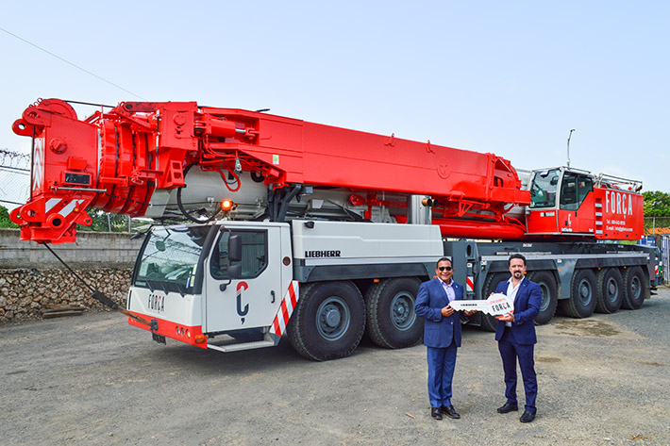
forca-ltm1400-7-1-handover.jpg
From left to right: Jhon Modesto (Força Diseño & Ingenieria SRL) und Christian Tableros (Liebherr México S. de R.L. de C.V.)
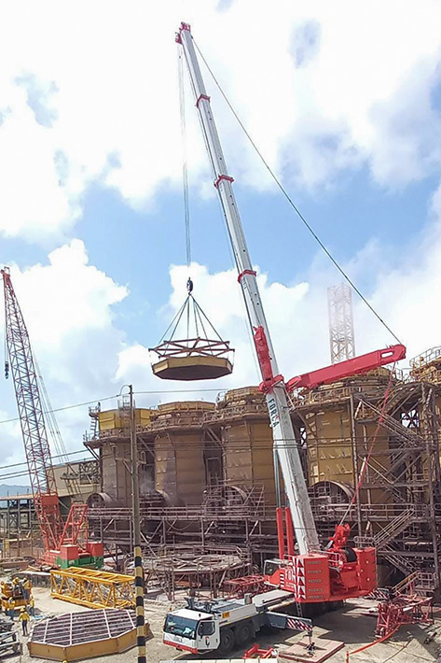
forca-ltm-1400-7-1-job.jpg
The Liebherr LTM 1400-7.1 strengthens the fleet of Força.

Contact person:
Wolfgang Beringer
Marketing and Communication
Telefon: +49 7391/502-3663
E-Mail: wolfgang.beringer@liebherr.com
Published by
Liebherr-Werk Ehingen GmbH
Ehingen (Donau) / Deutschland
www.liebherr.com

