

Press release

Powerful start: New crawler crane from Liebherr is here

⸺

LR 1700-1.0 proves its worth in the construction of a powerful wind turbine

Crane companies Hofmann and Wasel take delivery of first machines

Crawler crane sets new standards in its class – all innovations on board

Lifting capacities of the LR 1750/2 achieved or even surpassed in the wind farm

Time for something new! With the LR 1700-1.0, the Liebherr factory in Ehingen is bringing a worthy successor to the successful LR 1600/2 and the result of its latest developments in innovative crawler crane technology onto the market. A highly efficient powerhouse is coming to construction sites. The first of these are two machines – delivered recently to the German crane companies Hofmann (Paderborn) and Wasel (Bergheim near Cologne).

Ehingen (Donau) (Germany), 16 September 2021 – The new Liebherr LR 1700‑1.0 crawler crane is gaining momentum. The first jobs deploying the state-of-the-art powerhouse from Ehingen have been completed with tremendous success. The 700-tonne crawler crane recently fulfilled the high expectations placed in it at its première in a wind farm near Paderborn. The local crane company Hofmann Kran-Vermietung GmbH & Co KG, a subsidiary of the Bracht Group, used the crane to erect a Nordex Delta 4000 wind turbine. The LR 1700-1.0 masterfully dealt with the prefabricated 96-metre high concrete tower for the turbine with a hub height of 164 metres. The heaviest components were the nacelle and drive train with gross loads of 72 and 75 tonnes.

Heavy boom allows higher wind loads

At the “Holzhausen” wind farm, about 20 kilometres east of Paderborn, the LR 1700-1.0 was equipped with a 165-metre-long main boom. This includes nine lattice boom sections of the somewhat wider H‑Version ("Heavy"), each twelve metres long. “The H-Boom lets us operate under higher wind loads”, explains crane operator Christoph Bergmaier. The greater wind tolerance of this boom configuration can save the crane and assembly teams on site many a stoppage due to excessive wind. Liebherr allows wind speeds of 11.2 metres per second for the LR 1700-1.0 – as for all current LR crane types with special wind power equipment configurations. With only a minimally reduced maximum load, this value even increases to 13.4 metres per second. This is an invaluable advantage for customers and end users, because normally the wind stops at nine metres per second.

Hofmann's new LR 1700-1.0 comes with all the innovations of Liebherr's crawler crane development from recent years – and has other time-saving features too. “The VarioTray divisible derrick ballast and V-Frame allow us to work with 60 tonnes of derrick ballast during the entire assembly of the turbine – so we don’t have to carry out any time-consuming ballasting”, Christoph Bergmaier is pleased to say. The large ballast pallet is only docked for erecting or taking down the lattice boom – which, by the way, can be erected to an impressive length of 198 metres. A procedure taking about ten minutes with just four bolts – and a total of 375 tonnes of counterweight is already hanging from the derrick boom.

“Really user-friendly crane”

The continuously adjustable V-frame ballast radius enabled the blue-painted Hofmann crane to operate in relatively little space on the construction site near Paderborn – even during the slewing process. For the assembly of the wind turbine components, the two drivers then steered their crawler crane close to the tower – with a radius of 26 metres, all components were assembled. Even the heaviest loads on the hook, the 72-tonne nacelle and the three-tonne drive train, were handled without any problems. “The crane can be operated very smoothly and effectively even with heavy loads at height,” reports Christoph Bergmaier, who takes turns with Stephan Dickel at the controls of the Liebherr crane. His succinct conclusion after the first job with the new LR 1700-1.0 at the wind farm: “Powerful crane and really user-friendly!”

About Liebherr-Werk Ehingen GmbH

Liebherr-Werk Ehingen GmbH is a leading manufacturer of mobile and crawler cranes. Its range of mobile cranes extends from 2-axle 35 tonne cranes to heavy duty cranes with a lifting capacity of 1200 tonnes and a 9-axle chassis. Its lattice boom cranes on mobile or crawler crane chassis deliver lifting capacities of up to 3000 tonnes. With universal boom systems and extensive additional equipment, they can be seen in action on construction sites throughout the world. The Ehingen site has a workforce of 3,600. Extensive, global service guarantees the high availability of Liebherr mobile and crawler cranes. In 2020, the Liebherr plant in Ehingen recorded a turnover of 2 billion euros.

About the Liebherr Group

The Liebherr Group is a family-run technology company with a widely diversified product range. The company is one of the largest manufacturers of construction machines in the world, but also supplies technically advanced, user-focused products and services in many other sectors. The group currently comprises more than 140 companies based in every continent of the world, has a workforce of around 48,000 and recorded a consolidated total turnover of more than 10.3 billion euros in 2020. Since it was founded in 1949 in Kirchdorf an der Iller in southern Germany, Liebherr’s aim has been to win customers by supplying high quality solutions and to contribute to technological progress.

Photographs:

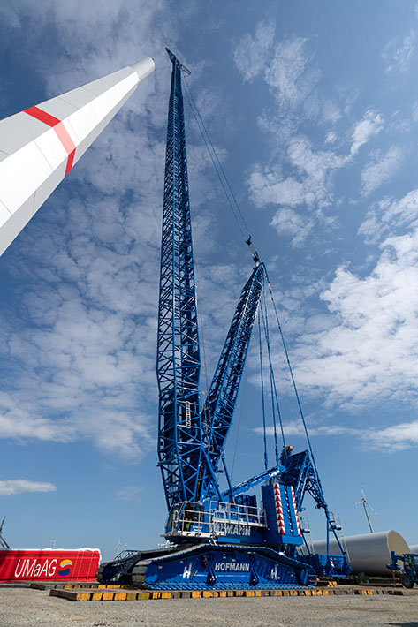

liebherr-lr1700-1.0-hofmann-1.jpg  
The new Liebherr LR 1700-1.0 crawler crane proves its merit in the wind farm.

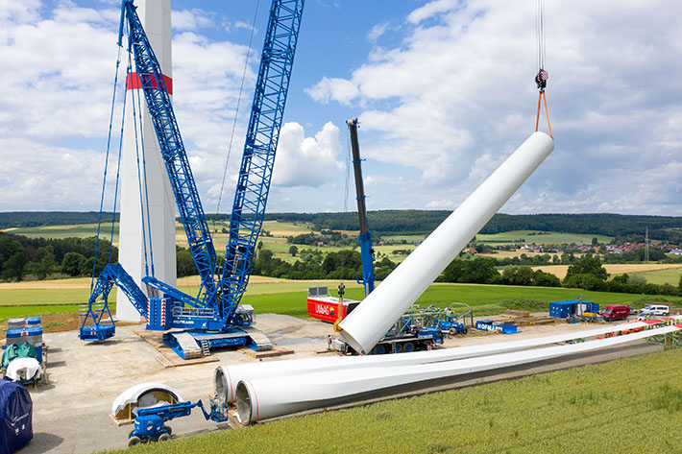

liebherr-lr1700-1.0-hofmann-2.jpg  
Teamwork: The heaviest tower segment of the Nordex wind turbine weighs in at a gross load of 70 tonnes. A Liebherr LTM 1250-5.1 mobile crane is helping to erect the tubular tower.

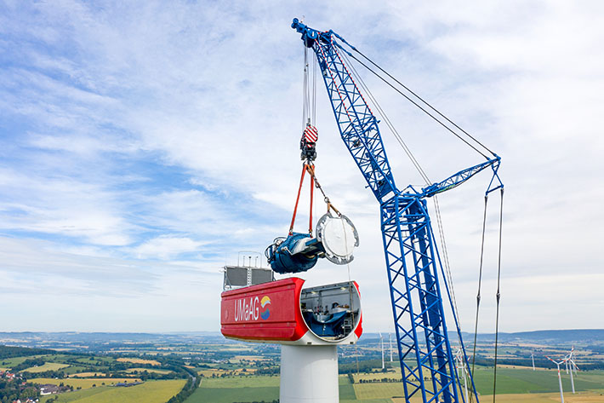

liebherr-lr1700-1.0-hofmann-3.jpg  
Peak performance: The twelve-metre fixed tip of the LR 1700-1.0 can handle a load of 170 tonnes, surpassing even the capacities of the LR 1750/2. Here it is used for installation of the drive train with a gross weight of 75 tonnes. The design of this boom tip allows relatively generous manoeuvring of large components such as the nacelle just below the pulley head.

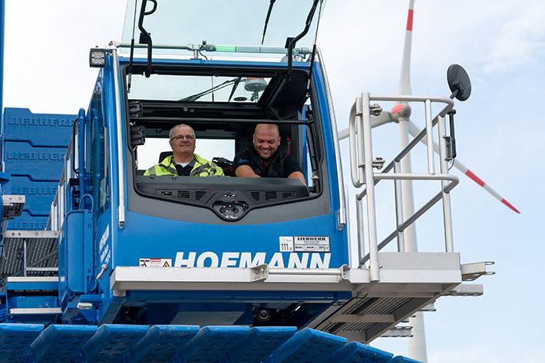

liebherr-lr1700-1.0-hofmann-4.jpg  
Good mood: Christian Bergmaier (left) and Stephan Dickel in the spacious cabin of their new Liebherr crawler crane.

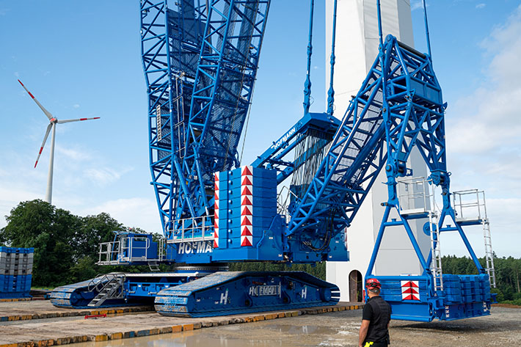

liebherr-lr1700-1.0-hofmann-5.jpg  
Space and time saver: The basic machine of the LR 1700-1.0, completely redesigned by Liebherr, here during slewing with the reduced derrick ballast VarioTray on the retracted V-frame.

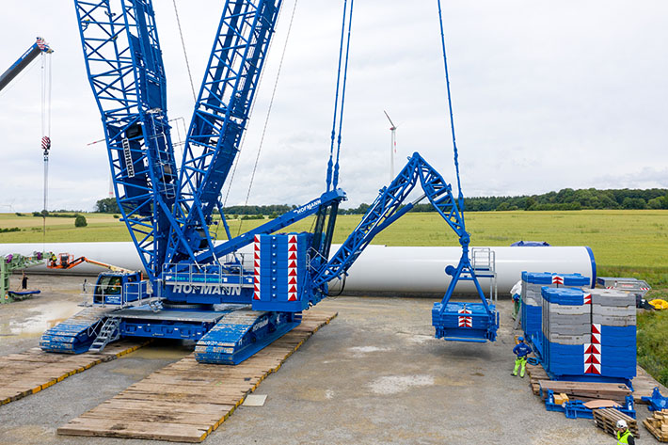

liebherr-lr1700-1.0-hofmann-6.jpg  
VarioTray: The LR 1700-1.0 only needs the full derrick ballast of 375 tonnes for erecting. For the lifts, only 60 tonnes are suspended from the infinitely adjustable folding frame V-Frame.

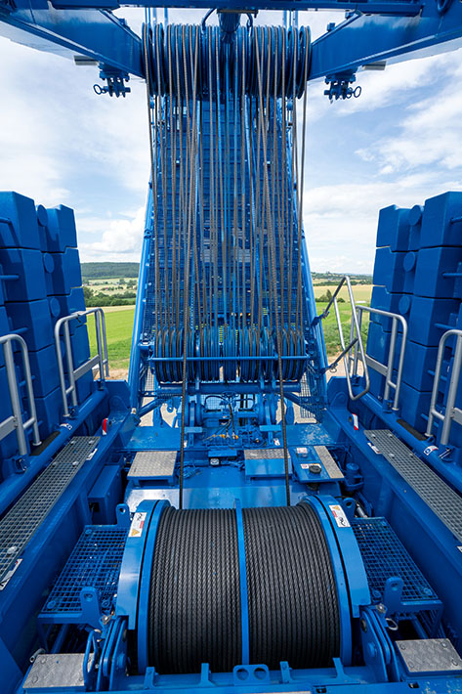

liebherr-lr1700-1.0-hofmann-7.jpg  
High-precision: The advantages of dual-line parallel operation include not only the high hook speed, but also prevention of the hook block being twisted in by the rope's own rotation (anti-twist design). The tilt sensor on the bottom hook block reports its exact alignment to the crane cabin.

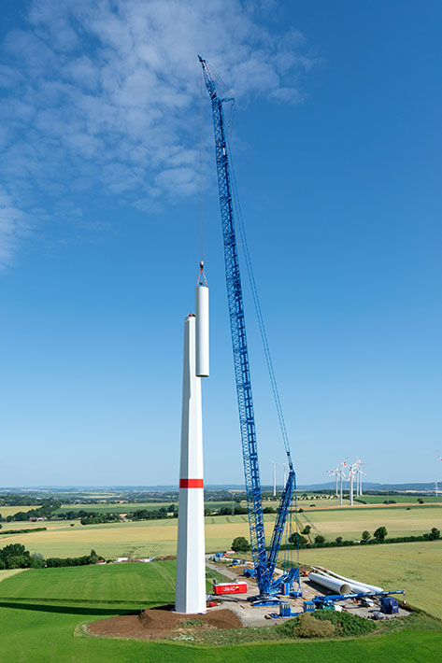

liebherr-lr1700-1.0-hofmann-8.jpg  
Wind power expert: Hofmann Kran-Vermietung has ordered the LR 1700-1.0 in the configuration for work in wind farms. The Bracht subsidiary from Paderborn will mainly use the crawler crane to erect wind turbines for its regular customer Nordex. Here, the crane is equipped with a 165-metre main boom, 108 metres of which are in the stronger heavy lattice boom variant.

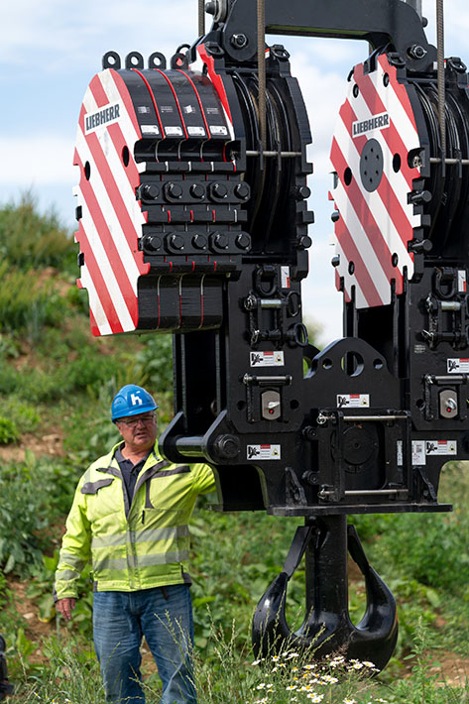

liebherr-lr1700-1.0-hofmann-9.jpg  
Gigantic: the mighty hook block of the LR 1700-1.0 is very fast thanks to parallel hoist operation and can be driven with high precision thanks to a tilt sensor. The use of two winches enables crane operator Christoph Bergmaier to reach extremely fast speeds, especially when the hook is empty.

Contact person:

Wolfgang Beringer  
Marketing and Communication  
Phone: +49 7391/502-3663  
Email: wolfgang.beringer@liebherr.com

Published by

Liebherr-Werk Ehingen GmbH  
Ehingen (Donau) / Germany  
[www.liebherr.com](http://www.liebherr.com)