Press release

Première in Africa: Allied Crane Hire takes delivery of Liebherr LTM 1230-5.1 mobile crane

⸺
Liebherr delivers the first LTM 1230-5.1 to Africa
Long telescopic boom and innovations offering more economy and flexibility are important decision criteria
Allied Crane Hire is an established specialist for crane hire in sub-Saharan countries
Liebherr has delivered the first LTM 1230-5.1 mobile crane to the African continent. It went to the crane and heavy transport company Allied Crane Hire, based in Cape Town, South Africa. The long telescopic boom of the 230-tonne crane and technical innovations such as VarioBallast®, VarioBase® and the Liebherr Single Engine Concept were important decision-making criteria.
Ehingen (Donau) (Germany), 14 August 2021 – Allied Crane Hire has established itself as a specialist in crane hire in sub-Saharan Africa. The 24-year-old company operates more than 80 mobile and crawler cranes, which are mainly used in petrochemicals, mining, wind and solar farms and the construction industry. The company bought its first Liebherr crane 20 years ago.
The LTM 1230-5.1 is now the latest model in the fleet. André Engelbrecht, Managing Director at Allied Crane Hire, explains: “Crane experts will agree that Liebherr has the best technology in mobile and crawler cranes and is a pioneer in the industry. An important criterion for us in choosing the LTM 1230-5.1 was its 75-metre telescopic boom. This allows us to do many crane jobs without having to set up a lattice jib”. The Liebherr LTM 1230-5.1 is an ideal crane for work in steep positions and at great heights, for example in wind turbine maintenance or petrochemical operations. With lattice extensions, the LTM-1230-5.1 reaches a maximum lifting height of 111 metres.
Another important purchase criterion for Allied Crane Hire was the Liebherr VarioBallast®. The ballast radius of the LTM 1230-5.1 can be adjusted between 4.8 and 5.7 metres. “Operations in the petrochemical and mining industries are extremely challenging: little space, time pressure and constantly changing conditions. This calls for high flexibility from the cranes," declares Engelbrecht.
Mobile crane specially designed for VarioBase®
The engineers at Liebherr-Werk Ehingen GmbH put the multi-award-winning VarioBase® support technology at the heart of the structural steel construction when creating the concept for the LTM 1230-5.1. This makes it the first crane to have an asymmetrical support base: The width is 7.4 metres at the front and 8.1 metres at the rear.
“Thanks to VarioBase®, it’s now possible to enable really high lifting capacities, especially in the rear working area, over the 8.1 metre wide supports – calculated in real-time by the LICCON controller”, explains Erik Benz, Head of the Mobile and Crawler Cranes Division at Liebherr-Africa. “This new digitalisation option has a major influence on the structural steel technology, while enhancing customer benefit in the form of increased lifting capacities”.
“We call the combination of trapezoidal and variable support base VarioBase®Plus”, adds Francois Pretorius, Sales Representative at Liebherr-Africa. “The single-stage sliding beams at the front are lighter. The weight saved could be used to increase the boom length.”
Allied Crane Hire also appreciates the many other technical Liebherr innovations, such as the Single Engine Concept and ECOmode, which reduce fuel consumption and noise emissions. “Many of our working conditions are really tough – so efficiency is a fundamental requirement for all the machines we operate. The new LTM 1230-5.1 is characterised by high performance, economy and flexibility – thanks to Liebherr's systematic advancement of successful technologies”, states Engelbrecht.
About Liebherr-Werk Ehingen GmbH
Liebherr-Werk Ehingen GmbH is a leading manufacturer of mobile and crawler cranes. Its range of mobile cranes extends from 2-axle 35 tonne cranes to heavy duty cranes with a lifting capacity of 1200 tonnes and a 9-axle chassis. Its lattice boom cranes on mobile or crawler crane chassis deliver lifting capacities of up to 3000 tonnes. With universal boom systems and extensive additional equipment, they can be seen in action on construction sites throughout the world. The Ehingen site has a workforce of 3,600. Extensive, global service guarantees the high availability of Liebherr mobile and crawler cranes. In 2020, the Liebherr plant in Ehingen recorded a turnover of 2 billion euros.
About the Liebherr Group
The Liebherr Group is a family-run technology company with a widely diversified product range. The company is one of the largest manufacturers of construction machines in the world, but also supplies technically advanced, user-focused products and services in many other sectors. The group currently comprises more than 140 companies based in every continent of the world, has a workforce of around 48,000 and recorded a consolidated total turnover of more than 10.3 billion euros in 2020. Since it was founded in 1949 in Kirchdorf an der Iller in southern Germany, Liebherr’s aim has been to win customers by supplying high quality solutions and to contribute to technological progress.

Photographs:

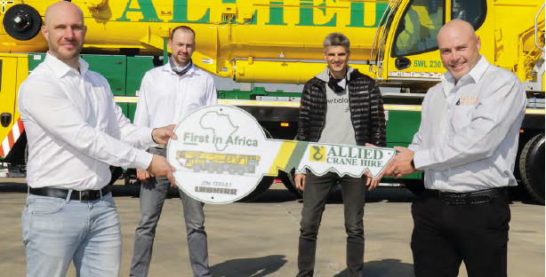
liebherr-ltm-1230-5-1-allied-handover.jpg
From left to right: Erik Benz, Francois Pretorius, Dieter Schmid (All Liebherr-Africa), André Engelbrecht (Allied Crane Hire).

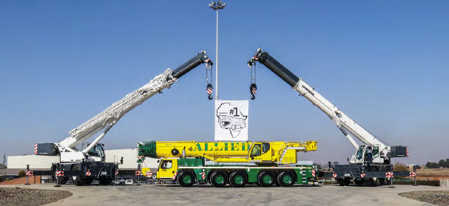
liebherr-ltm-1230-5-1-allied.jpg
Framed by two Liebherr LRT rough-terrain cranes: The first LTM 1230-5.1 in Africa.

Contact person:
Wolfgang Beringer
Marketing and Communication
Phone: +49 7391/502-3663
Email: wolfgang.beringer@liebherr.com
Published by
Liebherr-Werk Ehingen GmbH
Ehingen (Donau) / Germany
www.liebherr.com

