

Press release

Liebherr at Pollutec 2021

⸺

Hall 3, booth 119, aisle C

The latest innovations in the handling range on the Liebherr stand

A hydraulic cylinder and an intelligent digital camera complete the presented Liebherr range

**From october 12th to 15th, Liebherr will have a booth at the 2021 edition of the Pollutec trade fair in Lyon. At the heart of hall 3, dedicated to recycling – material and material reuse, the Liebherr stand (No. 119, aisle C) will unveil many new products from the earthmoving, handling and internal components sectors.**

Lyon (France), 14. September 2021 – At Pollutec 2021, Liebherr will notably present an L 509 tele telescopic wheel loader, an LH 22 M mobile handling machine and two telescopic handlers T 55-7s and T 60-9s. On the component side, a 260 bar hydraulic cylinder and an MDC3 smart digital camera will also find their place on the booth.

L 509 Tele

The Liebherr L 509 Tele telescopic wheel loader is a unique multifunctional machine which combines the lift height and reach of a regular telescopic loader with the productive material handling capacity of a classic wheel loader – the benefits of two machine types in a single product. Developed based on the Speeder L 509 stereo loader this telescopic wheel loader retains the proven stereo steering and can reach a top speed of 38 km/h as standard thanks to the powerful hydrostatic travel drive. It also complies with the emission stage V/ Tier 4f specifications.

The L 509 Tele telescopic wheel loader is powered by a powerful 54 kW / 73 hp diesel engine. It reaches a lifting height of up to 4.8 metres and is particularly suitable for loading trucks and containers as well as for lifting and stacking loading material. The powerful Z-linkage of the telescopic lift arm is specially adapted to the requirements of the telescopic wheel loader. The optimised linkage offers extremely precise parallel guidance in fork operation without manual readjustment, as can be seen at the exhibition.

L 546

Liebherr presents the L 546, the largest representative of its mid-range wheel loaders, at the Pollutec 2021 trade fair. The range comprises three models of wheel loaders – L 526, L 538 and L 546 – all of which remain true to the reputation of this machine class as powerful and reliable all-rounders. The generation is compliant with the emissions guidelines of emission stage V/ Tier 4f. In order to increase the robustness and durability of these wheel loaders, Liebherr has installed larger axles and reinforced the steel structures. The proven and efficient hydrostatic driveline also impresses with fuel savings of up to 25 % in comparison with other wheel loaders of the same size class. Numerous application-specific solutions also offer increased versatility. This makes the all-round wheel loaders from Liebherr ideal partners for demanding applications in areas such as the recycling sector.

The L 546 is powered by an efficient 138 kW / 188 hp diesel engine. The Pollutec exhibit is equipped with a parallel lift arm system, a high-tipping bucket and a LIKUFIX system. LIKUFIX is a hydraulic quick hitch with an integral automated hydraulic coupling system. The operating weight and tipping load in the L 546 are well balanced: With an operating weight of 14,200 kg, the Pollutec exhibit achieves a tipping load of 10,500 kg. The high tipping load combined with a low operating weight means that a high operating capacity can be realized.

LH 22 M Industry Litronic

The LH 22 M Industry Litronic material handler exhibited at Pollutec 2021, which complies with the requirements of exhaust emissions standard Stage V, represents the Liebherr range of small material handlers. Thanks to its robust and at the same time compact design, the machine is ideal for applications in the recycling area. This includes, for example, feeding processors and crushers, loading and unloading trucks and containers, sorting materials and waste products, as well as piling up and handling all sorts of materials.

The LH 22 M Industry Litronic material handler combines comfort, performance and reliability. With the latest engine and hydraulics technology, developed in-house by Liebherr, the main focus is on fuel efficiency while at the same time enhancing material handling performance. Despite its compact dimensions, it is extraordinarily powerful. The Liebherr diesel engine, which complies with the Stage V exhaust emissions standard, already delivers 105 kW / 143 hp at 1,800 rpm. This optimally designed engine power means that the system has a high torque available for powerful and fast movements. Moreover, load peaks are skilfully compensated for, meaning that the maximum torque is available at all times for the highest level of material handling performance.

Telescopic handlers T 55-7s and T 60-9s

At Pollutec 2021, Liebherr will be showing two telescopic handler models for recycling applications and industrial materials handling – the T 55-7s‏ and T 60-9s. It is not only the continuously variable hydrostatic drive and high-performance operating hydraulics that make these models stand out. This is also the assistance systems for increased productivity, such as Auto Power, Load Moment Plus and programmable bucket return, as well as the intelligent safety functions, such as Auto Hill Assist and intervening overload warning device. The total of three new telescopic handlers for industrial applications are powered by a powerful diesel engine with emission level IV (T 46-7s 100kW/136bhp, T 55-7s 115kW/156 bhp, T 60-9s 115kW/156bhp). Exhaust gases are retreated through a combination of diesel oxidisation catalyst (DOC) and selective catalytic reduction (SCR). Diesel particle filters are available for all models (standard on T 55-7s and T 60-9s). For use in countries with different emissions regulations Liebherr also offers its telescopic handlers with emission level IIIA.

Robust Team: MDC 3 and DC5

The smart camera and the fifth generation display controller (DC5), with an i.MX6 processor and the Linux/Yocto software environment form a visually powerful camera monitor system. The DC5 also brings visual comfort, as well as a lot of computing power to the driver's cab. Thanks to their high protection ratings, the MDC3 (IP6K9K) and the DC5 (IP65) are suitable for very demanding operating conditions. These proven solutions provide an optimal basis for customised developments.

Hydraulic cylinder series-production range 260 bar

Liebherr offers three standard series-production ranges for hydraulic cylinders for the optimal coverage of numerous application areas and industry requirements. The standard portfolio, therefore, includes a 260 bar series-production range**.** The series does not only offer cost-effective solutions, but also finds its use in a wide range of applications, both mobile and stationary.

With a wide choice of possible dimensions, mounting types, oil connections and piston rod coatings, the 260 bar series offers the required flexibility for customer demands.It consists of 28 basic piston-piston rod rated diameter combination variants. There are a total of four available mounting types and two alternative oil connections for each of these basic variants. Depending on the environmental impact, a single chrome or double chrome coating is possible. To ensure the most cost-effective solution for the target application, however, no functional expansions such as sensors or cushioning solutions are available for this series.

About the Liebherr Group

The Liebherr Group is a family owned technology company with a broadly diversified product range. The company is one of the world's leading manufacturers of construction machinery, but also offers high-quality, user-centred products and services in many other areas. The Group today numbers more than 140 companies on all continents, employs around 48,000 staff and generated a consolidated total turnover of more than 10.3 billion euros in 2020. Since Liebherr was founded in 1949 in Kirchdorf an der Iller in southern Germany, it has pursued the objective of inspiring its customers with outstanding solutions and contributing to technological progress.

Images

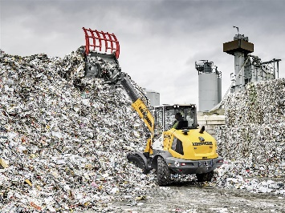

liebherr-wheel-loader-l-509-tele-1.jpg  
The new L 509 Liebherr telescopic wheel loader combines the lifting height of a regular telescopic loader with the handling performance of a classic wheel loader.

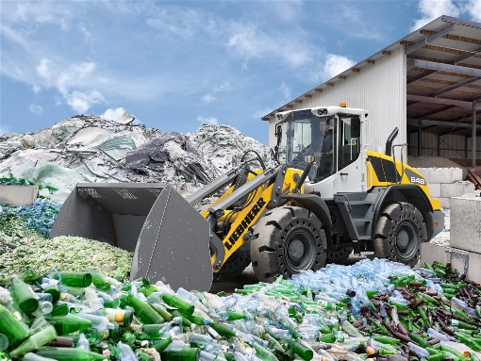

liebherr-wheel-loader-l-546-2.jpg  
The robust L 546 is the largest member of Liebherr’s mid-sized wheel loader range.

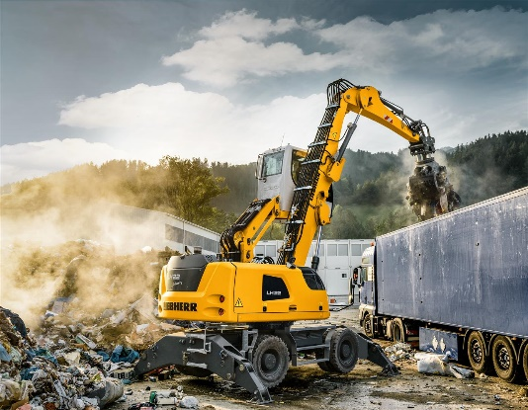

liebherr-material-handling-machine-lh-22-m-3.jpg  
The Liebherr LH 22 M Industry Litronic material handler is ideal for applications in the recycling area thanks to its robust and at the same time compact design.

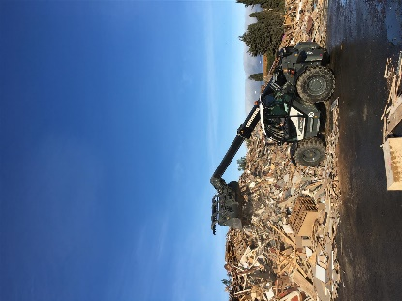

liebherr-telescopic-handler-t-55-7s-4.jpg  
Liebherr-T 46-7s industrial telescopic handler in recycling operation

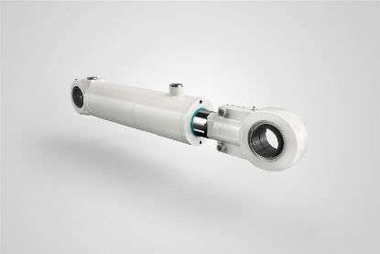

liebherr-hydraulic-cylinder-260-bar-5.jpg  
With a wide choice of possible dimensions, mounting types, oil connections and piston rod coatings, the 260 bar series offers the required flexibility for customer demands.

Contact person

Alban Villaumé  
Marketing Manager  
Telephone: +0033 89 21 36 09  
E-Mail: alban.villaume@liebherr.com

Published by

Liebherr-France-SAS   
Colmar, France  
[www.liebherr.com](http://www.liebherr.com)