Press release

Liebherr partners with Hexagon to deliver next generation mine automation

⸺
Liebherr Mining and Hexagon’s Mining division announced at MINExpo in Las Vegas a global framework agreement that advances the next generation of autonomous mining.
With this agreement, Liebherr demonstrates the interoperability of its autonomous offering.
Integrating the power of Hexagon’s technologies with Liebherr’s state-of-art autonomous solutions delivers higher levels of on-board intelligence, with reduced dependency on site infrastructure and centralized supervisory systems.
Liebherr, one of the world’s largest construction and mining equipment manufacturers, and Hexagon, a global leader in digital reality solutions, combining sensor, software and autonomous technologies have signed a framework agreement to deliver next generation mine automation.
Las Vegas (USA), 14 September 2021 – Hexagon’s Mining division and Liebherr today announced at MINExpo in Las Vegas a global framework agreement that advances the next generation of mine automation. Hexagon technology, including its autonomous mission management system, will be used in the mine automation options offered by Liebherr to customers. A high level of safety, flexibility and seamless integration are the hallmarks of Liebherr’s offerings, which includes its complete autonomous haulage solution.
“The autonomous mission management system will orchestrate autonomous fleet and unmanned mine traffic movements throughout the mine for optimised autonomous haulage. It is fully integrated with our fleet management and enterprise analytics and reporting portfolio products,” said Hexagon.
“We are thrilled to partner with Liebherr, which shares our vision of an autonomous future and is equally committed to the safety of miners,” said Andrew Crose, VP-Autonomous, Hexagon’s Mining division. “We’re very proud of the autonomous mission management system,” added Crose. “From one platform integrating multiple life-of-mine solutions, it embodies our mission to empower an autonomous future.”
“Integration of Hexagon’s technologies enables Liebherr to provide autonomous mining solutions, consistent with our vision of open architecture next generation mine automation,” said Scott Bellamy, Head of Product Management – Mining Trucks, Liebherr Mining. “Today’s announcement is an exciting milestone for both Liebherr and Hexagon, underpinning the next phase our collaborative partnership.”
Integrating the power of Hexagon’s technologies with Liebherr’s interoperable solutions delivers the next generation of mine automation with enhanced on-board intelligence, reducing dependency on site infrastructure and centralized supervisory systems.
About the Liebherr Group
The Liebherr Group is a family-run technology company with a highly diversified product portfolio. The company is one of the largest construction equipment manufacturers in the world. It also provides high-quality and user-oriented products and services in a wide range of other areas. The Liebherr Group includes over 140 companies across all continents. In 2020, it employed around 48,000 staff and achieved combined revenues of over 10.3 billion euros. Liebherr was founded in Kirchdorf an der Iller in Southern Germany in 1949. Since then, the employees have been pursuing the goal of achieving continuous technological innovation, and bringing industry-leading solutions to its customers.
About Hexagon
Hexagon is a global leader in digital reality solutions, combining sensor, software and autonomous technologies. We are putting data to work to boost efficiency, productivity, quality and safety across industrial, manufacturing, infrastructure, public sector, and mobility applications.

Our technologies are shaping production and people-related ecosystems to become increasingly connected and autonomous — ensuring a scalable, sustainable future.

Hexagon’s Mining division solves surface and underground mine challenges with proven technologies for planning, operations and safety.

Hexagon (Nasdaq Stockholm: HEXA B) has approximately 21,000 employees in 50 countries and net sales of approximately 4.6bn USD. Learn more at hexagon.com and follow us @HexagonAB.

Images
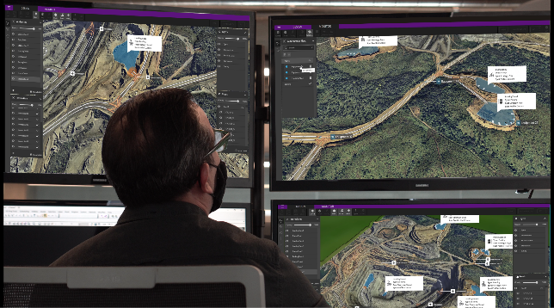

Hexagon autonomous mission management system.jpg
Hexagon’s autonomous mission management system will be used in the mine automation options offered by Liebherr.

Contact person Liebherr
Swann Blaise
Divisional General Manager, Marketing & Business Intelligence
Liebherr-Mining Equipment SAS
Telephone: +1 757 928 2239
E-Mail: swann.blaise@liebherr.com
Contact person Hexagon
Neville Judd
Communications Director
Hexagon’s Mining division
Telephone: +1 604 505 6154
E-Mail: neville.judd@hexagon.com
Published by
Liebherr-Mining Equipment SAS
Colmar / France
www.liebherr.com

