Liebherr and ENGIE partner to offer carbon-neutral solutions for the mining industry

⸺
Liebherr and ENGIE announced at MINExpo 2021 their partnership to offer integrated carbon-neutral solutions to decarbonise the mining industry.
With this agreement, Liebherr continues to execute its roadmap to achieve low carbon solutions in 2022, along with fossil fuel free solutions for the majority of applications by 2030.
This partnership supports ENGIE’s ambition to help energy-intensive industries like the mining sector reach their carbon-neutrality objectives.
The parties will jointly evaluate different decarbonisation pathways, including renewable hydrogen, to offer new well-to-wheel energy ecosystems for the mining industry.
Liebherr, one of the largest construction and mining equipment manufacturers in the world, and ENGIE, the global reference in renewable hydrogen, low-carbon energy and services, have signed an agreement to jointly evaluate, develop, and implement zero emission mining solutions for their customers.
Las Vegas (USA), 14 September 2021 – Liebherr Mining and ENGIE have officially announced their partnership on zero-emission mining solutions for a sustainable future at MINExpo International® 2021. Each company will bring its own expertise and knowledge to the table, to tackle the challenges of decarbonising the mining industry. The collaboration aims to evaluate different renewable energies, in particular renewable hydrogen, and hydrogen derived fuels, to develop an integrated well-to-wheel solution for the mining industry.
In consideration of the Paris Climate Agreement, Liebherr has taken the challenge of finding future energy ecosystems to power its mobile and heavy-duty mining equipment. The large range of application areas and fields of use of Liebherr construction and mining equipment requires an equally large variety of suitable drive systems to best meet the needs of customers. Liebherr strives for long-term sustainable solutions, investigating different options centred on environmental impact, safety, cost, reliability, maintainability, and flexibility. Liebherr already offers a nearly full range of electric excavators and trolley equipped trucks. Liebherr Mining has a clear roadmap to achieve low carbon solutions in 2022 for the entire truck and excavator product line, along with fossil fuel free solutions for most applications by 2030.
This joint proposal between Liebherr and ENGIE covers all considerations for the implementation of practical solutions. It will validate the best solutions in terms of technical, economic, financial, and business aspects, along with the removal of greenhouse gas (GHG) emissions. ENGIE, as a front-runner in the development of a worldwide industrial-scale renewable hydrogen economy, will contribute with its expertise including engineering, R&D, design, construction, operation, and inception, while Liebherr will bring its knowledge and experience in mining equipment and operation.
The common approach considers cost and GHG emissions of the holistic well-to-wheel solution, supporting the selection, design, and development of the right energy supply chain and zero emission mining equipment.
This convergence of Liebherr's and ENGIE's respective experiences in the decarbonisation of the mining sector from design to industrial deployment, is key to providing customers and the industry with the most valuable zero emission solutions. The synergy between the two organisations forms a partnership well equipped to deliver high-efficiency and carbon-neutral solutions for strategic mining markets – contributing to environmentally conscious mining.
“We are very honored by this collaboration with Liebherr to work on solutions for decarbonising the mining industry, a sector with huge energy demand at the core of the energy transition. This partnership perfectly embodies ENGIE’s strategy to develop hydrogen-based solutions on an industrial scale to help energy-intensive industries like the mining sector in their journey to decarbonisation”, said Michèle AZALBERT, Managing Director of ENGIE Green Hydrogen.
Oliver Weiss, EVP R&D, Engineering and Manufacturing of Liebherr’s Mining Division continued, “We are very impressed with the real ambition of ENGIE to decarbonise the mining industry and highly value the opportunity to collaborate with ENGIE. The complementary in-depth expertise that ENGIE brings to this partnership supports Liebherr’s strategy to provide the mining industry with practical and scalable decarbonisation solutions based on renewable hydrogen and hydrogen-based fuels.”

About the Liebherr Group
The Liebherr Group is a family-run technology company with a highly diversified product portfolio. The company is one of the largest construction equipment manufacturers in the world. It also provides high-quality and user-oriented products and services in a wide range of other areas. The Liebherr Group includes over 140 companies across all continents. In 2020, it employed around 48,000 staff and achieved combined revenues of over 10.3 billion euros. Liebherr was founded in Kirchdorf an der Iller in Southern Germany in 1949. Since then, the employees have been pursuing the goal of achieving continuous technological innovation, and bringing industry-leading solutions to its customers.
About ENGIE
The ENGIE group is a global reference in low-carbon energy and services. Together with our 170,000 employees, our customers, partners and stakeholders, we are committed to accelerate the transition towards a carbon-neutral world, through reduced energy consumption and more environmentally friendly solutions. Inspired by our purpose (“raison d’être”), we reconcile economic performance with a positive impact on people and the planet, building on our key businesses (gas, renewable energy, services) to offer competitive solutions to our customers.
Turnover in 2020: 55.8 billion Euros. The Group is listed on the Paris and Brussels stock exchanges (ENGI) and is represented in the main financial indices (CAC 40, DJ Euro Stoxx 50, Euronext 100, FTSE Eurotop 100, MSCI Europe) and non-financial indices (DJSI World, DJSI Europe and Euronext Vigeo Eiris - World 120, Eurozone 120, Europe 120, France 20, CAC 40 Governance).

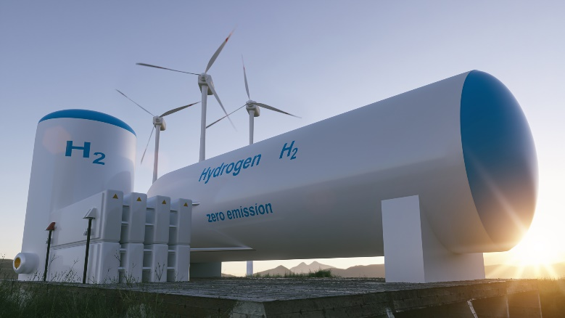
Images

renewable-H2.jpg
Liebherr and ENGIE will evaluate different renewable energies, in particular renewable hydrogen.

Contact person Liebherr
Swann Blaise
Divisional General Manager, Marketing & Business Intelligence
Telephone: +1 757 928 2239
E-Mail: swann.blaise@liebherr.com
Contact person Engie
Volanov & Associés
Telephone: +33 (0)6 88 29 72 37
E-Mail: engie@volanov.com
Published by
Liebherr-Mining Equipment SAS
Colmar / France
www.liebherr.com

