Press release

Looking towards the future

⸺
Toledo-Lucas County Port Authority (TLCPA) is operating two LHM 280 since many years and recently upgraded its crane fleet
A new Liebherr mobile harbour crane type LHM 550 is operational at the port since summer and will contribute to further growth of TLCPA
The new machine allows TLCPA to operate bigger grabs and opens them the business field of heavier project cargo

The Toledo-Lucas County Port Authority recently took delivery of new Liebherr mobile harbour crane technology. The port is already successfully operating two LHM 280 for bulk handling operation since many years and is now preparing for future challenges. A new LHM 550 will give TLCPA the opportunity to handle bigger grabs and heavier project cargo goods.
Rostock (Germany), September 2021 – The Port of Toledo is predominantly industrial and is one of the busiest ports on the Great Lakes. Toledo is a city in Lucas County in the northwest of the US state of Ohio, located southwest of Lake Erie. The Toledo-Lucas County Port Authority has been in charge at the port since 1955.
Since 2010, two LHM 280s have been in operation at the port of Toledo. Both cranes are primarily used for bulk handling. TLCPA is very satisfied with the performance of the cranes and especially appreciates the reliability of the two machines. In order to be able to serve its customers more quickly in the
bulk-handling sector in the future, a new and much more powerful Liebherr mobile harbour crane of the type LHM 550 has been ordered.
The LHM 550 is equipped with a 4.80 meters tower extension and a 54 meters boom for best reach. With a maximum lifting capacity of up to 144 tonnes, the new crane is able to use much larger grabs and thus handle more bulk material in a shorter time. In addition, the significantly higher payload, compared to the two existing machines, opens up the possibility for the customer to handle heavier project cargo in the future.
Investment in future growth
“The investment in a third mobile harbour crane creates a more efficient cargo handling performance at the Port of Toledo that results in shorter lay times for cargo vessels,” said Thomas Winston, President and CEO of Toledo-Lucas County Port Authority, “the new crane means further growth for us, not only in the bulk sector, but also in the project cargo business sector. In addition to increasing performance, the LHM 550 is an eco-efficient crane that has a Tier 4 final emissions standard and a highly efficient hydrostatic drive.”

Shipment by SAL
The new machine was transported in a disassembled state from Rostock, Germany to Toledo, USA. The heavy-lift carrier "Imke" of the SAL shipping company transported the crane over 4000 nautical miles to Toledo, Ohio. At the port of Toledo, the crane was then assembled, tested, and handed over by experienced Liebherr service engineers.

About Liebherr-MCCtec Rostock GmbH
Liebherr-MCCtec Rostock GmbH is one of the leading European manufacturers of maritime material handling solutions. The product range comprises ship, mobile harbour, and offshore cranes. Reachstackers and components for container cranes are also included in the product portfolio.
About the Liebherr Group
The Liebherr Group is a family-run technology company with a highly diversified product portfolio. The company is one of the largest construction equipment manufacturers in the world. It also provides high-quality and user-oriented products and services in a wide range of other areas. The Liebherr Group includes over 140 companies across all continents. In 2020, it employed around 48,000 staff and achieved combined revenues of over 10.3 billion euros. Liebherr was founded in Kirchdorf an der Iller in Southern Germany in 1949. Since then, the employees have been pursuing the goal of achieving continuous technological innovation, and bringing industry-leading solutions to its customers.

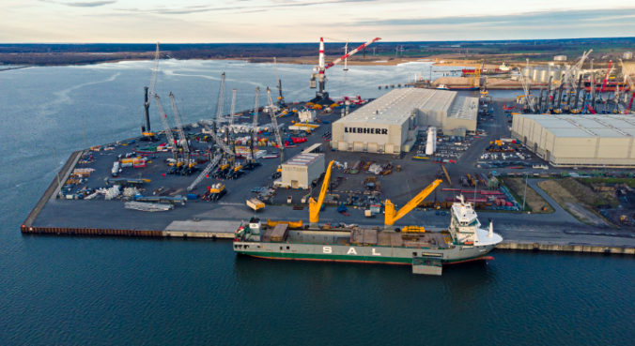
Images
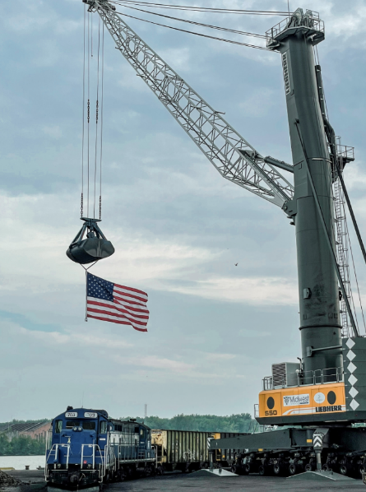
liebherr-lhm-550-toledo-usa.jpg
The new LHM 550 was shipped from Rostock, Germany, to Toledo, USA, by the shipping company SAL.
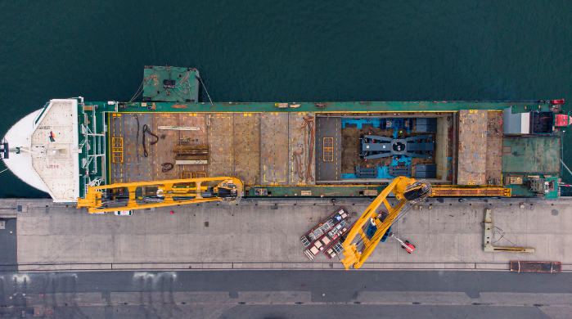
liebherr-lhm-550-toledo-usa-2.jpg
The new machine allows TLCPA to operate bigger grabs and opens them the business field of heavier project cargo.

liebherr-lhm-550-toledo-usa-3.jpg
The heavy-lift carrier "Imke" transported the crane over 4000 nautical miles to Toledo, Ohio.

Contact person
Philipp Helberg
Tel: +49 381 6006 5024
Email: philipp.helberg@liebherr.com

Published by
Liebherr-MCCtec Rostock GmbH
Rostock / Germany
www.liebherr.com

