Press release

Economical in mining operations: third Liebherr L 586 XPower® wheel loader for the Rinsche gravel plant

⸺
Purchasing criteria: low fuel consumption and high power output
Wheel loaders fitted with tyre protection chains for quarry operations
Load-and-carry operations with distances of up to 200 metres
In the Soest Börde in the heart of North Rhine-Westphalia, the Rinsche stone quarry extracts “German bluestone” and “Anröchter greenstone” also known as “Anröchter dolomite”. The Rinsche family business also mines large quantities of gravel. Three L 586 XPower® wheel loaders supplied by Liebherr play a significant part in this. The wheel loaders operate with impressively low consumption levels and high performance in load-and-carry operations they move up to 12 tonnes of limestone marl per loading cycle.
Anröchte (Germany), 26 July 2021 – A third Liebherr L 586 XPower® wheel loader was recently added to the machine park of the Rinsche gravel plant in Anröchte. The key factor in the recent acquisition were the positive experiences of the two previous L 586 XPower® wheel loaders purchased by Managing Director Wilhelm Rinsche in 2019. “With its power split driveline, our L 586 use only around 20 litres of diesel per operating hour. This is approximately 12 litres less than a comparable wheel loader from another manufacturer which we previously had in the quarry. The Liebherr wheel loaders enable us to achieve huge cost savings and greatly reduced CO₂ emissions.
Liebherr L 586 XPower® wheel loaders perform impressively in load-and-carry operations
The low fuel consumption is particularly worth noting because the wheel loaders, weighing more than 33 tonnes, are fitted with a range of special equipment for mining operations. The tyre protection chains are particularly distinctive and weigh up to 800 kilograms each depending on the version. Their main purpose is to improve traction in combination with the automatic self-locking differential. “The limestone soil in our quarries gets muddy and slippery particularly when it has been raining and this means we need the tyre protection chains,” explains Wilhelm Rinsche.
The main task of the wheel loader is to transport blasted material from the quarry face to the crusher. In this load-and-carry operation, the machines cover distances of up to 200 m. The wheel loaders also help with reloading. “Besides the low fuel consumption, we appreciate the consistently high power our Liebherr wheel loaders provide. Whether it's picking up material at the quarry face, travelling or reloading, the wheel loaders always deliver the full power output,” adds Wilhelm Rinsche.
Many years of cooperation between Liebherr and the Rinsche stone quarry
“The L 586 XPower® is Liebherr's largest wheel loader model and – like all XPower® wheel loaders – comes with the robust and efficient power-split travel drive as standard. We are delighted, since the first demonstration in the quarry in 2018, to now be delivering the third L 586 XPower® to Wilhelm Rinsche and his team,” explains Wilfried Holz during the machine hand-over procedure. Wilfried Holz is a sales manager at Liebherr-Baumaschinen Vertriebs- und Service GmbH in Dortmund and looks after Schotterwerk Rinsche GmbH.
Like Liebherr, the Rinsche gravel plant is a long-established family business. The company has 35 employees and owns three quarries in the area between Münster and Sauerland from which it removes approximately 500,000 tons of material annually. The core product is “Anröchter green sandstone”, a particular sandstone with blue and green colouring that is popular around the world as a high-quality and natural building material.
About Liebherr-Werk Bischofshofen GmbH
Liebherr-Werk Bischofshofen GmbH (Austria) develops, produces and sells wheel loaders of the Liebherr Group. The plant in the state of Salzburg has grown steadily over the decades thanks to sustainable innovations, creative solutions and high quality standards. The wheel loader range is constantly being expanded and includes different models in four different product groups: Compact loaders, Stereoloaders, medium-sized wheel loaders and large wheel loaders, which convince with their innovative drive concepts
About the Liebherr Group
The Liebherr Group is a family-run technology company with a highly diversified product portfolio. The company is one of the largest construction equipment manufacturers in the world. It also provides high-quality and user-oriented products and services in a wide range of other areas. The Liebherr Group includes over 140 companies across all continents. In 2020, it employed around 48,000 staff and achieved combined revenues of over 10.3 billion euros. Liebherr was founded in Kirchdorf an der Iller in Southern Germany in 1949. Since then, the employees have been pursuing the goal of achieving continuous technological innovation, and bringing industry-leading solutions to its customers.
Images
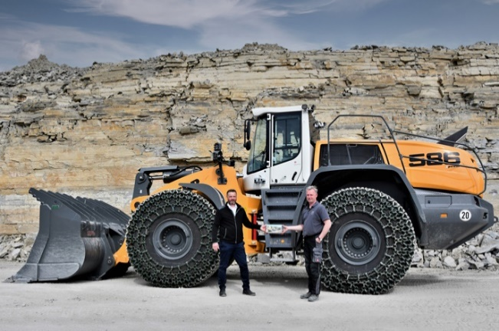
liebherr-wheel-loader-l586-xpower-machine-handover.jpg
Machine handover: Wilhelm Rinsche (right) receives his latest L 586 XPower® from Wilfried Holz (left).

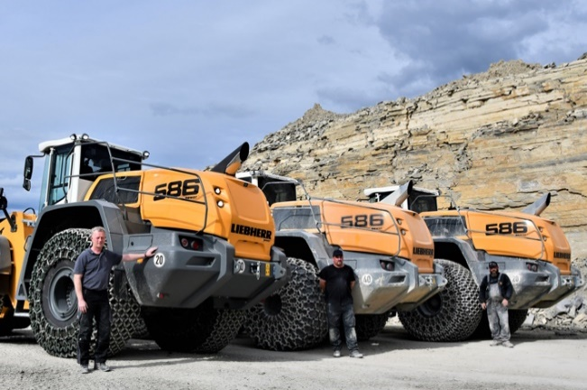
liebherr-wheel-loader-l586-xpower-natursteinwerk-rinsche.jpg
Wilhelm Rinsche (left), together with two machine operators, presents the company’s three Liebherr L 586 XPower® wheel loaders.

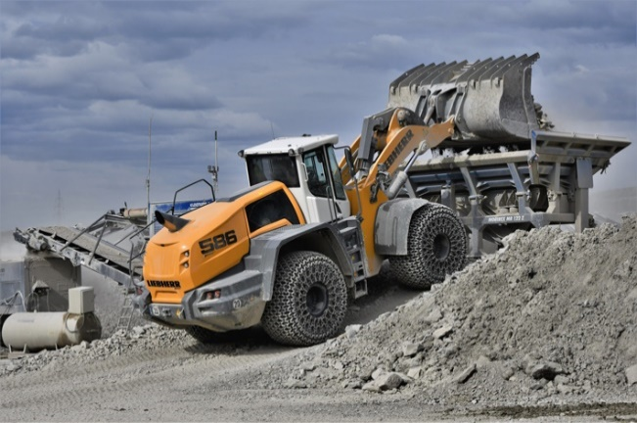
liebherr-wheel-loader-l586-xpower-loading-crusher.jpg
A Liebherr L 586 XPower® wheel loader loading a crusher at the Rinsche gravel plant.

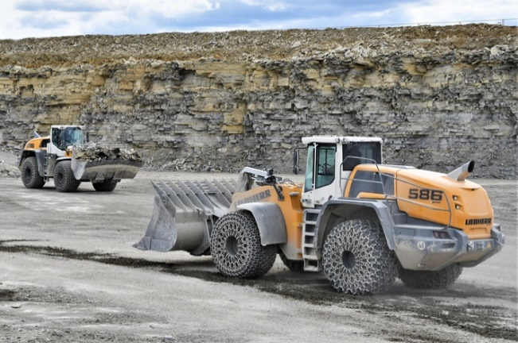
liebherr-wheel-loader-l586-xpower-load-and-carry.jpg
Load-and-carry operation using Liebherr L 586 XPower® wheel loaders in Rinsche gravel plant.

Contact person
Martin Koller
Marketing and Public Relations
Phone: +43 50809 11475
E-Mail: martin.koller.lbh@liebherr.com

Published by
Liebherr-Werk Bischofshofen GmbH
Bischofshofen/Austria
www.liebherr.com

