Press release

Darcy Pacheco increases capacities with a new LTM 1750-9.1

⸺
- Brazilian crane company decides for Liebherr LTM 1750-9.1 due to high capacities at large radius
- LTM 1750-9.1 equipped with boom extensions and 91 meter luffing jib
- First operation of the 800 tonne crane: maintenance of thermoelectric plant
Cargo handling and special transport company Darcy Pacheco Soluções de Peso received its newest mobile crane: the 800-tonne-capacity giant LTM 1750-9.1 arrived in Brazil on June, 10th. Here the 9-axle-crane debuts its operations in maintenance of a thermoelectric plant in the northeast of the country. Darcy Pacheco ordered the heavy-duty crane with telescopic boom extension and 91 metre luffing jib.
Ehingen (Donau), (Germany), 30th August 2021 – Industrial maintenance increasingly demands equipment capable of operating in more restricted areas. What could easily be done with crawler cranes, due to their high lifting capacity at large radii, now often needs machines that are more compact and powerful at the same time. “When we choose for the LTM 1750-9.1, we had its high load capacities at large radii in mind”, says Eduardo Silva, maintenance director for Darcy Pacheco. “With this 800-tonne crane, we are able to perform services that we used to perform with crawler cranes, benefiting from greater mobility and the possibility of operating in more restricted locations”, he adds. The LTM 1750-9.1 mobile crane will operate mainly in the maintenance of industrial plants, such as petrochemicals, pulp industry and maintenance of wind farms.
Darcy Pacheco's LTM 1750-9.1 mobile crane arrived in Brazil equipped with the exclusive Liebherr VarioBase® system. With this variable supporting system, crane work is secured via the LICCON control system even when the crane outriggers are not fully extended, for example in restricted areas. The 800-tonne crane also has ECOdrive: The additional eco mode delivers enhanced drive properties which both save fuel and reduce noise.

“Our partnership with Liebherr has been going on for years. We already had mobile cranes with capacities between 100 and 500 tonnes, and 400 to 750 tonnes crawler cranes in our fleet. Now we have increased capacity with this 800 tonne mobile crane”, as Eduardo Silva highlights about the acquisition of the new LTM 1750-9.1. “We are excited about the possibilities this crane offers. Furthermore, technical support, product quality and the excellent relationship we have with Liebherr are always factors that we take into account when making a decision for the manufacturer.”
About Darcy Pacheco
The Darcy Pacheco Group was founded in 1977 and comprises three companies – Darcy Pacheco Soluções de Peso specialises in hoisting work of all kinds, whilst DPS Wind focuses on assembling and maintenance of wind turbines and Pacheco Logística provides heavy and special haulage services. The three brothers and company founders Adauri, Ademilson and Adaureci Silva represent now the board of the Group while Eduardo, Cristiane, Guilherme and Juliano Silva run the group, which has over 800 employees. In addition to a number of other machines, the Darcy Pacheco Soluções de Peso Fleet includes telescopic mobile cranes with lifting capacities up to 800 tonnes and crawler cranes with lifting capacities up to 750 tonnes.
About Liebherr-Werk Ehingen GmbH
Liebherr-Werk Ehingen GmbH is a leading manufacturer of mobile and crawler cranes. Its range of mobile cranes extends from 2-axle 35 tonne cranes to heavy duty cranes with a lifting capacity of 1200 tonnes and a 9-axle chassis. Its lattice boom cranes on mobile or crawler crane chassis deliver lifting capacities of up to 3000 tonnes. With universal boom systems and extensive additional equipment, they can be seen in action on construction sites throughout the world. The Ehingen site has a workforce of 3,600. Extensive, global service guarantees the high availability of Liebherr mobile and crawler cranes. In 2020, the Liebherr plant in Ehingen recorded a turnover of 2 billion euros.
About the Liebherr Group
The Liebherr Group is a family-run technology company with a widely diversified product range. The company is one of the largest manufacturers of construction machines in the world, but also supplies technically advanced, user-focused products and services in many other sectors. The group currently comprises more than 140 companies based in every continent of the world, has a workforce of over 48,000 and recorded a consolidated total turnover of more than 11.7 billion euros in 2019. Since it was founded in 1949 in Kirchdorf an der Iller in southern Germany, Liebherr’s aim has been to win customers by supplying high quality solutions and to contribute to technological progress.

Photographs
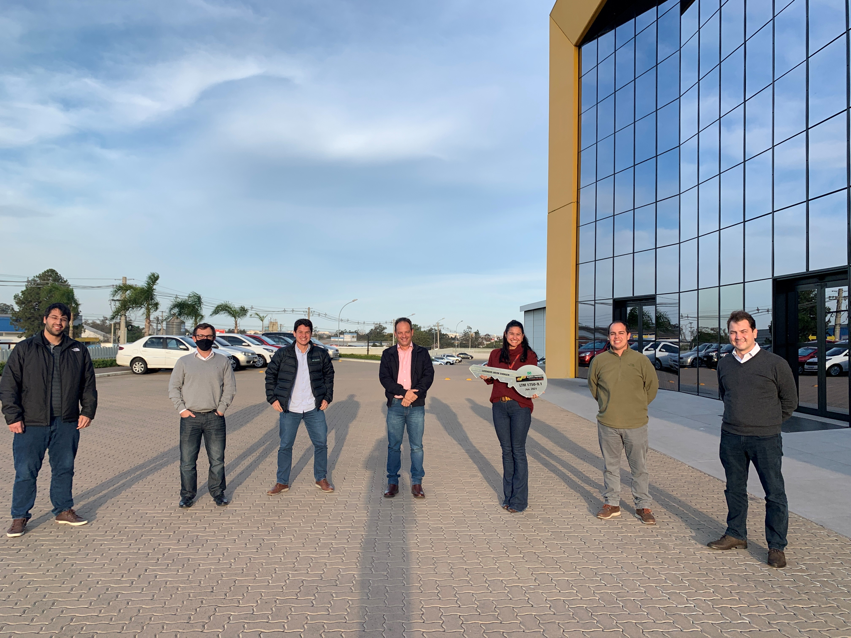
liebherr-ltm-1750-9-1-darcy-pacheco-group.jpg
F.l.t.r.: Juliano Silva (Darcy Pacheco Group), Heron Gayean (Liebherr Brasil Eireli), Guilherme Silva (Darcy Pacheco Group), Juliano Villela (Liebherr Brasil Eireli), Cristine Silva (Darcy Pacheco Group), Eduardo Silva (Darcy Pacheco Group) and Rene Porto (Liebherr Brasil Eireli).

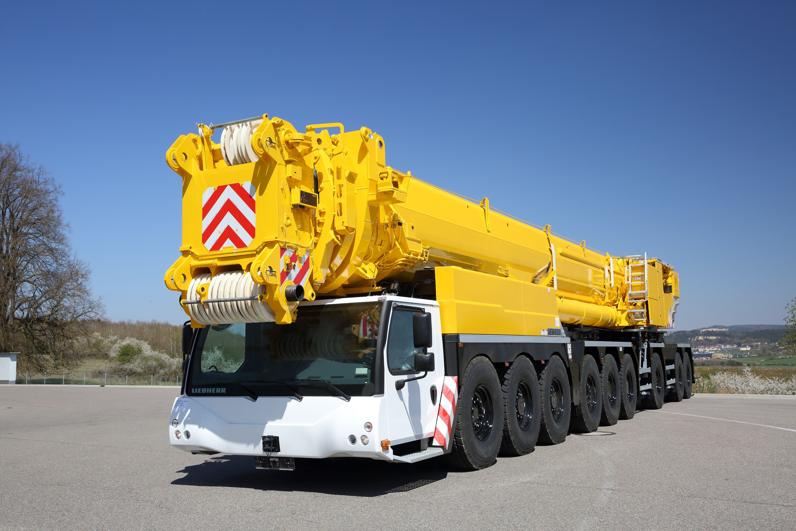
liebherr-ltm-1750-9-1-darcy-pacheco-crane.jpg
The new LTM 1750-9.1 from Darcy Pacheco brings high lifting capacities and state-of-the-art technology to Brazil.

Contact person
Wolfgang Beringer
Marketing and Communication
Phone: +49 7391/502-3663
Email: wolfgang.beringer@liebherr.com
Published by
Liebherr-Werk Ehingen GmbH
Ehingen (Donau) / Germany
www.liebherr.com

