

Press release

Liebherr USA. Co. launches partnership with Advance Technical Institute in new Co-op program for service technicians

⸺

Liebherr USA, Co. creates new heavy equipment co-op program

Signing bonus for eligible new hires upon program completion

Commitment to developing future workforce to provide Liebherr quality service

The new Co-op program offers a unique opportunity for students in Advance Technical Institute’s (ATI) Heavy Vehicle Technology program to train and get hands on experience with Liebherr construction equipment.

Newport News, VA (USA), August 16, 2021 – [Liebherr USA, Co.](https://www.liebherr.com/en/usa/start/start-page.html) launched a new partnership with local Virginia Beach company [Advanced Technology Institute](https://auto.edu) (ATI). In this partnership, Liebherr USA, Co. will host up to six students each year who are attending ATI in the Heavy Vehicle Technology program, studying to be service technicians.

ATI’s [Heavy Vehicle Technology program](https://auto.edu/programs/heavy-vehicle-technology/) offers diesel repair training in a hands-on shop environment where students have the opportunity to work on manual and automatic engines ranging from 400 to 12,000 lbs., developing skills that could lead to a rewarding career as a heavy equipment or diesel mechanic.

Liebherr USA, Co. is sponsoring the hydraulics program at ATI and has made an [L 526](https://www.liebherr.com/en/int/products/construction-machines/earthmoving/wheel-loaders/details/643170.html) wheel loader available for training for all students going through ATI’s hydraulics classes. This partnership allows ATI students to become Liebherr certified as part of their program completion. Upon completion of the Co-op program, Liebherr is offering a signing bonus of 50% of tuition charges for eligible new hires that are offered and accept full-time employment with the company.

The first group of students entered the program in January 2021. While in the Co-op program, they are part time Liebherr employees, working in the earthmoving and mobile cranes divisions repair shops in Newport News, Virginia getting hands on training and experience on the subjects they’re learning in the classroom. “This partnership not only helps to build a pipeline of future talent, it exposes all of ATI’s students to the Liebherr brand, which allows us to build a future workforce of Liebherr employees,” said Vicki Wishon, Liebherr USA Co. Human Resources Manager.

About the Liebherr Group

The Liebherr Group is a family-run technology company with a highly diversified product portfolio. The company is one of the largest construction equipment manufacturers in the world. It also provides high-quality and user-oriented products and services in a wide range of other areas. The Liebherr Group includes over 140 companies across all continents. In 2020, it employed around 48,000 staff and achieved combined revenues of over 10.3 billion euros. Liebherr was founded in Kirchdorf an der Iller in Southern Germany in 1949. Since then, the employees have been pursuing the goal of achieving continuous technological innovation, and bringing industry-leading solutions to its customers.

**About Liebherr USA, Co.**

Liebherr USA, Co. based in Newport News, VA provides sales and service on behalf of nine different Liebherr product segments: earthmoving, mining, mobile and crawler cranes, tower cranes, concrete technology, deep foundation machines, maritime cranes; components, and refrigeration and freezing.

Images

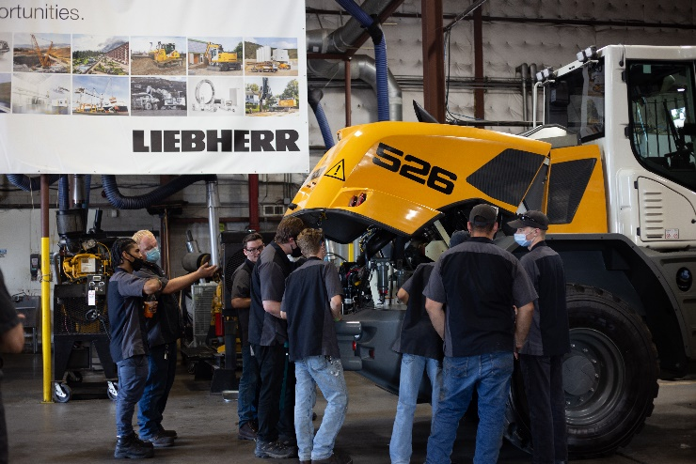

ATI-Wheel Loader Delivery-159.jpg  
**Image Caption:** ATI students examining the wheel loader engine compartment

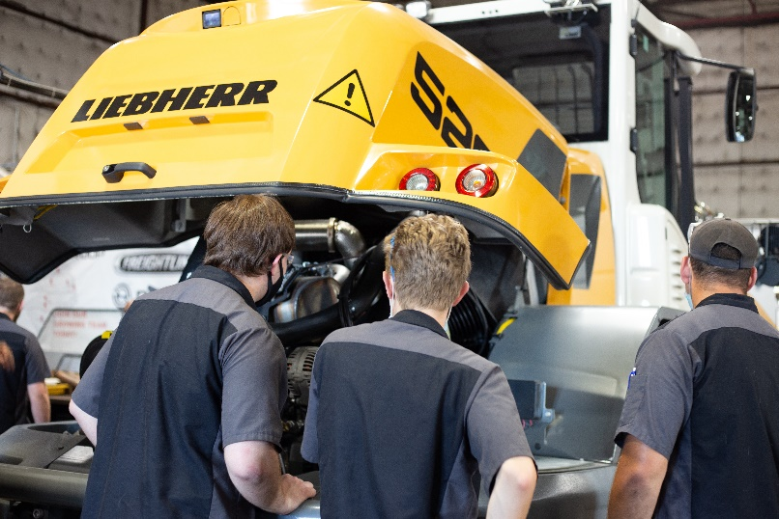

ATI-Wheel Loader Delivery- 166.jpg  
**Image Caption:** ATI students examining the L 526 wheel loader engine compartment

Contact person

Ana Cabiedes  
General Manager, Marketing   
Tel: 757-240-4250  
E-Mail: ana.cabiedes@liebherr.com

Published by

Liebherr USA, Co.   
Newport News / USA  
www.liebherr.com