Press release

Liebherr floating cranes supply North Vietnam with energy

⸺
Long-term customer Oldendorff Carriers purchased seven four-rope grab cranes, type CBG 360
Four cranes are installed on two next-generation transloader vessels in North Vietnam
Three units of CBG 360 have been delivered for a transshipment vessel in West Africa
Liebherr has delivered four transshipment cranes, type CBG 360, to its long-term customer Oldendorff Carriers for a major project in North Vietnam. In the coming years, the cranes, which excel through their reliability and high operating speeds, will be used for power generation in the region. Another three cranes of the same type will be commissioned in West Africa for handling bauxite.
Rostock (Germany), August 2021 – Handling and transporting 100 million tonnes of cargo in 25 years: that is the goal of the NS2 project of Oldendorff Carriers, Germany´s largest bulk shipping company. To achieve this, Oldendorff Carriers' fleet will work with Liebherr floating cranes. The core of the North Vietnamese project is the power plant´s 2 x 600 megawatt power generation units, which supply the region with energy. The CBG-series ensures a continuous turnover of material for the power plant's operation. The deployed cranes are characterised by their long service life and low maintenance requirements, which are a decisive advantage especially on the open seas and in remote areas.
Long-term partnership
Liebherr and Oldendorff Carriers can look back on decades of cooperation based on partnership and trust. Like Liebherr, Oldendorff Carriers is a family-owned company that has been operating successfully on the market for many years. For the large-scale project to supply energy to North Vietnam, they were looking for a low-maintenance handling solution. "Oldendorff Carriers values the reliability of Liebherr products and is therefore also counting on high-performance Liebherr four-rope grab cranes, type CBG 360, for this major project," said Jan Breckling, Senior Sales Manager for transshipment and ship cranes at Liebherr Maritime Cranes, “the CBG is a heavy-duty crane designed for continuous operation. The new equipment will therefore play a crucial and at the same time permanent role in our customer's long-term transshipment project."
Extended action radius
Each of the four CBG 360 floating cranes is installed on a 10-metre-long eccentric platform. This allows an extended operating radius of 46 metres for a lifting capacity of 30 tons. The maximum lifting capacity of 36 tons can be utilized at up to 40 metres. The improved positioning and outreach creates more operational flexibility and makes the unloading of the cargo holds even more efficient.
Captain Johannes van Dijk, Technical Director Projects at Oldendorff Carriers, said: “We needed a robust, reliable cargo handling system for our project in North Vietnam. For that reason, we chose Liebherr CBG 360 cranes, which are high-performance cranes designed for continuous operation.”

The first transloader, “Calypso”, with two CBG 360 cranes went into service at the beginning of 2021 and start of work coincides with Oldendorff Carriers' 100th company anniversary. Like its sister vessel, it has a length of 145 metres and a deadweight capacity of 18,000 tonnes. In West Africa, the “Albert Oldendorff” with three CBG 360 is in operation for bauxite handling. This transshipment vessel is equipped with hoppers and a conveyor system, which leads to a faster turnover of the material. The cranes are installed side-mounted and directly discharge into the hopper conveyer belt system.

About Oldendorff Carriers
Oldendorff Carriers is a 100-year-old family owned shipping company operating a fleet of about 700 bulk carriers and 50 transshipment vessels. The company is represented by 20 offices around the world with 10 bulk Transshipment projects and has a workforce over 4,500 people from 60 countries.
About Liebherr-MCCtec Rostock GmbH
Liebherr-MCCtec Rostock GmbH is one of the leading European manufacturers of maritime material handling solutions. The product range includes ship, mobile harbour and offshore cranes. Reachstackers and components for container cranes are also included in the product portfolio.
About the Liebherr Group
The Liebherr Group is a family-run technology company with a broadly diversified product range. The company is one of the world's largest manufacturers of construction machinery, but also offers high-quality, user-oriented products and services in many other areas. Today, the group comprises more than 140 companies on all continents, employs around 48,000 people and generated a consolidated total turnover of more than 10.3 billion Euros in 2020. Since its foundation in 1949 in Kirchdorf an der Iller in southern Germany, Liebherr has pursued the goal of convincing its customers with sophisticated solutions and contributing to technological progress.
Images
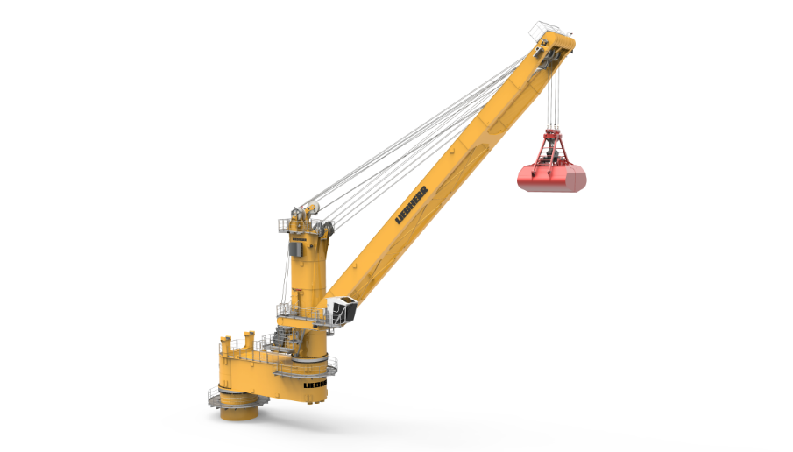

liebherr-CBG 360-Excentre-36mboom.jpg
The 10-metre-long eccentric platform extends the crane's operating radius to 46 metres with a lifting capacity of up to 36 tonnes.

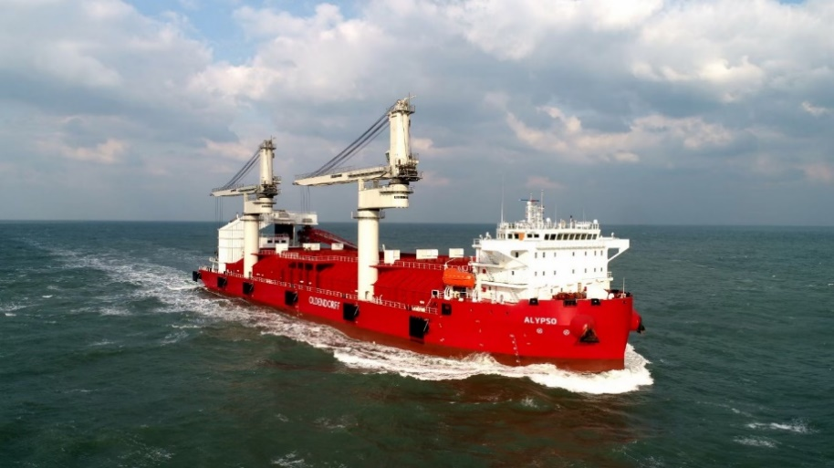

liebherr-CBG360-Calypso-Oldendorff-Carriers.jpg
The “Calypso” with two CBG 360 from Liebherr, which is in operation in North Vietnam to supply energy to the region.

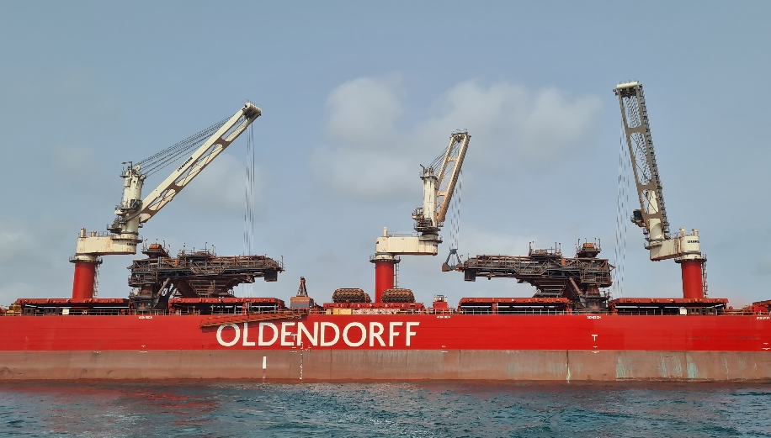

liebherr-CBG360-Albert-Oldendorff-Carriers.jpg
The “Albert Oldendorff” is equipped with three CBG 360, which are currently handling bauxite.

Contact
Stefan Fröbe
Marketing Manager Maritime Cranes
Phone: +49 381 6006 5025
E-Mail: stefan.froebe@liebherr.com
Published by
Liebherr-MCCtec Rostock GmbH
Rostock / Germany
www.liebherr.com

