Press release

Time-tested concept – Max Bögl Group takes delivery of another Liebherr LTR 1220 telescopic crawler crane

⸺
Liebherr telescopic crawler crane application concept has proven its worth at Max Bögl
Economical jobs for assembling prefabricated concrete components
Simple transport and fast set-up time of the LTR 1220 are key features
The Max Bögl Group based in Sengenthal is convinced of the telescopic crawler crane concept. As a result of its good experience with Liebherr machines in the 100 and 220 tonne class, the Bavarian company has now purchased another LTR 1220. It particularly shows its strengths in the assembly of prefabricated concrete components. The crane’s short set-up time on site was another key point behind the decision.
Ehingen (Donau), (Germany), 5 August 2021 – Herbert Wieseckl, Group Leader of the Technical Machines Department at Max Bögl, explains: “The concept of the Liebherr telescopic crane has proven itself. We run several LTR 1100 and LTR 1220 cranes. We are delighted with how quickly they can be moved on site. The cranes are perfectly designed for the economical assembly of prefabricated concrete components, such as columns, girders and floors, and deliver some significant benefits compared to lattice boom cranes. For building logistics centres, for example, the floors may be installed and the LTR can nevertheless drive under them because it can retract its telescopic boom. That is simply not possible for a lattice boom crane.”
High flexibility and good off-road handling
The LTR 1220 combines the advantages of a telescopic crane with those of a crawler crane. The crawler travel gear delivers outstanding off-road handling as well as manoeuvrability with excellent handling. In addition, the full load can be moved with the crane. The advantages of the telescopic crane over a lattice boom crane include the shorter set-up times, simpler transport and the variability of the boom system.
The 60 metre telescopic boom on the LR 1220 can be extended and retracted to the required length quickly and fully automatically. This allows the machine to be driven under obstacles, for example. The telescopic crawler crane also enables large loads to be telescoped using the boom, a feature which is simply not possible with lattice booms. Since, unlike a mobile crane, a crawler crane does not need to be supported it can be relocated on the site quickly and is immediately ready for use again.
Economical transport and erection
In addition to the fact that it is very easy to use and provides excellent visibility with its multiple cameras, Herbert Wieseckl also praises the fast set-up time of the LTR 1220: “Both the clearance height and clearance width when supporting the basic machine are designed so that the trailer can travel underneath the crane for attachment. The crawler carriers and the entire crane can then be erected on site very quickly.”
The crane is self-erecting. The basic machine is moved to the site on a flat-bed trailer and is then supported on the jack-up cylinders. The central ballast, cross carrier, crawler carrier and turntable ballast are installed without an auxiliary crane.
The undercarriage of the LTR 1220 is hydraulically telescoped from the track carrier width of 4.5 m to the intermediate width of 5.88 m or the maximum width of 7.25 m. There are load charts in the LICCON control system for all three crawler widths. On uneven ground, the LTR 1220 can operate at all three widths, and even at a lateral angle of up to 4°, a feature which is also supported by the LICCON control system.

About the Max Bögl Group
With over 6500 highly trained personnel at 40 sites around the world and an annual turnover of over 2 billion euros, Max Bögl is one of the largest construction contractors in the German construction industry. Since it was founded in 1929, the company’s history has been dominated by innovation in research and engineering – from bespoke individual solutions to sustainable, ecological packaged construction solutions. With pioneering in-house developments for the major topics of our time, such as renewable energy, urbanisation, mobility and infrastructure, the group is already producing solutions for the megatrends of our globalised world. Based on long experience and competence in high precision prefabricated concrete construction, Max Bögl is also positioning itself as a major player in the development of innovative products, technologies and construction methods.
About Liebherr-Werk Ehingen GmbH
Liebherr-Werk Ehingen GmbH is a leading manufacturer of mobile and crawler cranes. Its range of mobile cranes extends from 2-axle 35 tonne cranes to heavy duty cranes with a lifting capacity of 1200 tonnes and a 9-axle chassis. Its lattice boom cranes on mobile or crawler crane chassis deliver lifting capacities of up to 3000 tonnes. With universal boom systems and extensive additional equipment, they can be seen in action on construction sites throughout the world. The Ehingen site has a workforce of 3,600. Extensive, global service guarantees the high availability of Liebherr mobile and crawler cranes. In 2020, the Liebherr plant in Ehingen recorded a turnover of 2 billion euros.
About the Liebherr Group
The Liebherr Group is a family-run technology company with a widely diversified product range. The company is one of the largest manufacturers of construction machines in the world, but also supplies technically advanced, user-focused products and services in many other sectors. The group currently comprises more than 140 companies based in every continent of the world, has a workforce of around 48,000 and recorded a consolidated total turnover of more than 10.3 billion euros in 2020. Since it was founded in 1949 in Kirchdorf an der Iller in southern Germany, Liebherr’s aim has been to win customers by supplying high quality solutions and to contribute to technological progress.

Photograph:

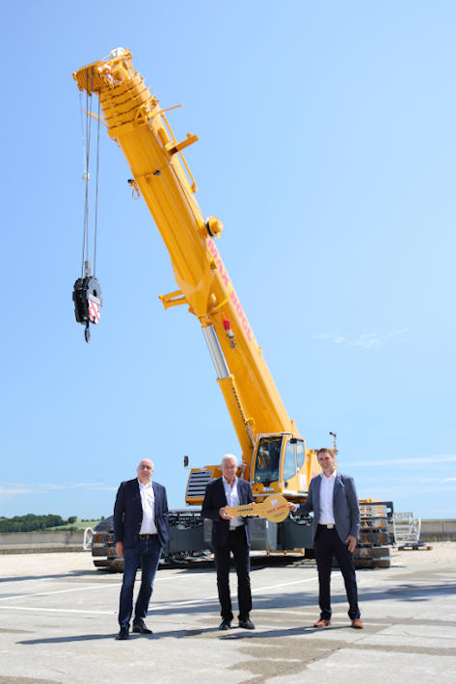
liebherr-ltr1220-boegl.jpg
Crane handover in Ehingen (from left to right): Wolfgang Sailer (Liebherr-Werk Ehingen GmbH), Herbert Wieseckl (Max Bögl Group), Florian Maier (Liebherr-Werk Ehingen GmbH).

Contact person:
Wolfgang Beringer
Marketing and Communication
Phone: +49 7391/502-3663
E-Mail: wolfgang.beringer@liebherr.com
Published by
Liebherr-Werk Ehingen GmbH
Ehingen (Donau) / Germany
www.liebherr.com

