Press release

Liebherr in Ehingen switches to climate-neutral HVO fuel

⸺
The use of hydrogenated vegetable oils (HVO) to power vehicles and machines is essentially CO2-neutral
Flexible use of HVO in pure form or added to fossil diesel for existing internal combustion engines in Liebherr mobile and crawler cranes all over the world
Annual reduction of up to 6500 tonnes of greenhouse gas by switching to HVO at Liebherr’s plant in Ehingen

From September 2021, Liebherr-Werk Ehingen GmbH will power its mobile and crawler cranes exclusively using pure HVO fuel. HVO fuels which comply with standard EN 15940 with a base of hydrated vegetable oils and other synthetic fuels produced using renewable energies can make a valuable contribution to reducing global emissions of greenhouse gases. All Liebherr engines up to the 560 KW power class are approved for operation with HVO.
Ehingen (Donau), (Germany), 2 August 2021 – Modern HVO is a synthetic fuel manufactured mainly from vegetable and animal oil and fat waste from the food industry. This is converted into hydrocarbons by adding hydrogen. HVO is an abbreviation which stands for hydrogenated vegetable oils. The major benefit of HVO is that using it as a fuel instead of fossil diesel is essentially CO₂-neutral. In the future, this fuel will be used in all Liebherr mobile and crawler cranes. One of Liebherr’s main focus is to ensure, in partnership with its HVO suppliers and manufacturers, that no foodstuffs, particularly palm oil, are used in the production of its HVO.
Liebherr mobile and crawler cranes – ready for action with HVO
The conversion from fossil diesel to HVO fuel will apply to the crane acceptance procedure and test drives as well as to the initial fuelling of cranes before delivery. Over the last few months, Liebherr has been working on preparing its entire range of mobile and crawler cranes for use with HVO. For this purpose, the diesel engines were first checked, certified and approved by the manufacturers. The cranes have also undergone extensive testing and trials with pure HVO by customers and in the company’s own Test Department.
Dr. Ulrich Hamme, Managing Director Design and Development at Liebherr in Ehingen comments: “If we consider the entire life-cycle of a crane from cradle to grave, including its production, CO₂ emissions from a five-axle crane using HVO fall by 74 percent compared to a crane powered by diesel. This was shown in a study and calculation carried out by business consultancy Frontier Economics. This is an important step in reducing CO₂ emissions.” The main reduction in CO₂ emissions is during the operating phase – which is particularly significant for Liebherr cranes due to their high quality and the resultant long service life. To achieve the maximum possible CO₂ reductions, the crane must be powered permanently using pure HVO.

HVO is also an alternative fuel for existing fleets
HVO and synthetic fuels made using renewable energy sources are an interesting concept for Liebherr as they are suitable for use in existing machines right now. Liebherr attaches a great deal of value to the durability of its products. Alternative fuel types such as HVO enable older Liebherr machines with internal combustion engines to be operated in essentially climate-neutral form. For all Liebherr engines up to the 560 KW power class, for example, they are approved for operation with HVO. In Europe, but also in Asia, Africa or South America, lots of machines with internal combustion engines continue in use for a great many years and therefore also affect our climate. As HVO can be added to fossil diesel fuel in any ratio and used with conventional internal combustion engines, most of these machines in existing fleets all over the world can in fact be powered effectively with HVO right away. The CO₂ saving is reduced accordingly with a lower HVO content in the fuel mixture.
One of the challenges, in part, is the practicability and availability of alternative fuels. “To make HVO or other synthetic fuels attractive for crane operators, they must be available nationwide and in plentiful quantities at filling stations, as is the case today with diesel. That will not be possible from one day to the next. But Liebherr is making a start, and we are hopeful that it will have a signal effect”, says Hamme.
Production Director at Liebherr-Werk Ehingen GmbH, Ulrich Heusel, continues: “Germany has included synthetic, paraffin-based fuels, which do not yet comply with EN 15940 (XTL), in its regulations relating to the quality of fuels. This is why HVO is not yet available at the filling station network. HVO is available at public filling stations for road vehicles in Finland, Sweden, Denmark, Norway, the Netherlands and Belgium as an additive for fossil diesel fuel or in pure form.”
Reductions in CO₂ emissions by using HVO in vehicle at the plant in Ehingen
Liebherr has also analysed all of its plant transport vehicles at the Ehingen site. The results show that the fleet can also be powered by HVO with a few exceptions. Liebherr is therefore planning to switch these vehicles to the climate-neutral fuel in the near future.
“As a result, we will be able to save 2.5 million litres of fossil diesel per year by switching to HVO fuel. That will mean an annual reduction of around 6500 tonnes of CO₂”, is how Heusel describes the expected result of the action at Liebherr’s Ehingen plant.

About Liebherr-Werk Ehingen GmbH
Liebherr-Werk Ehingen GmbH is a leading manufacturer of mobile and crawler cranes. Its range of mobile cranes extends from 2-axle 35 tonne cranes to heavy duty cranes with a lifting capacity of 1200 tonnes and a 9-axle chassis. Its lattice boom cranes on mobile or crawler crane chassis deliver lifting capacities of up to 3000 tonnes. With universal boom systems and extensive additional equipment, they can be seen in action on construction sites throughout the world. The Ehingen site has a workforce of 3,600. Extensive, global service guarantees the high availability of Liebherr mobile and crawler cranes. In 2020, the Liebherr plant in Ehingen recorded a turnover of 2 billion euros.
About the Liebherr Group
The Liebherr Group is a family-run technology company with a widely diversified product range. The company is one of the largest manufacturers of construction machines in the world, but also supplies technically advanced, user-focused products and services in many other sectors. The group currently comprises more than 140 companies based in every continent of the world, has a workforce of around 48,000 and recorded a consolidated total turnover of more than 10.3 billion euros in 2020. Since it was founded in 1949 in Kirchdorf an der Iller in southern Germany, Liebherr’s aim has been to win customers by supplying high quality solutions and to contribute to technological progress.

Photographs
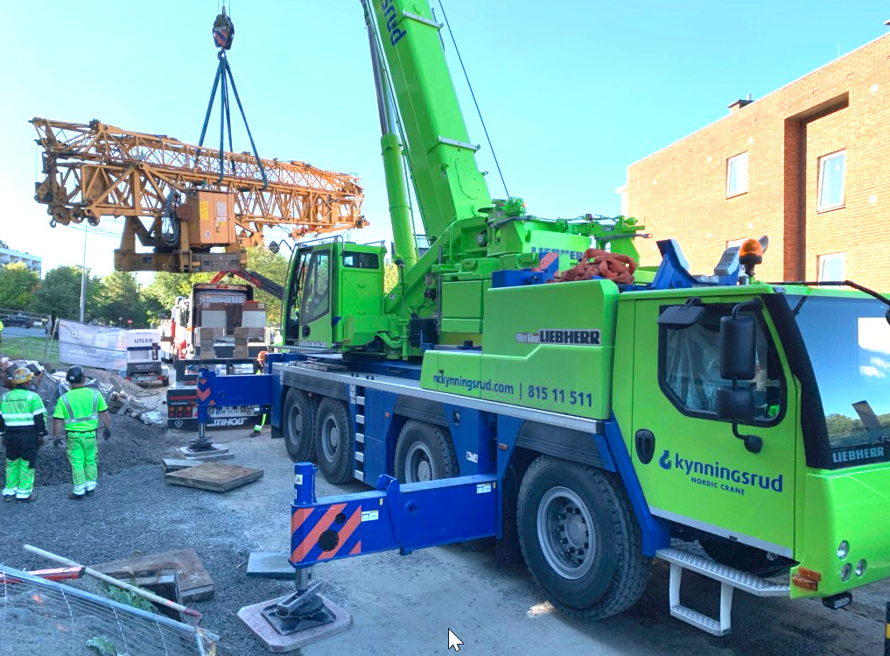
liebherr-hvo-test-kynningsrud.jpg
Liebherr trials the use of HVO fuel in an LTM 1090-4.2 mobile crane in Norway.

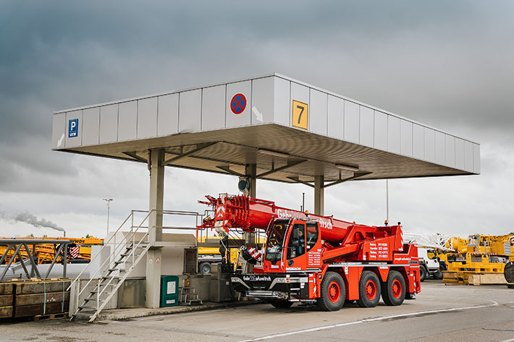
liebherr-hvo-filling-station-ehingen.jpg
The filling station at the Liebherr plant in Ehingen will shortly be converted to HVO fuel.

Contact person
Wolfgang Beringer
Marketing and Communication
Phone: +49 7391/502-3663
E-Mail: wolfgang.beringer@liebherr.com
Published by
Liebherr-Werk Ehingen GmbH
Ehingen (Donau) / Germany
www.liebherr.com

