Press release

Bruns Kranvermietung based in Lüneburg takes delivery of its first Liebherr mobile crane

⸺
LTM 1070-4.2 delivers increased mobility and flexibility with a 10 tonne axle load
The variable VarioBase® supporting base was a major factor behind the decision
Time-tested Liebherr 70 tonne crane features the very latest mobile crane technology
Bruns Kranvermietung GmbH based in Lüneburg has taken delivery of its first Liebherr mobile crane, an LTM 1070-4.2. The mobility, flexibility and technical innovations on the Liebherr 70 tonne crane persuaded the company to buy it. Simpler driving permits with a 10 tonne axle load and the VarioBase® variable supporting base were major criteria behind the northern German company ordering its first mobile crane from Liebherr.
Ehingen (Germany), 27 July 2021 – A. Keck from Bruns Kranvermietung said: “The fact that the LTM 1070-4.2 can be driven with an axle load of just 10 tonnes delivers enormous benefits because we now face significant licensing conditions in the rural area around our company base for the usual 12 tonne axle load on mobile cranes.”
In mobile crane development, Liebherr focuses on meeting different axle load requirements in order to be able to be economically mobile worldwide. In fact, even in countries and areas where mobile cranes with a 12 tonne axle load are permitted on the roads, crane operators have for some time been demanding cranes which can be driven with 10 tonnes per axle by simply removing the ballast. This version delivers major benefits for obtaining licences and route permits.
The LTM 1070-4.2 can carry 10.7 tonnes of ballast and its double folding jib with an axle load of 12 tonnes, whilst it can still carry 3.8 tonnes of counterweights with a 10 tonne axle load. That enables it to carry out a whole host of crane jobs because with the boom fully raised its lifting capacity is hardly affected, even with reduced ballast.
State of the art crane technology
Liebherr originally launched the 70 tonne crane with its 50 metre telescopic boom with the model name LTM 1070-4.1. New technical features such as speed-dependent rear axle steering, disc brakes and the new LICCON2 controller were added in 2008 and the model name was changed to LTM 1070-4.2. Afterwards Liebherr continuously updated the model to keep it up with the state of the art in mobile crane technology. For example, technical innovations such as VarioBase®, ECOmode, new crane cabs, new one-piece steel wheel rims and the latest generation of disc brakes have been added to it. More than 2000 cranes of this model have now been delivered by Liebherr to customers all over the world.
“Liebherr’s VarioBase® has an excellent reputation in the industry and is a pioneer among systems which enable cranes to operate safely with a reduced supporting base. That was a strong argument in favour of us buying from Liebherr. It enables us to react flexibly to a wide range of situations on sites. What is more, VarioBase® actually makes the crane more powerful if it can operate immediately above the outriggers”, said Keck.
The operators, who received general and induction training on the new crane at the actual Liebherr plant in Ehingen, are full of praise for their new tool. Keck summed up their impressions: “Liebherr does a great deal for the crane operators. Everything is very comfortable, including the premium, air-conditioned seats. The driver's cab is very spacious and the crane cab delivers superb all-round visibility – a whole new level for operators. Setting up the crane using the BTT control console and its simple extension to complete remote control are unique.”

About the Bruns Group
Bruns was founded in 1924 as a construction contractor, but now focuses on the heavy haulage sector and mobile crane rental. The purchase of its first mobile crane in 1967 saw the birth of what is now Bruns Kranvermietung, a reliable partner for hoisting, relocation and transport services in the Lüneburg and Süderelbe region. The purchase of Alex Grund GmbH Kranarbeiten und Transporte in 2002 means that the company now also has a foothold in Hamburg.
About Liebherr-Werk Ehingen GmbH
Liebherr-Werk Ehingen GmbH is a leading manufacturer of mobile and crawler cranes. Its range of mobile cranes extends from 2-axle 35 tonne cranes to heavy duty cranes with a lifting capacity of 1200 tonnes and a 9-axle chassis. Its lattice boom cranes on mobile or crawler crane chassis deliver lifting capacities of up to 3000 tonnes. With universal boom systems and extensive additional equipment, they can be seen in action on construction sites throughout the world. The Ehingen site has a workforce of 3,600. Extensive, global service guarantees the high availability of Liebherr mobile and crawler cranes. In 2020, the Liebherr plant in Ehingen recorded a turnover of 2 billion euros.
About the Liebherr Group
The Liebherr Group is a family-run technology company with a widely diversified product range. The company is one of the largest manufacturers of construction machines in the world, but also supplies technically advanced, user-focused products and services in many other sectors. The group currently comprises more than 140 companies based in every continent of the world, has a workforce of around 48,000 and recorded a consolidated total turnover of more than 10.3 billion euros in 2020. Since it was founded in 1949 in Kirchdorf an der Iller in southern Germany, Liebherr’s aim has been to win customers by supplying high quality solutions and to contribute to technological progress.

Photograph:

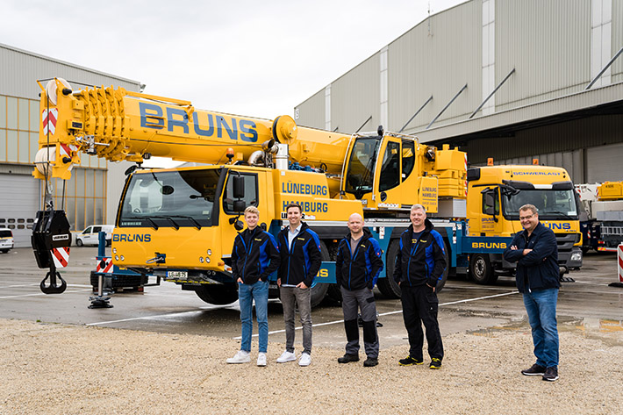
liebherr-ltm1070-4-2-bruns.jpg
Crane handover in Ehingen (from left to right): H. Bruns, A. Keck, T. Walter, O. Bostjancic (all from Bruns Kranvermietung GmbH), J. Fähse (Liebherr-Werk Ehingen GmbH).

Contact person:
Wolfgang Beringer
Marketing and Communication
Phone: +49 7391/502-3663
Email: wolfgang.beringer@liebherr.com
Published by
Liebherr-Werk Ehingen GmbH
Ehingen (Donau) / Germany
www.liebherr.com

