Press release

Premiere – prefabricated constructions specialist Pekabex invests in Liebherr mobile crane

⸺
Prefabricated constructions specialist Pekabex has purchased its first mobile crane – an LTM 1160-5.2
Pekabex is a leading manufacturer of prefabricated constructions and concrete components as well as a general contractor for construction investments
LTM 1160-5.2 combines efficiency and power
“This is our company’s very first mobile crane. We have never had this type of machine before”, says Grzegorz Dużyński. He is Head of the Assembly Department at Polish prefabricated constructions specialist Pekabex. The group has had a Liebherr LTM 1160-5.2 available to it since the start of May 2021. Pekabex is one of the leading manufacturers of prefabricated constructions and concrete components in Poland.
Ehingen (Donau), (Germany), 15 July 2021 – Grzegorz Dużyński explains: “What mainly convinced us was the reliability of Liebherr machines and the company’s service, which is at the highest level. Liebherr’s quality standard and experience are the same foundations as those on which our company is based.”
LTM 1160-5.2 combines power and efficiency
The Liebherr LTM 1160-5.2 mobile crane features high lifting capacities, great economy and versatility. Thanks to Liebherr’s innovative VarioBase® and VarioBallast® systems, the crane can adjust its outriggers and its ballast radius to suit specific site situations. These smart systems deliver higher lifting capacities as well as maximum safety even when the crane is used in constricted conditions. “We were looking for a crane with a 180 tonne capacity, which can reach sites with difficult access”, says Grzegorz Dużyński. “The LTM 1160-5.2 will make things a great deal easier for us. We often have to work on constricted sites with very heavy, large modules.”
The Pekabex Group has been active on the Polish and other markets for 49 years. Pekabex currently manufactures around 230,000 cubic metres of prefabricated prestressed and reinforced concrete components at five factories in Poland and one in Germany. These include ceiling beams, roof trusses, walls, hollow chamber panels, slabs and supports.
“We need a reliable machine which can manage the challenges posed by the growing number of homes we are building in Poland”, says Grzegorz Dużyński. “The crane will also move between sites and be used both to build residential units and industrial buildings.” The group plans to make further investments and increase its presence on the European market.
About Pekabex
The Pekabex Group has over 2000 employees and supplies solutions for the design, production, delivery and assembly of structures. The company also acts as a lead contractor for construction projects which involve prefabricated reinforced concrete components. Pekabex tackles construction projects of all types, such as industrial buildings, residential and office buildings, infrastructure projects and a very wide range of special projects.

About Liebherr-Werk Ehingen GmbH
Liebherr-Werk Ehingen GmbH is a leading manufacturer of mobile and crawler cranes. Its range of mobile cranes extends from 2-axle 35 tonne cranes to heavy duty cranes with a lifting capacity of 1200 tonnes and a 9-axle chassis. Its lattice boom cranes on mobile or crawler crane chassis deliver lifting capacities of up to 3000 tonnes. With universal boom systems and extensive additional equipment, they can be seen in action on construction sites throughout the world. The Ehingen site has a workforce of 3,600. Extensive, global service guarantees the high availability of Liebherr mobile and crawler cranes. In 2020, the Liebherr plant in Ehingen recorded a turnover of 2 billion euros.
About the Liebherr Group
The Liebherr Group is a family-run technology company with a widely diversified product range. The company is one of the largest manufacturers of construction machines in the world, but also supplies technically advanced, user-focused products and services in many other sectors. The group currently comprises more than 140 companies based in every continent of the world, has a workforce of around 48,000 and recorded a consolidated total turnover of more than 10.3 billion euros in 2020. Since it was founded in 1949 in Kirchdorf an der Iller in southern Germany, Liebherr’s aim has been to win customers by supplying high quality solutions and to contribute to technological progress.

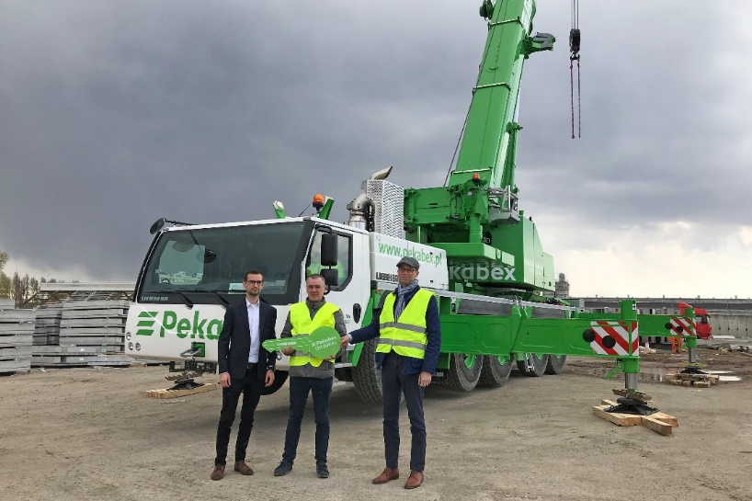
Photograph
liebherr-ltm1160-5-2-pekabex.jpg
Crane handover in Poland (from left to right): Szymon Nowacki (Liebherr-Polska sp. z o.o.), Grzegorz Dużyński (Pekabex Bet S.A. – Head of the Assembly Department), Przemysław Borek (Pekabex Bet S.A. – President of the Board of Pekabex Bet S.A.).

Contact person
Wolfgang Beringer
Marketing and Communication
Phone: +49 7391/502-3663
Email: wolfgang.beringer@liebherr.com

Published by
Liebherr-Werk Ehingen GmbH
Ehingen (Donau) / Germany
www.liebherr.com

