Press release

Liebherr-Aerospace puts a new machining center integrating a Liebherr robot into operation

⸺
Liebherr-Aerospace Toulouse SAS, Liebherr’s center of excellence for air management systems, has put into operation at its production site in Campsas (France), a new high capacity five-axis machining center featuring a state-of-the-art rotary pallet loading system. Liebherr-Verzahntechnik GmbH, Liebherr’s center of excellence for gear technology and automation systems, supplied the robot. This innovation allows Liebherr-Aerospace to strengthen and modernize its production capacities and opens the door for Liebherr-Verzahntechnik to enter the aerospace market.
Toulouse (France). July 2021 – The production site of Liebherr-Aerospace Toulouse SAS in Campsas (France) has put into operation a new five-axis high capacity machining center including a robot, which palletizes the machine’s tools.
The machining center of the next generation features a six-wheel tool magazine, which contains 363 cutting tools. It is equipped with a 52 kW/430 Nm milling spindle that can rotate at 12,000 rpm. In addition, an IoT connector package enables real-time monitoring of the equipment and remote maintenance. The rotary loading system can lift up to 1.5 tons and stores up to 15 work pieces in its cell. The different modes of control ensure autonomy and flexibility in production. Waiting times are thus significantly reduced and Liebherr-Aerospace can respond and adapt even better to future market demands. As a man/machine interface, this new system will also facilitate the work of operators by refocusing them on high value-added tasks.
Optimal use of synergies within the Liebherr Group
The rotary loading system was jointly developed by teams of Liebherr-Verzahntechnik GmbH in Kempten (Germany), center of excellence for gear technology and automation systems, and Liebherr-Aerospace Toulouse SAS, center of excellence for air management systems within the Liebherr Group. This close internal cooperation has not only allowed a technological evolution of machining centers, but also laid a sound foundation for future collaborations between the two companies.

« During the pre-investment consultation phases, the integration of Liebherr-Verzahntechnik in our project had several advantages in terms of technology and synergy potential within the Liebherr Group. From the design phase to the entry-into-service, the mutual trust and communication were the main drivers for success. Having Liebherr-Verzahntechnik as an industrial partner allows us to continuously improve the reliability of our production means and to guarantee best performance. Thanks to the flexibility and configuration of this robot, we will be able to meet the new requirements of our customers and ensure future increases in production rate, » explains Mathieu Oulié, Methods Engineer at Liebherr-Aerospace Toulouse SAS.
“For Liebherr-Verzahntechnik, it was important to be able to offer a solution tailored to one of the specific needs of the aerospace market. Based on the RLS 1500, we have integrated a special pallet gripping system enabling to preserve the specific pallets (zero point system) already used by Liebherr-Aerospace Toulouse, while allowing a higher load capacity and a larger size. The whole Liebherr Group benefits from this "win-win" cooperation between our two divisions, improving the productivity of one and allowing access to a new market for the other”, explains Charles Mannocci, Country Manager Automation Systems at Liebherr-Verzahntechnik GmbH.

About Liebherr-Aerospace Toulouse SAS
Liebherr-Aerospace Toulouse SAS develops, manufactures, distributes and services air management systems for aircraft. The number 1 systems provider among the world’s leading providers, Liebherr-Aerospace Toulouse supports its customers, which include aircraft and helicopter manufacturers, as well as airlines, with their projects. The company employs 1,500 people at its two sites in Toulouse and Campsas (Tarn-et-Garonne), and achieved a turnover of € 402 million in 2020. Liebherr-Aerospace Toulouse SAS is a subsidiary of the aerospace and transportation systems divisional control company of the Liebherr Group.

About Liebherr-Verzahntechnik GmbH
Founded in 1969, Liebherr-Verzahntechnik GmbH now employs around 1,700 staff worldwide. There are currently 1,300 employees working at the headquarters in Kempten. In 2020, the Allgäu-based company achieved a turnover of 213 million euros. More information about Liebherr-Verzahntechnik GmbH: www.liebherr.com/geartechnology

About the Liebherr Group
The Liebherr Group is a family-run technology company with a highly diversified product portfolio. The company is one of the largest construction equipment manufacturers in the world. It also provides high quality and user-oriented products and services in a wide range of other areas. The Liebherr Group includes over 140 companies across all continents. In 2020, it employed around 48,000 staff and achieved combined revenues of over 10.3 billion euros. Liebherr was founded in Kirchdorf an der Iller in Southern Germany in 1949. Since then, the employees have been pursuing the goal of achieving continuous technological innovation, and bringing industry-leading solutions to its customers.

Image
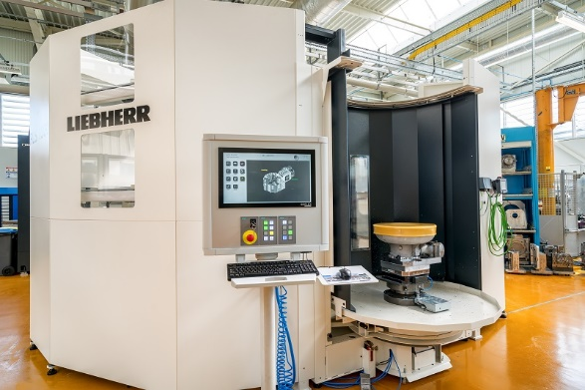
liebherr-aerospace-toulouse-new-machine-campsas-copyright-liebherr.jpg
New high capacity fixe-axis machining center integrating for the first time a state-of-the-art rotary pallet loading system by Liebherr - © Liebherr

Contact person
Ute Braam
Corporate Communication
Telefon: +49 8381 46 4403
E-Mail: ute.braam@liebherr.com
Published by
Liebherr-Aerospace & Transportation SAS
Toulouse / France
www.liebherr.com

