Press release

1,300 maritime cranes – from Rostock to the world

⸺
Liebherr Rostock has manufactured and delivered 1,300 maritime cranes since 2005
Crane number 1,300 was shipped from Rostock, Germany to Ghana in June
Thanks to continuous innovation, Liebherr remains the world market leader in mobile harbour cranes

Since the start of production in 2005, Liebherr-MCCtec Rostock GmbH has manufactured and delivered well over 1,000 maritime cranes. Today, the numerous mobile harbour, ship and offshore cranes are in use in over 100 countries on all continents. Now the 1,300th crane has left the Rostock premises to its destination in Ghana.
Rostock (Germany), June 2021 - Slowly, ship cranes on the heavy-lift vessel BBC-Russia raise the new machine over the quay edge. The LHM 550 is one of two Liebherr mobile harbour cranes that will, in a few hours, begin the 5,500-kilometre journey to Ghana. On receiving their new machines, the West African Port of Tema is expanding its fleet of cranes for container handling. This delivery marks the eighth mobile harbour crane from Rostock to the port operator: Ghana Ports and Harbours Authority (GPHA).
"We have a longstanding partnership with Liebherr. We are impressed with both Liebherr products and their service. It is not only the individual consulting but also the fast delivery that has promoted an expansion and increase of our business," says Ing. Stephen Kwamina Owiah, Port Logistics Manager GPHA.
The berths adjacent to the Liebherr factory in Rostock's port are accessible to ships with a draught of up to 13 metres and are free from shipping obstacles such as locks and bridges. The factory’s direct connection to the Baltic Sea makes it possible to load the fully-assembled cranes, in working order. As such, the two machines boarding the BBC-Russia are timeously ready for use after arrival at the port of destination.
"The Rostock international port offers us ideal conditions for shipping the often large-dimensioned equipment. We now load 60-65 percent of the cranes in fully assembled condition," says Gregor Levold, General Manager - Shipping and Heavy Lift Handling at Liebherr-MCCtec Rostock GmbH.
An experienced team makes use of various loading options when shipping the cranes. An example is the roll on/roll off (RoRo) procedure on board special ships which enables the machines to travel independently from the quay onto the vessel. The loading onto the BBC-Russia is being carried out in the lift on/lift off (LoLo) procedure. The LoLo procedure involves cargo being lifted up onto the ship using on-board cranes. However, road freight also offers advantages for many customers due to the immediate proximity of the Liebherr factory to the German motorway network.
World market leader in mobile harbour cranes
It is not only the good infrastructural links that ensure the success of Liebherr-MCCtec Rostock GmbH. One of the reasons Liebherr has been the world market leader of mobile harbour cranes for over 10 years is their commitment to high customer satisfaction. Through worldwide customer service Liebherr takes care of customer machines, even in times of crisis, to ensure that ports are able to provide supplies to their people. Despite the worldwide lockdown as a result of the COVID-19 pandemic, Liebherr mobile harbour cranes remained functional in ports across the world.
"More than 1,000 colleagues are close to our customers every day in our numerous service companies around the world. Together we are continuously developing our cranes," says Andreas Müller, Sales Director for Mobile Harbour Cranes at Liebherr-MCCtec Rostock GmbH.
Innovations as a constant companion
In addition to the worldwide customer service network, it is the continuous technical development of the cranes and assistance systems that gives Liebherr's customers the decisive edge. In future, the mobile harbour crane series is set to run on the fossil-free HVO 100 diesel. The diesel reduces emissions by up to 90% and is derived from renewable raw materials. Additionally, a fundamentally revised hybrid drive for the Mobile Harbour Crane will be introduced shortly. The revision will allow users to switch between two different modes: the boost mode which provides extra power for faster handling, and the eco mode which significantly reduces fuel consumption. The future-oriented hybrid drive offers the user a high degree of flexibility. Depending on the individual situation, the innovative system can be individually tuned and thus delivers optimal performance in every situation.

About Liebherr-MCCtec Rostock GmbH
Liebherr-MCCtec Rostock GmbH is one of the leading European manufacturers of maritime material handling solutions. The product range comprises ship, mobile harbour, and offshore cranes. Reachstackers and components for container cranes are also included in the product portfolio.
About the Liebherr Group
The Liebherr Group is a family-run technology company with a highly diversified product portfolio. The company is one of the largest construction equipment manufacturers in the world. It also provides high-quality and user-oriented products and services in a wide range of other areas. The Liebherr Group includes over 140 companies across all continents. In 2020, it employed around 48,000 staff and achieved combined revenues of over 10.3 billion euros. Liebherr was founded in Kirchdorf an der Iller in Southern Germany in 1949. Since then, the employees have been pursuing the goal of achieving continuous technological innovation, and bringing industry-leading solutions to its customers.

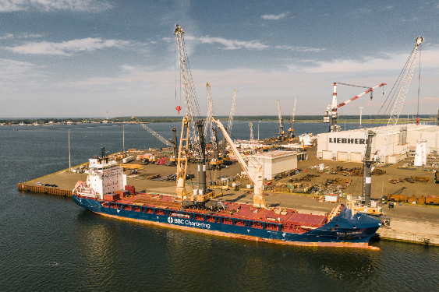
Images
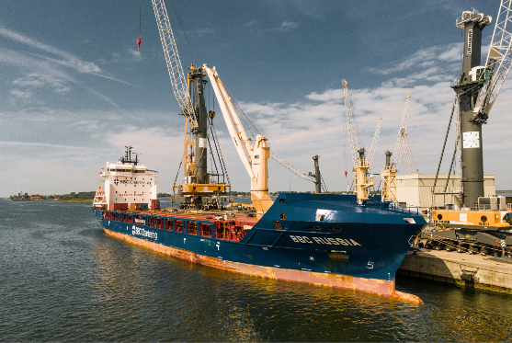
liebherr-shipping-rostock-germany-2.jpg
Liebherr Rostock has manufactured and delivered 1,300 maritime cranes since 2005
liebherr-shipping-rostock-germany.jpg
Crane number 1,300 was shipped from Rostock, Germany to Ghana in June

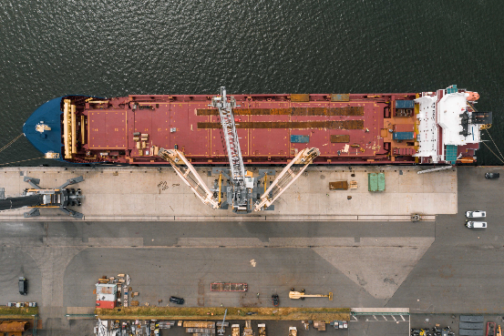
Video
Link Video: https://www.youtube.com/watch?v=SIn_IrEo8iQ
From Rostock to the world: Worldwide shipping of maritime cranes

Contact person
Philip Helberg
Tel: +49 381 6006 5024
E-Mail: philipp.helberg@liebherr.com
Published by
Liebherr-MCCtec Rostock GmbH
Rostock / Germany
www.liebherr.com

