Press release

“VarioBase® is the Ferrari of crane support systems”

⸺
Liebherr LTC 1050-3.1 highly flexible for a whole host of different jobs
Hildesheim-based crane contractor K&W orders three new LTM mobile cranes
VarioBase® leads to the company changing crane supplier to Liebherr
Hildesheim-based K&W Autokrane GmbH & CO.KG has a fleet of eight mobile cranes. To date, an LTM 1030-2.1 and a compact LTC 1050-3.1 were its only machines bearing the Liebherr logo. Now the company has ordered three LTM mobile cranes from the Ehingen-based crane manufacturer. The reason behind the change of manufacturer – the extremely successful VarioBase® crane support system.
Ehingen (Germany), 6 July 2021 – The first of the three ordered Liebherr mobile cranes are due to make the journey from the crane factory in Ehingen, southern Germany northwards at some point in August. It will be an LTM 1160-5.2. This 5 axle crane with lifting capacities of up to 180 tonnes will expand the portfolio of the Hildesheim-based company upwards and will be K&W’s new flagship. During the year, two additional cranes will follow in their black and yellow livery – an LTM 1110-5.1 and an LTM 1055-3.2.
Joint Managing Director Christoph Klein admits that the company’s only experience with Liebherr cranes to date has involved an LTM 1030-2.1 and the LTC 1050-3.1 compact crane. The LTC is true to its name as a compact lifting machine as it requires a minimal amount of space, particularly in adverse site conditions or in low industrial buildings. In the latter case, the powerful 3 axle crane has a short erection jib with a practical heavy duty hook. This enables it to attach loads or fastening equipment level with the jib. As a result of its design, this addition, whose angle can be adjusted, can reach a hoisting height up to just below the building roof or limiting levels – in contrast to jobs where a conventional hook block is used. This is a major benefit for installing tanks, assembling gantry cranes or positioning large machine tools. As is the telescoping elevating cab, which provides the crane operator with a perfect view at all times, ensuring a high level of safety during hoisting work.
A crane for a wide range of jobs
“The LTC does everything for us,” says Klein. “From quick day jobs to long term sites to crane work inside buildings, the compact crane has been used universally by us for the last four years.” The VarioBase® system developed by Liebherr, which enables each outrigger to be extended to a different length has proven its worth in various situations, but particularly when working inside industrial buildings.
This system, which is extremely popular and established within the market, has now become an essential part of crane operations. “Quite simply, VarioBase® is the Ferrari of crane support systems”, is how Christoph Klein describes the main feature behind his company’s switch to Liebherr cranes.
Klein, who manages the company alongside Michael Wanjek, has crane customers within a radius of around 80 kilometres of the company’s based in Hildesheim. In addition to crane and industrial assembly work, K&W also provides heavy and special haulage services as well as recovery and towing services of all types.

Photographs

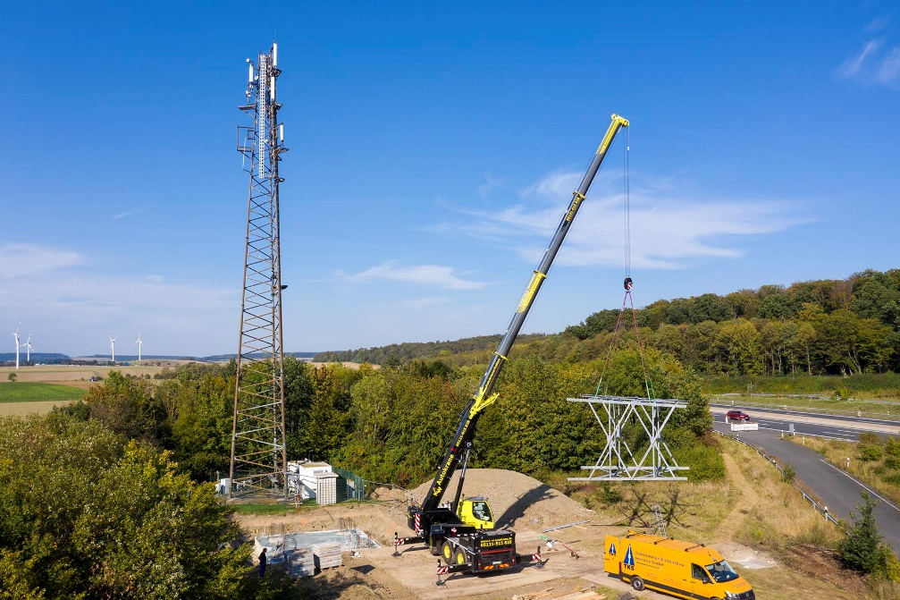
liebherr-ltc1050-3-1-k&w-1.jpg
Suitable for universal use – the LTC 1050-3.1 from K&W helps out with assembly work on a radio mast.

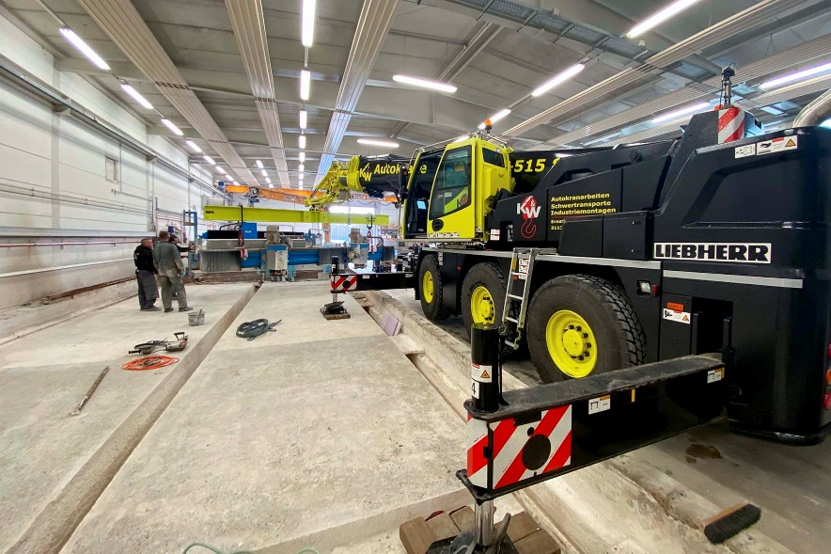
liebherr-ltc1050-3-1-k&w-2.jpg
Hall specialist – the compact crane particularly shows its strengths inside low industrial buildings.

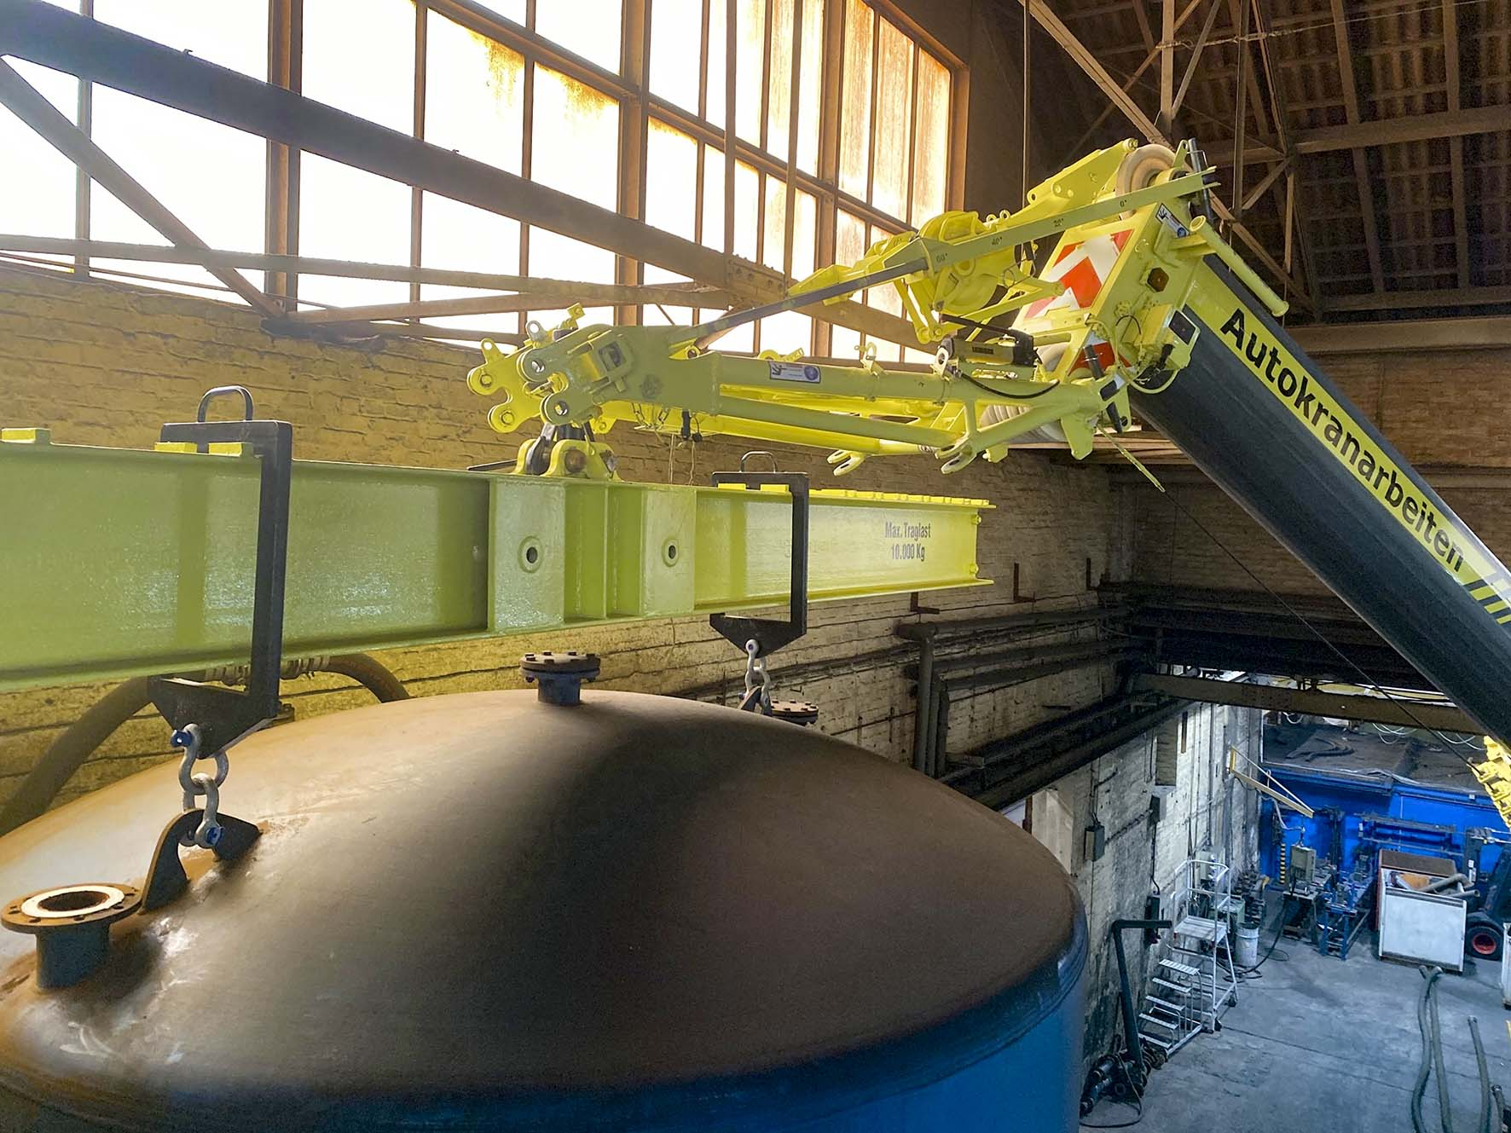
liebherr-ltc1050-3-1-k&w-3.jpg
Variable – the angle of the erection jib can be adjusted to the specific requirements. This makes hoisting heights up to just below the building roof or other limiting levels possible.

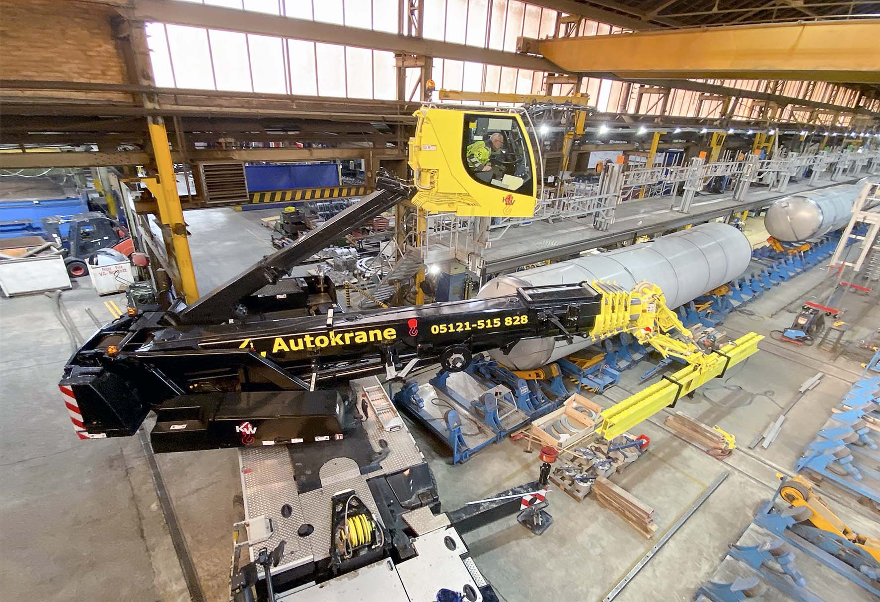

liebherr-ltc1050-3-1-k&w-4.jpg
A clear view – the telescoping elevating cab provides the crane operator with a great view of what is happening at all times.

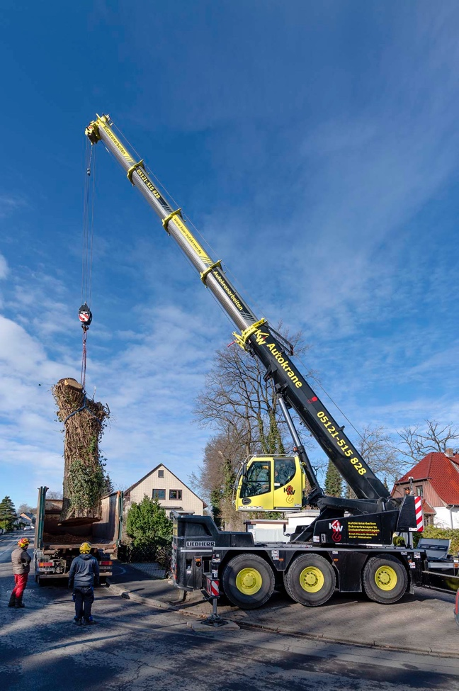

liebherr-ltc1050-3-1-k&w-5.jpg
Gardening – the compact crane even only requires a small parking bay to remove a six tonne oak trunk.

Contact person
Wolfgang Beringer
Marketing and Communication
Phone: +49 7391/502-3663
Email: wolfgang.beringer@liebherr.com
Published by
Liebherr-Werk Ehingen GmbH
Ehingen (Donau) / Germany
www.liebherr.com

