Questionnaire WMS II
Liebherr water content measurement system WMS II

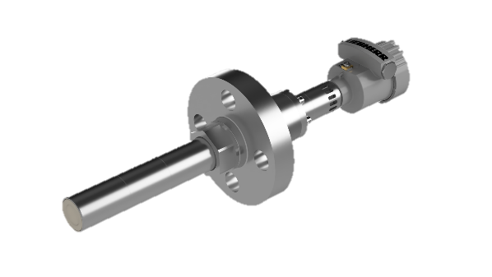
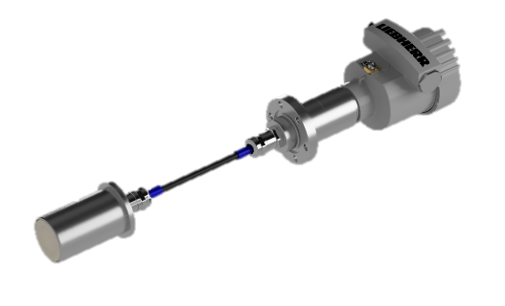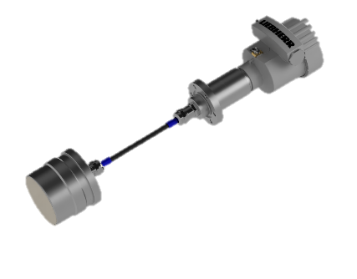
WMS II planar sensor P45-GD WMS II planar sensor P78-GD WMS II rod sensor P45-GD

Company: |  | Contact:
Street: |  | Post code, Town:
Phone: |  | E-Mail:
www. |  | Date:

Process and medium characteristics:
Marking  Medium/Liquid: | other emulsion:  Composition:
Marking  Powder & Bulk: | Other Powder&Bulk:  Grain size:  min: mm max: mm
Medium/Material  temperature (°C) | min.: norm.: max.:
Ambient temperature (°C) | min.: norm.: max.:
Pressure (bar) | min.: norm.: max.:
Density (kg/m³): | min.: norm.: max.:  Variation:
Viscosity (Pas) | min.: norm.: max.:
Measurement range
Water content/Moisture: min: % water content/moisture max: % water content/moisture
Required accuracy: +/- % water content/moisture

Water saturation at: ca. % water content
Rate of wear: low high
Adhesive strength: low high
Conductivity: yes no

Moisture reference (% water content):

Installation Place / measurement point:
Sensor installation place
Emulsions: Tube size, : mm, or Inch “
Wall thickness: mm
Tank highness: m
: m
Other installation site:
Measuring field shaft sensor: front side Option: lateral measuring field

Retractable fitting (only shaft sensor, up to pressure 6 bar,
material: 1.4571) desired: yes no

Installation place
Powder &Bulk: Tube : mm
Other
Process type: Continuous operation Batching operation (Starting signal 24 V)
Material layer on sensor: min: mm max: mm

Material Sensor: other material:
Distance measuring point (s) – PLC/Controll-system, max: m

Number of measuring points:
Separate display necessary:

Certificates: ATEX / UKEX:
EU-type examination certificate number: EPS 21 ATEX 1 140 X
EPS 22 UKEX 1 159 X

EN IEC 60079-0:2018, EN 60079-1:2014, EN 60079-11:2012,
EN 60079-26:2015, EN 60079-31:2014



Gas EX-protection:
II 1/2 G Ex db/ia IIC T4 Ga/Gb
Dust EX-protection:
II 1/2 D Ex tb/ia IIIC T135°C Da/Db


IECEx:
Certificate number: IECEx EPS 21.0047X

IEC 60079-0:2017 Edition: 7.0, IEC 60079-1:2014-06 Edition: 7.0,
IEC 60079-11:2011 Edition: 6, IEC 60079-26:2014-10 Edition: 3.0,
IEC 60079-31:2013 Edition: 2

Gas EX-protection:
Ex db/ia IIC T4 Ga/Gb
Dust EX-protection:
Ex tb/ia IIIC T135°C Da/Db

Desired applicable device category:

Other local certificates necessary:

Other:

Process connection: Pressure: 75 bar (16 bar with WMS II planar sensor P78-GD)
Threaded flange: ASME B16.5
Temperature class: 1500
Flange: DN 40 or 1 ½ Zoll

Other process connection necessary:

Output signal: 4 - 20 mA, actively supplied from sensor
power supply unit, max. load 500 Ω, resolution 16 bit

HART-Protocol

Power supply: 12 V DC (SELV/PELV)

Short description of the plant/description of the process cycle around the measuring point/ other information:

