Liebherr online coating thickness measurement/
weight per unit and definition type Litronic FMS-CCS
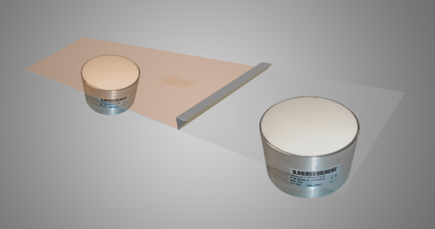

Company: |  | Contact person:
Adress: |  | www:
Phone: |  | E-Mail:
Branch: |  | Date:

Basic material:
Basis material thickness +- %
stable ☐ unstable ☐
Lamination: yes ☐ no ☐
Material:
Lamination Thickness up to
Moisture content from up to %
Weight proportion: %
Per cent by volume:%
Solvent: yes ☐ no ☐
Using only in EX-free areas

Using only in EX-free areas

Belt width:
Belt speed:
Measurement: with contact ☐ contactless ☐
Measurement unit:
Material temperature:
Ambient temperature:
Installation place:
Number of measuring points:
Short description of the plant or description of the process cycle around the measuring point:

